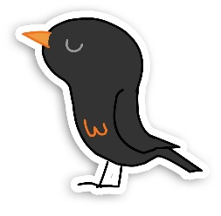

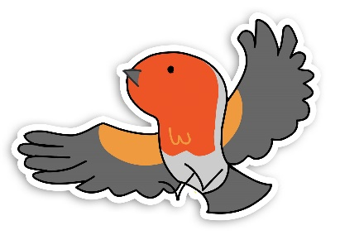
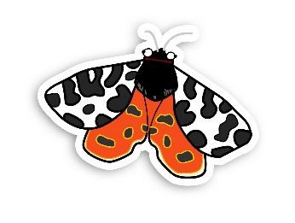
Wildlife Watch Group Promotional Toolkit

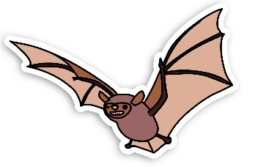
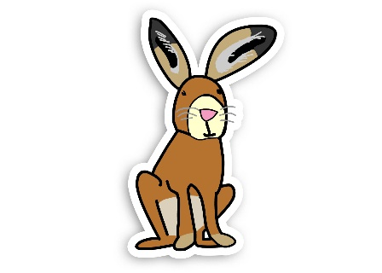

Introduction
This Wildlife Watch Promotional Toolkit is here to help you when it comes to advertising your Wildlife Watch group. It contains poster templates, logos, top tips and more.
Promotion is a big part of Wildlife Watch, whether it is advertising for new members or recruiting new volunteers - but don’t worry, the Trust is here to help you along the way!
There are templates throughout that you can print off, or copy and paste into a new document to add your stamp on them.
If you have any questions or looking for any form of support, reach out to Rachel, Engagement Officer, rfaichnie@scottishwildlifetrust.org.uk.

Support from the Trust 3
Poster and Programmes 4
- Wildlife Watch Poster/Programme templates 5
- Make your own! 5
Wildlife Watch Branding 11
- Wildlife Watch Logos 11
- Scottish Wildlife Trust Logos 11
- Scottish Wildlife Watch Logo 11
- Animal characters 12
- Icons 13
- Wildlife Watch Badger and Gang 14
- Paint Splats and Circles 15
Media Releases 16
- Media Release Template: Advertising Wildlife Watch Group for new members 16
- Media Release Template: Advertising new Wildlife Watch Group launch 17
- Wildlife Watch Group weblinks (shortened URLs – ideal for media releases) 18
Using Photos in Promotion 19
- Photo Guidance 19
Considering Accessibility 20

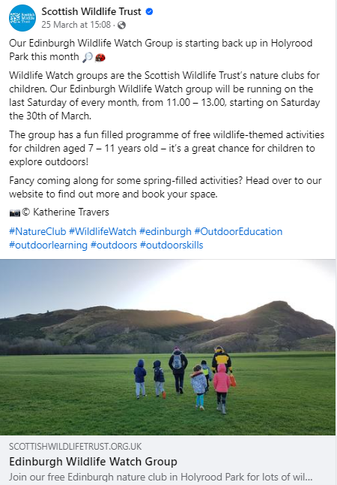
Support from the Trust

Looking to spread the word and encourage more families to join your group?
Reach out to Rachel, rfaichnie@scottishwildlifetrust.org.uk and we can promote your group on our social media, like we did here for the Edinburgh Wildlife Watch group.
We can post on our various channels (including Facebook, Instagram, LinkedIn, and X) sharing photos, programmes, or your webpage link, encouraging people to reach out and to book onto your sessions.

Looking for more volunteer help?
Reach out to Rachel, rfaichnie@scottishwildlifetrust.org.uk, and we can create a volunteer advertisement on our website and promote it through our channels (as well as other volunteering sites).

Your group’s webpage on the Scottish Wildlife Trust website
Each Wildlife Watch group has its own page on the Scottish Wildlife Trust website, which you can find here. The page displays all your group’s key information and contact details, so it is a great place to direct parents to.
We want to keep your pages as accurate and up to date as possible, so if any of your key details change (such as timings or locations) please let Rachel know as soon as you can so we can amend your page.
Similarly, if you have any programmes, posters, or photos you would like added to your page, send them over to Rachel.
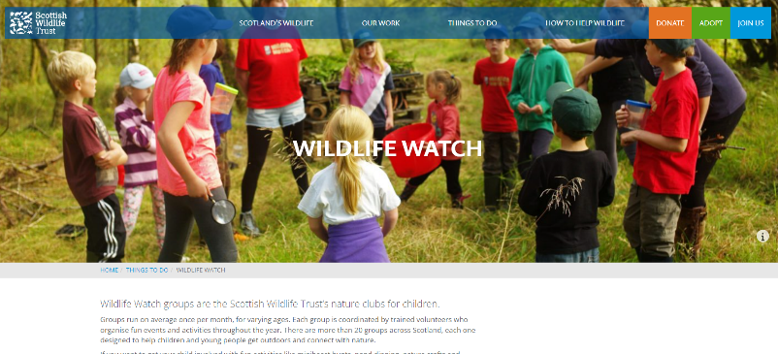

Poster and Programmes
Posters and programmes are a great resource to make – for example they can be shared with parents giving them session dates and key information, or they can be used to promote your group to the local community.
They can be printed and put up in local shops/community hubs/billboards etc, or you can share them online (as a JPEG file is usually best) through social media (e.g. your own social media pages, the Trust’s pages, or local community Facebook groups).
Here are some tips on what information to include:

Poster
- Wildlife Watch logo, Scottish Wildlife Trust logo, any partnership logos (if you have them)
- Wildlife Watch Group name
- Short description (e.g., We are a nature club for children. We explore the natural world in our local area through a mix of outdoor activities and indoor crafts.)
- When you meet (e.g., second Saturday of every month)
- Contact information (e.g., email address)
Programme
- Wildlife Watch logo, Scottish Wildlife Trust logo, any partnership logos (if you have them)
- Wildlife Watch Group name
- Session titles, dates, times, and locations
- Contact information (e.g., email address)

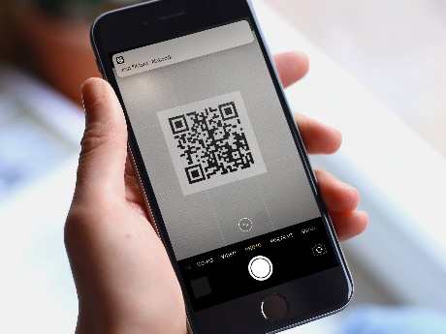
Adding a QR code to your poster or programme is a great way to direct readers to your group’s page on our website, or to your Facebook page (if your group has one), especially if you are printing copies to put up.
You can make one easily for free here, by just copy and pasting your weblink. You can then download the QR code as an image and add it to your poster!
Make sure to let people know what the QR code is taking them too when you display it, for example ‘scan the QR code with your mobile to visit XXX’.
© iMore
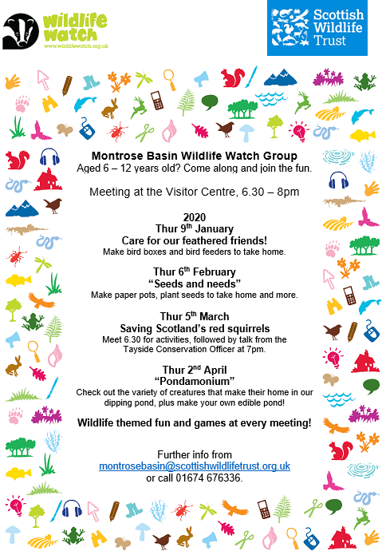

Wildlife Watch Poster/Programme templates
Below you can find four different Wildlife Watch poster/programme templates that you are welcome to use!
You can print them and add your text or copy and paste them into another Microsoft Word document to add your text boxes.
Please note if you are copy and pasting the templates into another document, to make sure the Scottish Wildlife Trust Logo and the new Wildlife Trust logo are also copied over (in this document they are just layered on top of the poster template).
Here the Montrose Wildlife Watch Group have made a poster/programme with all their information on it, using one of the templates below!

Make your own!
You can get creative and make your own posters and programmes as well! Remember to include a Wildlife Watch Logo and a Scottish Wildlife Trust logo in your design (you can find these in Wildlife Watch Branding section) – plus any other logos you need (particularly if your group is in partnership).
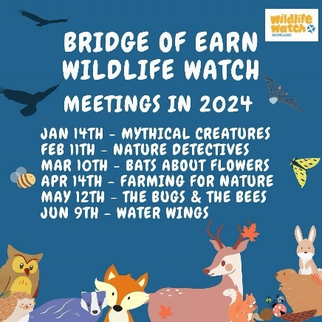
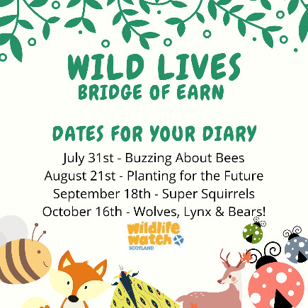
We recommend staying consistent with the design you use for your posters and programmes as they helps create a sense of brand for your group. For example Bridge of Earn Wildlfie Watch use a consistent font, logo and characters for all their programmes.

A great free graphic deisgn tool is canva.com – it is user friendly and great for making posters/programmes/flyers and more.
You could also ask your group’s members to draw and design their own poster!
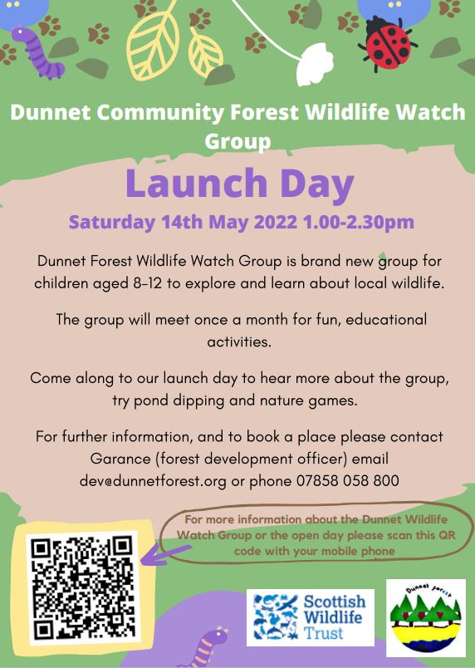
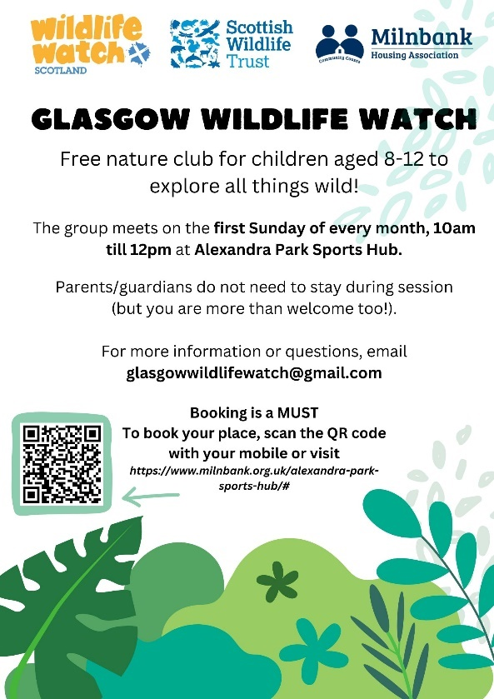
Here are a few examples for some of our groups…
Glasgow Wildlife Watch Poster Dunnet Wildlife Watch Poster

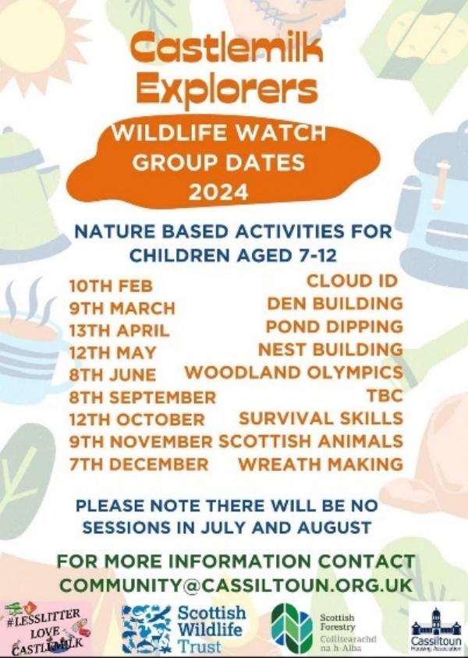
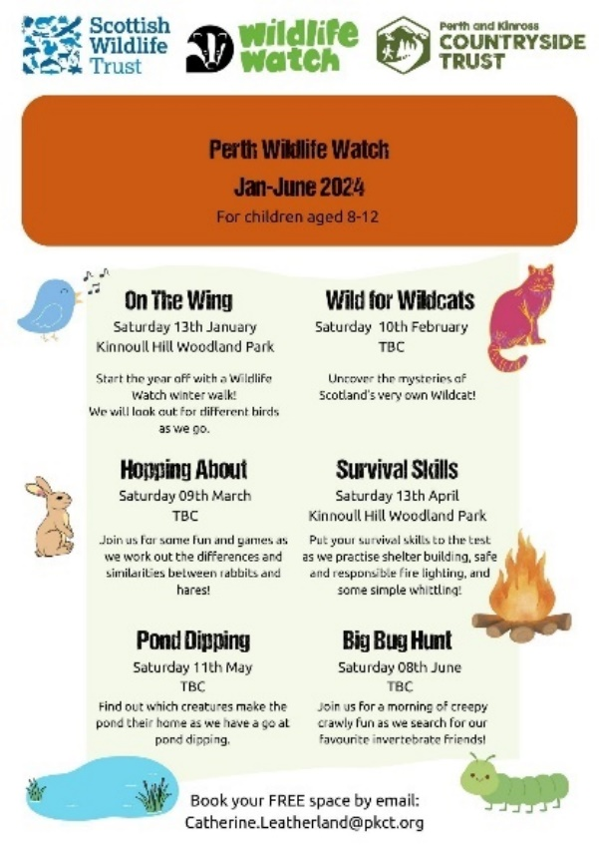

Perth Wildlife Watch Programme Castlemilk Explorers Programme

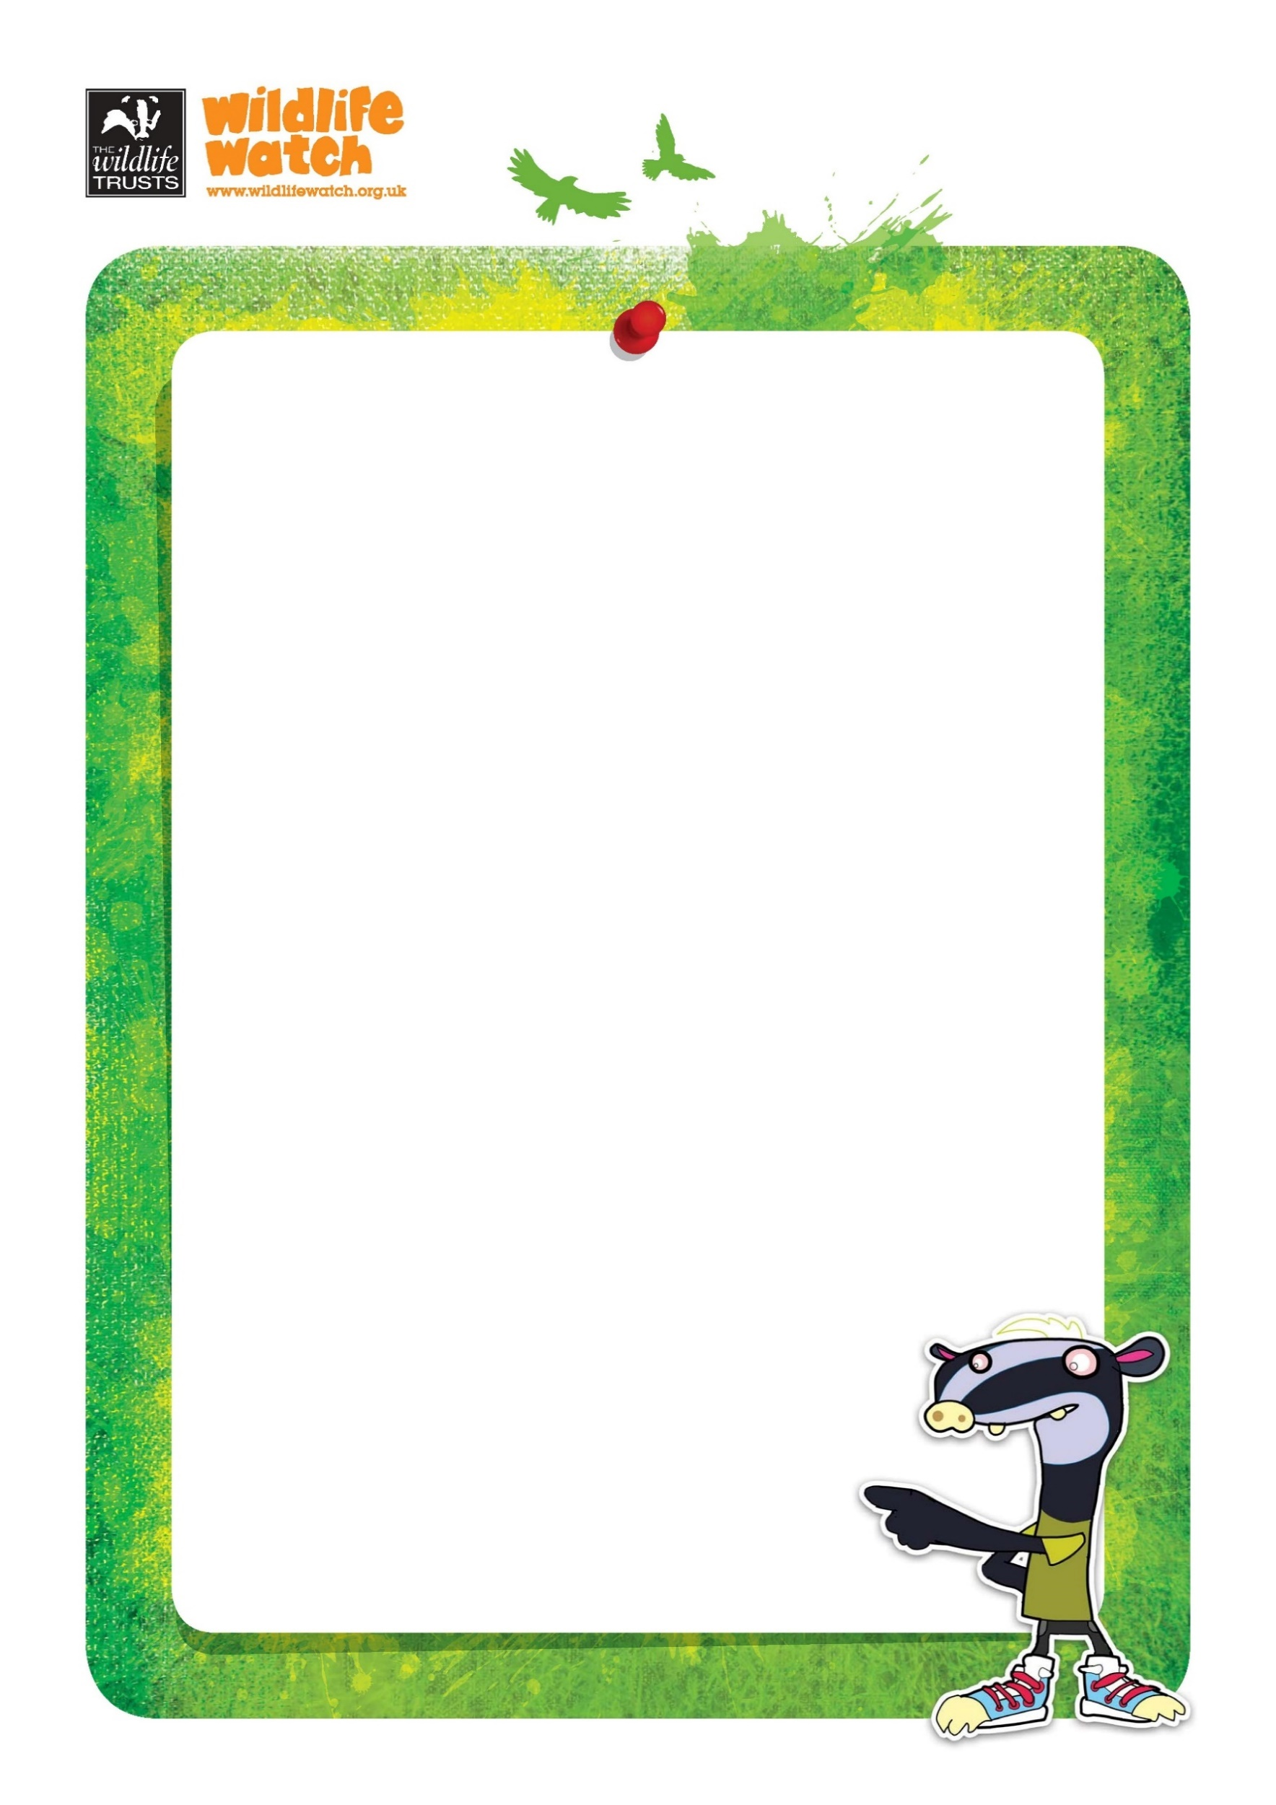

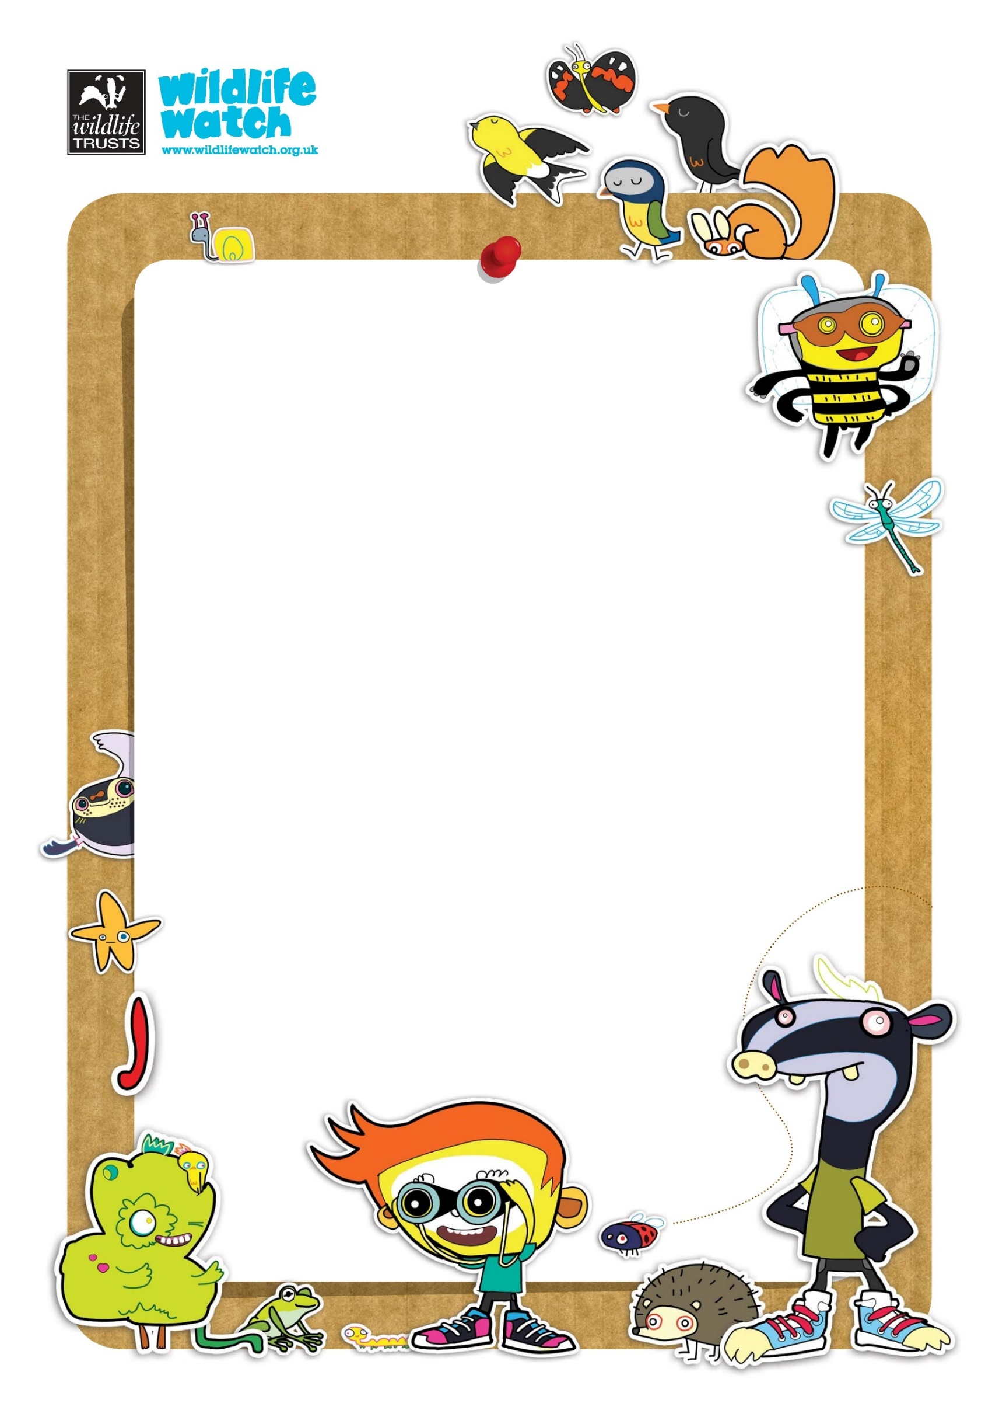

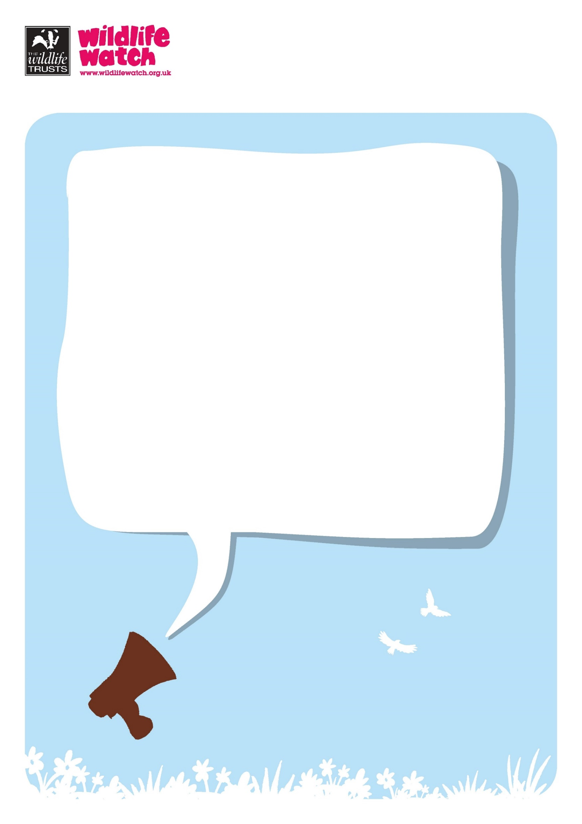

Wildlife Watch Branding
Wildlife Watch has various logos, icons and characters that you are more than welcome to use when it comes to your Wildlife Watch groups, from posters and programmes to any education resources you make.
Copy and paste from the selection below (all JPG files).

Wildlife Watch Logos

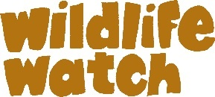

Scottish Wildlife Trust Logos

Scottish Wildlife Watch Logo

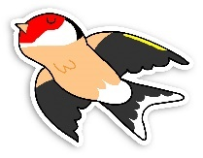
Animal characters
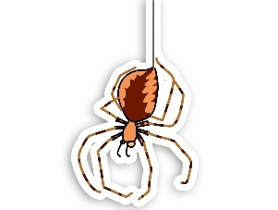
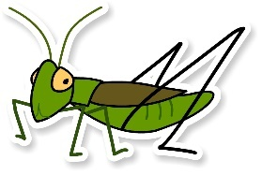
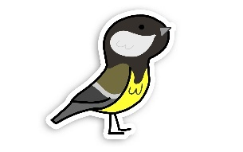
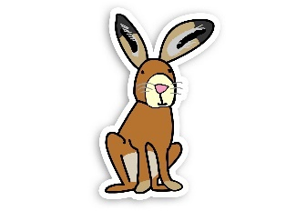
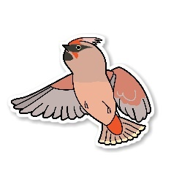
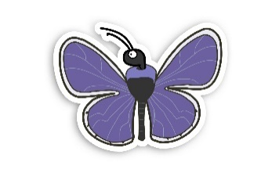
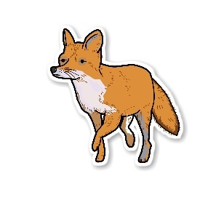
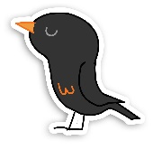
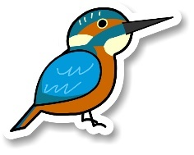
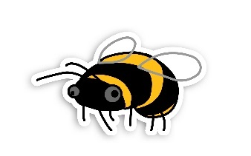
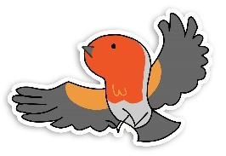
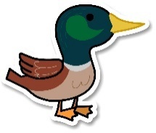
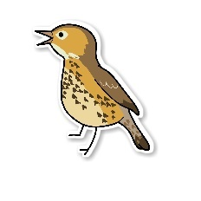
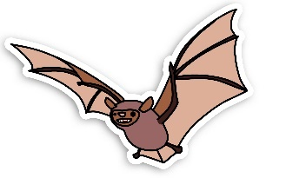
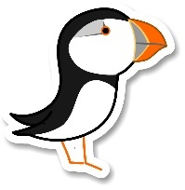
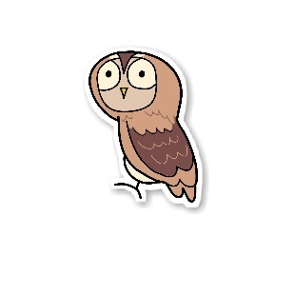
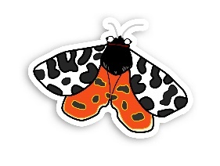
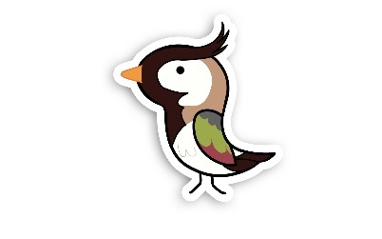
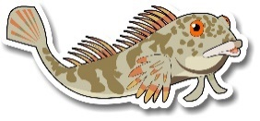

Icons

Wildlife Watch Badger and Gang

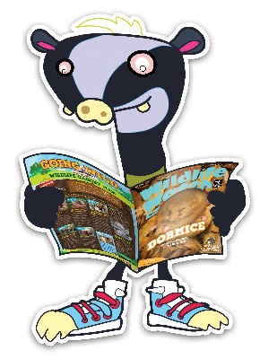

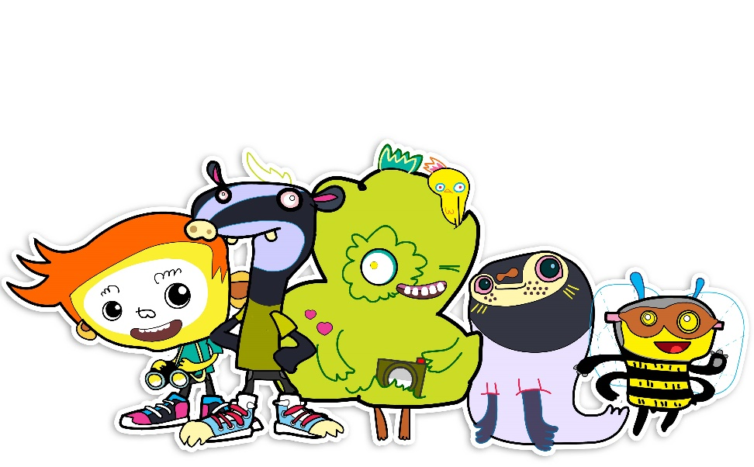

Paint Splats and Circles

Media Releases
Media releases can be a great way to spread the word about your group. They can be shared with local newspapers, radio stations, community newsletters etc.
If you are interested in sending out a media release but unsure where to start, get in touch with Rachel, rfaichnie@scottishwildlifetrust.org.uk and we can provide support, including helpful contacts.
Below you will find two media release templates, one for new groups launching and one for groups looking to recruit new members. All you need to do is copy and paste the relevant template into a separate document and fill in the correct information when indicated (in red).

Media Release Template: Advertising Wildlife Watch Group for new members

Title: Kids encouraged to get closer to nature
Text: A fun filled programme of free outdoor activities is planned for children aged [insert age] years old by [insert name of group] Wildlife Watch Group. The nature club, supported by the Scottish Wildlife Trust, meets at [insert location] on the [insert date, e.g. first Saturday] of every month from [insert timings].
Activities planned over the forthcoming months to help children learn more about their local environment include:
[insert upcoming session dates and activities]
Leader, [Insert volunteer name] said: “We have a range of fun crafts and outdoors activities planned over the coming months including [insert quote from group leader]”
“The group is a great chance for children to enjoy time outdoors and learn about their local green spaces and the wildlife on their doorstep.
Rachel Faichnie, Engagement Officer with the Scottish Wildlife Trust, who provide support to over 25 groups across Scotland, said: “Wildlife Watch Groups are a wonderful way for children to learn about wildlife, from mighty millipedes to killer kestrels, that live on our doorsteps”.
“ I would encourage parents to support their children to connect with nature, have fun and make friends by joining [insert name of group] Wildlife Watch Group.”
Places can be booked via email at [insert email address] Find out more about [insert name of group] Wildlife Watch Group on their [insert your Wildlife Watch page website link, which you can find below] and [insert your Facebook page link] page.
For anyone interested in becoming a Wildlife Watch Group leader, volunteer, or are thinking of setting up a new group contact Rachel Faichnie, Engagement Officer with the Scottish Wildlife Trust by emailing: rfaichnie@scottishwildlifetrust.org.uk. Training and ongoing support is provided to volunteers and leaders.
Find out more about the Scottish Wildlife Trust’s Wildlife Watch Groups on their website.

Media Release Template: Advertising new Wildlife Watch Group launch
Title: New children’s nature club in [insert location]
Text: Children aged [insert age] are invited to join a new nature club in [insert location]. The [insert name of group] Wildlife Watch Group is part of the Scottish Wildlife Trust’s network of over 25 children’s nature clubs across the country ranging from Orkney to Eskdale and Aberdeen to the Isle of Eigg.
Running every month, children can enjoy a fun-filled session of events and activities throughout the year on the [insert date] of every month. The group is organised by [insert organisation or ‘volunteers’] who are delighted to be offering opportunities for children to learn more about their local environment and wildlife.
[Insert a Leader’s name] from the group said: “[insert quote from group leader]”
From [insert date] the group will meet at [insert meeting place, booking details etc]
Places can be booked via email at [insert email address] Find out more about [insert name of group] Wildlife Watch Group on their [insert your Wildlife Watch page website link, which you can find below] and [insert your Facebook page link] page.
Rachel Faichnie, Engagement Officer with the Scottish Wildlife Trust said: “The creation of a new Wildlife Watch Group enables more children to enjoy memorable wildlife experiences and learn about lots of wonderful wildlife, from tiny beetles to noisy blackbirds, that live right on their doorstep.
“Well done to everyone involved in creating this group. I would encourage all parents to support their children to have fun and make friends through learning about nature with the [insert name of group] Wildlife Watch Group.”
For anyone interested in becoming a Wildlife Watch Group leader, volunteer, or are thinking of setting up a new group contact Rachel Faichnie, Engagement Officer with the Scottish Wildlife Trust by emailing: rfaichnie@scottishwildlifetrust.org.uk. Training and ongoing support is provided to volunteers and leaders.
Find out more about the Scottish Wildlife Trust’s Wildlife Watch Groups on their website.

Wildlife Watch Group weblinks (shortened URLs – ideal for media releases)

When sending a media release it is important to include a link to your webpage for the reader/listener to visit to find out more information. Linking to your groups page on our website is ideal as all the information is in the same place for parents to see. Below you will find shortened links for each group which are ideal for using in media releases.
Important to note: if the media release is going to be printed you need to include a link written out in full (like below), but if the release will be only online, you can use a hyperlink and embedded it in the text like this.

Aberdeen Wildlife Watch Group | https://scottishwildlifetrust.org.uk/aberdeen
Bridge of Earn Wildlife Watch Group | https://scottishwildlifetrust.org.uk/bridge-of-earn
Castlemilk Explorers Wildlife Watch Group | https://scottishwildlifetrust.org.uk/castlemilkexplorers
Cumbernauld Wildlife Watch Group | https://scottishwildlifetrust.org.uk/cumbernauldgroup
Dunnet Forest Wildlife Watch Group | https://scottishwildlifetrust.org.uk/dunnet
Edinburgh Wildlife Watch Group | https://scottishwildlifetrust.org.uk/edinburgh
Eigg Wildlife Watch Group | https://scottishwildlifetrust.org.uk/eigg
Eskdale Wildlife Watch Group | https://scottishwildlifetrust.org.uk/eskdale
Falls of Clyde Wildlife Watch Group | https://scottishwildlifetrust.org.uk/fallsofclydegroup
Forres Wildlife Watch Group | https://scottishwildlifetrust.org.uk/forres
Galloway Peregrines and Red Kites Wildlife Watch Group | https://scottishwildlifetrust.org.uk/galloway
Glasgow Wildlife Watch Group | https://scottishwildlifetrust.org.uk/glasgow
Inverness Wildlife Watch Group | https://scottishwildlifetrust.org.uk/inverness
Irvine Wildlife Watch Group | https://scottishwildlifetrust.org.uk/irvine
Kilmartin Museum Wildlife Watch Group | https://scottishwildlifetrust.org.uk/kilmartin
Let’s LOOC Wildlife Watch Group | https://scottishwildlifetrust.org.uk/letslooc
Lochaline Primary Nature Club | https://scottishwildlifetrust.org.uk/lochaline
Milngavie Wildlife Watch Group | https://scottishwildlifetrust.org.uk/milngavie
Montrose Basin Wildlife Watch Group | https://scottishwildlifetrust.org.uk/montrosegroup
Muiravonside Wildlife Watch Group | https://scottishwildlifetrust.org.uk/muiravonside
Orkney Junior Wildlife Watch Group | https://scottishwildlifetrust.org.uk/orkney
Perth Wildlife Watch Group | https://scottishwildlifetrust.org.uk/perth
Roslin Glen Wildlife Watch Group | https://scottishwildlifetrust.org.uk/roslin
Rowantree Primary Wildlife Watch Group | https://scottishwildlifetrust.org.uk/rowantree
St Bartholomew’s Nursery Wildlife Watch Group | https://scottishwildlifetrust.org.uk/stbartholomews
Strathblane Primary Wildlife Watch Group | https://scottishwildlifetrust.org.uk/strathblane

Using Photos in Promotion

Adding photos of your Wildlife Watch Group to your posters and programmes, or including them in your media releases or social media posts, is a great way of capturing people’s attention (and showing how fun Wildlife Watch is!).
However, it is incredibly important that we have the correct consent for any identifiable photos of children we share. Please familiarise yourself with the photo guidance below.
If you have any questions let Rachel, rfaichnie@scottishwildlifetrust.org.uk know – there are never silly questions when it comes to safeguarding! And remember, when in doubt opt for photos of hands or backs of heads instead.

Photo Guidance
Any photo in which the person can be identified counts as personal data. There are stricter rules for identifiable photos of children, due to both GDPR and safeguarding regulations. We love photos of Wildlife Watch so please keep taking them, but it is essential that you follow this guidance when doing so.

Taking photos

- Any photo of a child (under 18) requires written consent (via the Parental Consent form).
- If the child is under 12, the parent/guardian provides this consent.
- If the child is 12 or over, they need to provide this consent themselves.
- It may be easiest to have them sign the Parental Consent form alongside their parent/guardian, as this confirms they’re happy with how it has been filled out.
- Everything else on the Parental Consent form still needs to be completed by the adult – for example please do not collect children’s email addresses.
- If you are unsure if consent has been provided – do not take identifiable photos. It is not worth the risk to the child.
- It is not essential to collect specific written consent from adults unless they are the subject of the photo (e.g. a single person in the photo, staged shot). You do need to make them aware that you will be taking photos and what they might be used for, and give them the option to not appear in photos. Please use the Trust’s Event Photo notice for this.

Storing photos

- Photos should be uploaded to a nominated Leader’s device – they should not be retained indefinitely on the device used to take the photos.
- Save the photos in a location that can only be accessed by the nominated Leader. Preferably this will be backed up e.g. OneDrive.
- Using the consent forms for the children that appear in an image, work out the year in which the oldest child in the photo will turn 12. This will be the expiry date of that image and should be saved in the filename e.g. ED2020.
- Once aged 12, all previous consent given by the parent/guardian for use of personal data expires. This means that the Trust can no longer use Wildlife Watch photos of children once they turn 12, unless their consent is gained. We could re-permission, but for practical reasons it will be easier for most groups to delete the photos at this point.
- Once a year, go through your stored photos and delete any with the current year in their expiry date code.
- Photos that have already been used in print, on the Trust website, or on Trust social media will remain on those platforms/materials. However, the photos will not be used in any further content.
- When sending your photos to the Engagement Officer, please confirm that consent had been provided for all children in the photos.
- Please ensure your files are named, with codes included, before sending to the Engagement Officer (or other Trust staff e.g. the comms team). This helps our staff team to monitor their photo records in accordance with our policy.

Considering Accessibility
When creating things like posters, programmes and social media content, it is important to think about accessibility when it comes to language and visuals. We never expect everything to be accessible for everyone, but it is great to be mindful of different needs and continue to educate ourselves.
Here are a few bitesize tips! Try to incorporate a few of these where you can.
- Avoid complex phrases, jargon or slang. This way of writing is more accessible for everyone – particularly people who are non-native English speakers, those who experience low literacy, or who have a cognitive disability that impacts comprehension.
- Avoid too many emojis. They can be really fun but they can also confuse screen readers so try and find a nice balance.
- Minimum of font size 12. This can help those with visual impairments.
- Avoid using green/red, blue/purple/ and light green/yellow combinations. These can be hard for those with visual impairments and those who are colour blind to differentiate.
- Avoid text overlaying patterned backgrounds. This can make it hard for some people to read the text.
- Use inclusive language. Try to use gender neutral pronouns and share diverse voices.
- Capitalise new words in hashtags. #NewWord. This helps screen readers.
- Describes links as well as using a URL. Rather than just adding a URL into the text with no context, include a little description of what the link is. This helps screen readers. For example: ‘You can find all of our Wildlife Watch groups on our website here’
- Have image descriptions / use alt text. Please see below for more information about alt text.

Using ALT text:
Alt text, alterative text, is a description of an image on a webpage. This helps people (such as those using screen readers or with visual impairments) who are unable to see the images still understand what they are showing. Alt is written in the HTML code and is not usually visible on the page itself but can be picked up by screen readers.
Most social media programmes, and software such as Microsoft Word, provide an option for alt text. Some generate an automatic alt text – which can be accurate, but not always!
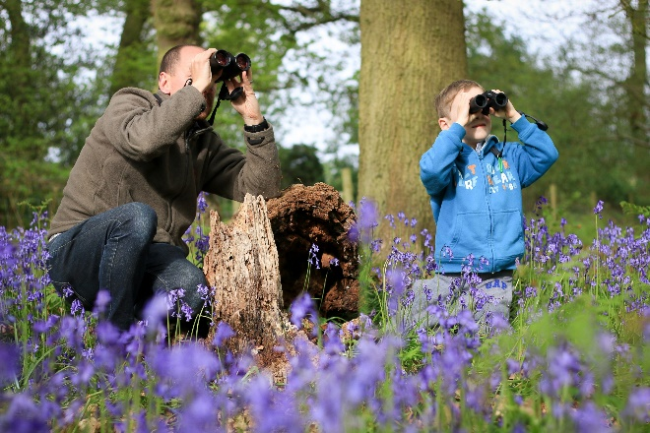
If you are including any images and are able to add alt text, your alt text should be short but descriptive. Your image description should highlight the relevance to the image to the text it is supporting. A useful formula to help decide on the alt text is Object > Action > Context. The object is the main focus of the image. The action described what is happening (often what the object is doing). The context describes the surrounding environment. This format keeps the alt text objective, succinct, and descriptive.
For example, an image description you could use for this image could be:
‘An adult and a child are looking for birds through their binoculars whilst they are in the woods surrounded by purple flowers’.

© Tom Marshall

If you have any questions or looking for any form of support, reach out to Rachel, Engagement Officer, rfaichnie@scottishwildlifetrust.org.uk.

