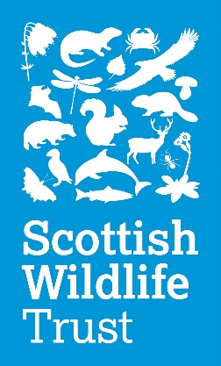
Annual General Meeting 2019

Date: Saturday 21 September
Venue: The Main Hall, Heriot-Watt University,
Scottish Borders Campus, Nether Road,
Galashiels TD1 3HF

Agenda for the 55th Annual General Meeting – 11.00 to 12.30
- Apologies
- To approve the minutes from the 54th AGM held at the National Museum of Scotland, Chambers Street, Edinburgh, EH1 1JF.
- To receive the Council’s report and accounts for the year ended 31 March 2019. The Annual Report and Financial Statements can be downloaded from the Trust’s website. Copies are available on request from the Company Secretary. Copies will also be available at the AGM.
- To re-appoint auditors of the Trust: RSM, Centenary House, 69 Wellington Street, Glasgow, G2 6HG.
- To note co-option of members to Council.
- Any other relevant business. All other business must be notified to the Company Secretary by 30 August 2019.

Company Secretary: Susan McKenzie
Registered Office: Scottish Wildlife Trust, Harbourside House, 110 Commercial Street, Edinburgh, EH6 6NF.

Access and Travel Details
Galashiels has good rail and road connections. We would strongly recommend that guests use public transport options where possible.
Click here to see the location of the Heriot-Watt campus on Google Maps.
BY TRAIN: The Heriot-Watt campus is 1.3 miles from Galashiels Train Station on Stirling Street. Several local buses run between the train station and the Heriot-Watt campus.
BY BUS: The X95 bus, operated by Borders Buses, runs hourly from Edinburgh to Galashiels, stopping on Abbotsford Road near the fire station. From there, you can catch the No.74 to the Heriot-Watt car park, or it is around a 15-minute walk (0.7 miles).
BY CAR: The Heriot-Watt campus is located off the A7, just north of the Kingsknowe roundabout. Free car parking is available at the venue’s main car park.
ACCESSIBILITY: The site is fully accessible, with lift access to The Main Hall.

