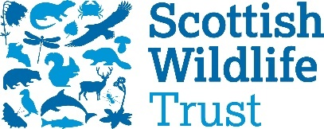
The Scottish Wildlife Trust’s new award programme
The Scottish Wildlife Trust Conservation Award

Structure of the Awards
The programme consists of three, time limited tiers. Within each tier, there is a minimum number of days required for completion.
Timescale
12 month award scheme, starting in September and completed end of August.
- Induction – late August/early September 2019
- Bronze – Sept – Nov 2019
- Silver – Dec – Feb 2019/2020
- Gold – March – August 2020
Bronze
3 months – a minimum of 12 days of volunteering at the location/role applied for, at an average of one day a week.
Silver
3 months – a minimum of 12 days of volunteering, at an average of one day a week, and part of that time spent on a personal project (such as social media, surveying, recording, writing a series of blogs, helping to design a trail, or designing new educational or promotional material).
Gold
Choice of:
- Long term placement lasting 6 months, commitment of 3 to 5 days a week
- 21 hours a week at their current location/role with additional responsibility over that 6 month period. This is the flexible stream - can break the 21 hours up over the week.
If choosing option one, applicants may need to apply and/or have an interview with the volunteer manager before March 2020, to ensure suitability for the Gold placement.
Participants in the awards programme will have access to shadowing and training opportunities.

