Water vole

Arvicola amphibius

Water voles were once a common sight along UK waterways. However since the 1970s their numbers have shown serious decline and they are currently our most rapidly declining mammal. Factors responsible include habitat fragmentation and predation by American mink. A national survey carried out between 1996 and 1998 showed that the water vole had been lost from 94% of sites and had vanished from entire catchments in northeast Scotland, North Yorkshire and Oxfordshire. Scotland supports 40% of UK population, mostly in the Highlands.
Water voles are a UKBAP Priority Species and included on the Scottish Biodiversity List. The places of shelter or protection of the Water vole are protected under the Wildlife and Countryside Act 1981, as amended, but not the animals themselves. This level of protection is under review and may be extended in future. The Water vole is also on SNH’s Scottish species action list as a species requiring conservation action.

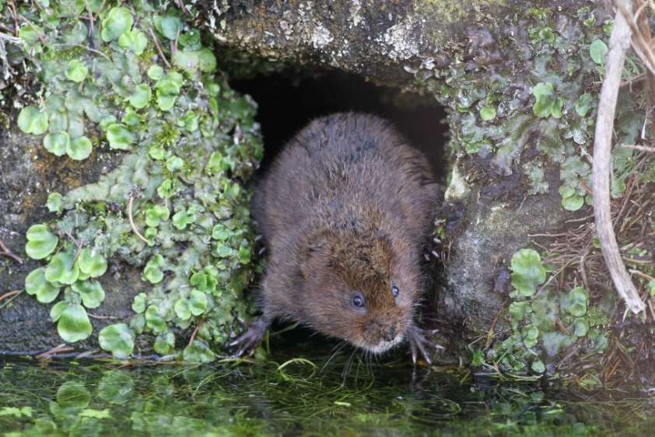
Water vole © Magaret Holland.

Description
Water voles (Arvicola amphibius) are the largest vole in Britain. They are sometimes confused with the Brown rat. However, Water voles have rounder faces, smaller ears (which do not protrude from the fur), smaller eyes, and a much shorter tail which is furry. Through most of their range they have a rich chestnut-brown coat, but individuals in Scotland often have black fur.
The droppings are the most distinctive field sign and are usually deposited in latrines which are typically found at prominent points along the watercourse. They are cylindrical with blunt ends, about 8-12 mm long and 4-5 mm wide and vary in colour from greenish (usually when fresh) to brown or black.

Distribution
The water vole occurs throughout Europe from the UK to eastern Siberia. It is widespread throughout the UK, found everywhere except for the Channel Islands, the Isles of Scilly, Scottish islands, Northern Ireland and the Isle of Man. In the UK, prime water voles sites are found along densely vegetated banks of slow flowing rivers, ditches, lakes and marshes where water is present throughout the year.
In Scotland, Water voles have suffered greatest declines in the lowlands and are now mainly restricted to the smaller tributaries and headwaters of upland rivers.
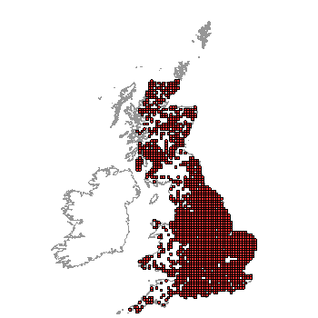
Distribution of Water vole in UK. (From NBN Gateway accessed 10/10/13)

Ecology
Water voles are herbivores, feeding on a huge variety of waterside vegetation. They like to sit and eat in the same place, and piles of nibbled grass and stems may be found at ‘feeding stations’ by the water's edge. Water voles burrow into river banks, creating inter-connecting tunnel systems with many entrances which include residential burrows, nest chambers, and bolt holes. The amount of bankside and emergent vegetation cover is very important, with the best sites offering a continuous swathe of tall plants. Recently occupied burrows are surrounded by characteristic grazed ‘lawns’ of shorter vegetation.
Water voles live in loose colonies of rarely more than ten breeding individuals. In upland areas, these social groups may comprise only a single family unit of an adult pair and two youngsters. Within this loose colonial social structure, the voles defend individual linear territories during the breeding season - each animal defending a territory of between 30 and 200 m of watercourse (the average is c.100 m). The males occupy territories that are roughly twice the size of the females’, often overlapping those of adjacent females³. Both sexes use their droppings in conjunction with their scent glands to mark these areas.
Breeding takes place between April and September, during which usually two or three litters are produced, each consisting of three to seven pups³. Smaller, single litters are more typical of upland-dwelling populations. The pups are born blind and naked in a nest chamber made of grass, but are ready to leave the nest after just three to four weeks. If the young are born before July they may breed that autumn, but most will reach sexual maturity after their first winter. Water voles do not hibernate, but become less active and gregarious during the winter with a female, her daughters and unrelated males sharing a communal nest.
Water voles have many predators including birds of prey, Grey heron, Stoats and Weasels. To escape predators, they take cover in dense vegetation, dive into water or dart into underground burrows. Unfortunately this is ineffective against the non-native American mink that can catch it on the bank, in the water and underground.

Threats
Water voles have been declining for some time, but have seen particularly rapid declines in the last few decades. Factors responsible include:
- Habitat degradation
The large-scale loss and fragmentation of sensitive waterside habitats due to riverbank modification, drainage and flood defence works. Pollution of waterways and poisoning by rodenticides meant for rats is also sometimes a problem.
- Grazing
Over-grazing can result in close-cropping of the bankside vegetation and poaching of the riverbank. This can have detrimental effect on Water voles in lowland areas. Conversely, an absence of grazing or control of the bankside vegetation can also be equally detrimental, leading to growth of dense thickets and a decline in the bankside grasses, reeds, sedges and rushes favoured by the voles.
- American mink (Mustela vison)
American mink were originally brought to the UK for their fur, but escapees have established and spread in the wild. Mink are able to successfully hunt the Water vole both on land and in the water. Furthermore, female mink are capable of following the voles into their burrows. There appears to be a correlation between the loss of Water vole sites and American mink presence. However, the decline in Water voles started well before mink became widely established, suggesting that habitat loss, fragmentation and degradation is also a problem: the mink may simply have been ‘the last straw’.

Management
The patchy and fragmented distribution of Water vole colonies, combined with the voles’ dispersal behaviour, is such that the protection of individual colonies in isolation is unlikely to achieve any lasting conservation benefits. Instead, a strategy that considers a number of nearby populations together is more likely to be effective.
• Creating and maintaining large-scale good quality habitat is key to ensuring the species’ survival. Ensure habitat connectivity exists between individual colonies.
• Maintain abundant herbaceous vegetation such as tall grasses and herbs alongside the water body. Fencing may help, although the growth of young trees and scrub needs to be prevented.
• Minimise the opportunity for mink colonisation through habitat management to reduce their opportunities for denning, coupled with targeted mink control.
Even if a section of otherwise suitable watercourse is unoccupied in one year, it could be occupied in subsequent years. Therefore potentially suitable habitat within 1.5km of an occupied site should also be managed appropriately.

Current work
At appropriate sites throughout the UK, the Wildlife Trusts are improving riverbank habitats, controlling Mink and being involved in Water vole reintroduction schemes.
- The Trossachs Water Vole Project
The Trossachs Water Vole Project (TWVP) is based in the Loch Ard forest area, near Aberfoyle. Water voles had not been seen in the area for over 30 years. In the early 1990s Forestry Commission Scotland (FCS) began a large scale habitat improvement scheme, improving the area for the benefit of all wildlife including water voles. An American mink control programme followed, setting the stage for Scotland's first water vole reintroduction programme.
Since 2008 the TWVP, supported by RZSS, FCS, Loch Lomond and Trossachs National Park and SNH has reintroduced and is monitoring and assisting further population expansion of the Water vole. To date Water voles can be found in a variety of wetland habitats across the Loch Ard forest area. It is hoped that with continued support from the local community and effective mink control, Water voles will continue their colonisation across the National Park.
- Scottish Mink Initiative
This project is a response to the ecological and economic threat of mink in Scotland. It is a partnership between the Rivers and Fisheries Trusts of Scotland (RAFTS), University of Aberdeen, Scottish Wildlife Trust, Scottish Natural Heritage and at least 16 other local organisations. Its overall aim is to protect nationally significant populations of water voles, salmonids, ground nesting birds and other native riparian biodiversity by establishing and sustaining an area free of breeding mink extending from the mid-Tay to the South Esk, around the east coast to the River Nairn; with a belt reaching from Dornoch and Cromarty on the east to Ullapool on the west.
- UK Water Vole Steering Group
This group comprises representatives from the Environment Agency, The Wildlife Trusts, People’s Trust for Endangered Species, Natural England, Scottish Natural Heritage, Natural Resources Wales and the Scottish Environment Protection Agency. It believes that a national Water vole monitoring programme is needed: annually recording populations at a sample of key areas across the UK would provide a better indication of how this vulnerable mammal is faring over time.
- University of Aberdeen
Prof. Xavier Lambin leads a research group investigating both American mink and Water vole populations in Scotland.

Wider context
American mink not only decimate Water voles. They can devastate populations of ground nesting birds and in areas where stocks of fish such as salmon and trout are already low, this invasive non-native predator can also be a problem.
Research has shown that Water voles play an important role in riparian habitats through their burrowing and by cropping bankside vegetation. Water voles’ dubious accolade of ‘Britain’s most rapidly declining mammal’ can serve to highlight the damaging effects of American mink and poor riparian management, encouraging positive conservation measures to restore damaged habitats.

Quick Facts
- There has been no national survey of the water vole since 1998.
- Scottish water voles are genetically distinct from those in the rest of the UK. The voles that colonised England and Wales following the last Ice Age originated from South East Europe, whereas Scotland's voles appear to be descended from migrants from northern Iberia.
- Scottish or upland Water voles are smaller than their English cousins rarely weighing over 170 g compared to the maximum size of 300 g for an English vole.
- Despite their name, the Water vole is not particularly well-adapted to an aquatic lifestyle – it lacks webbed feet and its fur is prone to water-logging after only a few minutes of immersion.
- Their life span is, on average, just five months. The maximum longevity in captivity is two years.
- There are numerous other local names for the species, including ‘waterdog,’ ‘water mole’ and ‘earth hound.’ In Gaelic, it is known as ‘radan uisge’ or ‘lamhallan’.
- Their burrow systems have several horizontal layers to guard against flooding.
- The Water vole is famously known as 'Ratty' in Kenneth Grahame's classic children's story, The Wind in the Willows.
- Water voles inhabit the water ditches of Edinburgh Airport and can be found in water channels of 30cm width on the top of the Cairngorms plateau.
- In Britain the Water vole is usually regarded as an aquatic, burrow-dwelling rodent that spends much of its time above ground close to water. In parts of continental Europe Water voles spend almost all their time beneath ground and often live in crop fields where they can become a serious agricultural pest. Colonies of these ‘fossorial’ water voles survive on several small islands in the Sound of Jura, where there is no permanent freshwater. Here they feed exclusively on underground roots and rhizomes.
Selected references
Capreolus Wildlife Consultancy (2005). The ecology and conservation of water voles in upland habitats. Scottish Natural Heritage Commissioned Report No. 099 (ROAME No. F99AC320).
Approximately 40% of the UK Water vole population is now thought to occur on Mainland Scotland and many of these remaining animals are living in upland habitats. This report looks at habitat, diet and population dynamics in upland areas and makes suggestions for conservation.

- Preferred habitat comprised well-vegetated mosaics of sedge, rush, grass and ericoids adjacent to slow flowing, shallow burns with penetrable banks and relatively gentle bank angles. Such habitats are localised and in consequence populations of water voles in upland habitats tend to be naturally highly fragmented.
- Spring, summer and autumn diet, as assessed from plant remains at feeding stations, was dominated by species belonging to the sedge, rush and grass families. Rushes were selectively exploited, sedges eaten in proportion to availability and grasses avoided relative to their abundance in the general environment.
- Colonies comprised a mean of 4.6 animals (range 1–15). First and last conceptions were estimated to have occurred on 3rd April and 25th August respectively, giving a breeding season of 144 days and the potential for females to produce four litters. This reproductive potential was not achieved: on average only 1 litter was produced, with a maximum of three being recorded.
- Monitoring of water vole populations would be best achieved by undertaking latrine counts together with surveys of % site occupancy, providing indices of abundance and snap-shots of spatial distribution respectively.

Raynor, R. (2004). Scotland's Wildlife: Conserving Scotland's Water Voles. SNH publications
www.snh.org.uk/publications/on-line/wildlife/voles/default.asp
This web-based publication aims to provide land managers and others interested in conserving water voles with an overview of the species in Scotland, the threats that it faces and, in particular, advice on the management practices that are considered beneficial and may help to reverse the decline.

Jefferies, D.J. (editor) (2003). The Water Vole and Mink Survey of Britain 1996-1998 with a history of the long-term changes in the status of both species and their causes. The Vincent Wildlife Trust.
Strachan, R. and Jefferies, D.J. (1993). The Water Vole Arvicola terrestris in Britain 1989–1990: Its Distribution and Changing Status. The Vincent Wildlife Trust, London, UK.

Aars, J., Lambin, X., Denny, R. and A.C. Griffin (2001). Water vole in the Scottish uplands: distribution patterns of disturbed and pristine populations ahead and behind the American mink invasion front. Animal Conservation 4, 187–194.

They surveyed and live-trapped water voles over two years in eight c. 25 km² blocks in the upland of Scotland behind and ahead of the mink invasion front. Water voles had a similar distribution in the Grampian Mountains of north-east Scotland, on the edge of the invasion front, and in the Assynt area of north-west Sutherland well beyond the front.
- Water voles occurred in small, discrete colonies.
- Median nearest-neighbour distance between colonies was 0.6–0.7 km in both areas.
- Colonies experienced a high degree of turnover with extinction and colonization being commonplace. Only a fraction of suitable sites were occupied at a given time.
- High dispersal rates connecting numerous (> 30) colonies over large areas (> 25 km²) enable Water voles to persist in such circumstances.
- Localized mink invasions have fragmented a previously continuous meta-population into smaller clusters and this may indirectly affect the likely persistence of water vole colonies not directly exposed to predation by mink.
- The meta-population structure appears to be a fundamental feature of water voles in the uplands of Scotland. In the absence of American mink in north-west Scotland, it is reasonable to assume that water vole meta-populations are in a state where extinction and recolonisation, on average, are compensating for each other over time scales of a few years.

Jeffries, D. J., Morris, P. A. and Mulleneux, J. E. (1989). An enquiry into the changing status of the Water Vole Arvicola terrestris in Britain. Mammal Review, 19: 111–131.
The changing status of the Water vole Arvicola terrestris in Britain was investigated using an analysis of the data contained in County Mammal Reports. These were supplemented by a questionnaire survey and site descriptions from the Waterways Bird Survey organized by the British Trust for Ornithology. There was close conformity between the results obtained from these differing sources. There are indications that the Water vole population has suffered a long-term decline this century, possibly due to adverse habitat changes. Pollution of rivers in the 1950s by organochlorine insecticides, compounded in the 1960s and 1970s by the spread of the introduced American mink (Mustela vison) have apparently exacerbated the situation in recent years. All sources agreed that predation by Mink was considered to be the most important single threat to the Water vole population.

Capreolus Wildlife Consultancy (2005). The ecology and conservation of water voles in upland habitats. Scottish Natural Heritage Commissioned Report No. 099 (ROAME No. F99AC320).
In 1758 Linnaeus published two species Arvicola terrestris and Arvicola amphibius on the same page. They were later realized to be the same species and A. terrestris used as the name. More recently (2005) the name A. amphibius was discovered to in fact be the earlier one and so has now been adopted. As a result both Latin names exist in the literature.
Raynor, R. (2004) Scotland's Wildlife: Conserving Scotland's Water Voles. SNH publications
Raynor, R. (2004). Scotland's Wildlife: Conserving Scotland's Water Voles. SNH publications
www.rzss.org.uk/conservation-programmes/projects/current-projects/water-voles
www.scottishmink.org.uk/about-us/
http://abdn.ac.uk/lambin-group/
www.snh.gov.uk/about-scotlands-nature/species/mammals/land-mammals/water-voles/
Raynor, R. (2004). Scotland's Wildlife: Conserving Scotland's Water Voles. SNH publications

