Sea trout

Salmo trutta

Poor management of aquatic habitats and spread of disease from commercial Salmon fisheries has led to a drastic decline in Scottish Sea trout populations, with numbers returning to spawn dropping by over 50% since the 1970s. Particularly badly affected are rivers in the salmon farming areas of the west Highlands and Inner Hebrides, where sea trout are now almost extinct.
With a life cycle that is dependent on both rivers and the sea, wild Sea trout are a sensitive barometer of the health of both marine and freshwater environments. Historically, they have received little protection within conservation legislation (although there are fisheries acts that offer some protection from over-exploitation). However, since 1997 Brown trout have been included on the UK Biodiversity Action Plan Priority Species List and Sea trout are classed as a ‘Priority Marine Feature’ under new Scottish marine legislation.

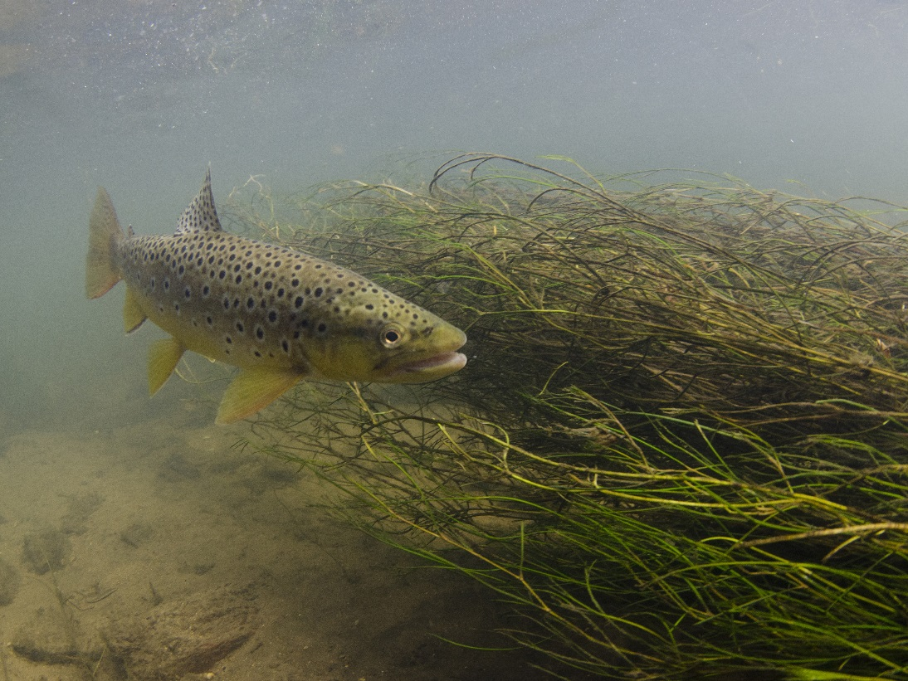
Brown trout – river dwelling form © Jack Perks

Description
Sea trout and Brown trout are the same species (Salmo trutta). Along with Salmon and Grayling, they are members of the salmonid family which can be distinguished from other freshwater fish by having an adipose fin, a small extra fin between the dorsal and tail fins. Whilst Brown trout remain resident in freshwater, Sea trout are anadromous, migrating to sea to feed before returning to the river spawn. Going to sea gives sea trout access to a much richer source of food than their freshwater-dwelling counterparts, and sea trout are usually substantially bigger.

Distribution
Salmo trutta is one of the most widespread freshwater fish in Europe with a natural range that extends from Iceland to North Africa, and from Ireland to the Caspian Sea. It is found throughout the UK. Since the late 19th century, the species has been widely introduced across the globe for angling purposes, and can now be found as far afield as Chile and New Zealand.

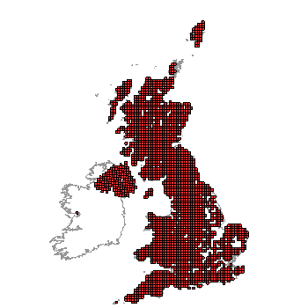
Distribution of Salmo trutta in the UK. Includes Brown trout and Sea trout. (From NBN Gateway: Accessed 01/09/13)

Ecology
Eggs are laid in the late autumn and hatch the following spring. Young fry suffer high mortality during the first three months, with only about 5% surviving to the summer. In the summer the fry migrate a bit further downstream to deeper waters and richer food sources and become known as parr or fingerlings. They are recognisably trout now, but have distinctive fingerprint marks along the side, which are lost as they get older.
The 'smolt' stage is reached after about two years. The fish turn a silvery colour and undergo significant physiological changes (termed smoltification) that will enable them to cope with life in sea water. Not all trout become smolts; some remain resident in the river as Brown trout. The smolts migrate downstream to the sea usually between April and early June. Unlike Salmon, Sea trout don’t usually migrate far and tend to stay in coastal waters.
Sea trout return to rivers each year to spawn, usually between June and October. They do not always return to their natal rivers and may stray into other nearby rivers. During their time in the freshwater they lose their silver colour and come to look like resident Brown trout, but are usually bigger. Spawning begins in mid-October and continues through to early January. Eggs are laid in gravel pockets or 'redds' that have been excavated in the river bed by the female fish. Once the eggs have been fertilised the female covers them with gravel.
A Sea trout that has spawned is known as a kelt. Some die, but around 75% of them survive and make their way back to the sea to recover and grow. Their normal lifespan is five to six years, during which time they reach sizes averaging 45 cm and weight of 3 kg.

Threats
A number of factors are threatening the survival of Sea trout both in the sea and the river systems in which they spawn.
- Fish Farms
Commercial Salmon farms can have adverse effects on local Sea trout populations through transfer of disease and parasites, notably lice infestations. A big increase in fish farming in the west Highlands has coincided with a significant decline Sea trout in these areas during the last 20 years². Lice infestations originating from the fish farms are believed to be largely responsible.
- Angling industry
Wild Sea trout are considered prize trophy for many anglers and measures are necessary to ensure they are not over-exploited. Another potential threat to wild populations comes from interbreeding with stocked ‘farmed’ trout. Farmed trout are selectively bred for different characteristics to wild fish, for example to spawn earlier and put on weight faster. By interbreeding with farmed trout, ‘wild’ genes conferring traits for survival in the wild may be lost from the population.
- Non-native invasive species
Invasive non-native species can have significant impacts on aquatic ecosystems, affecting the suitability of habitat for supporting trout, for example through altering prey availability or increasing exposure of juvenile fish to predators. Examples of non-native invasive species affecting Scottish marine habitats are Common cordgrass (Spartina anglica) and Wireweed (Sargassum muticum).
- Habitat Degradation
Increasing loads of sediment, excessive water abstraction, pollution and loss of surrounding wetland habitats threaten aquatic ecosystems on which trout rely. There may also be impacts at sea from factors such as increase in seal numbers, pelagic trawlers and off-shore energy generation.
- Climate change
Sea trout are dependent on an abundance of clear, cold water. As cold water habitats warm, all life history phases of the fish from river-dwelling eggs and juveniles to sea-going adults could be adversely affected.

Management
- The angling industry, Salmon farming industry and conservation bodies need to work together to alleviate the threats to Sea trout. Measures include:
- Introducing tight controls on commercial fish farms to prevent escape of farmed animals and their parasites and diseases.
- Regulation of land use in catchment areas to reduce nutrient runoff and siltation due to soil erosion.
- Improving water quality by addressing pollution and maintaining water quantity by addressing abstraction.
- The removal of in-river obstacles such as weirs, or installation of fish passes to allow free passage to migrating fish.
- Marine Protected Areas (MPAs) can help to protect sea trout. This should include management to enhance the marine habitats and food sources which sea trout rely upon, for example by protecting eelgrass beds, maerl beds and sandeels.

Current work
The Salmon & Trout Association (S&TA) was established in 1903 to address the damage done to our rivers by the polluting effects of the Industrial Revolution. It is the only UK fisheries charity which campaigns politically for the management, protection and conservation of salmon, trout, sea trout and all other indigenous fish species and aquatic animals, together with the water environment necessary for them to thrive.
The Rivers and Fisheries Trust of Scotland (RAFTS) has an Invasive Species and Biosecurity Programme, which is taking action across Scotland to prevent the introduction of control the spread of invasive non-native species and fish diseases.
Scottish Wildlife Trust is campaigning for Marine Protected Areas.

Wider Context
The Scottish aquatic environment is among the most diverse in the world and includes rivers, lochs, estuaries, coastal waters and offshore waters. With a life cycle that is dependent on both rivers and the sea, sea trout requires all aspects of this aquatic environment to be properly protecetd. Sea trout are part of the natural, social and economic fabric of Scotland and attract anglers from all over the world. A study in 2004 revealed that recreational anglers for sea trout and salmon spent a total of £73m in Scotland annually. The salmon farming industry is also an important part of the economy, especially in the North West and Scotland is the third largest producer of farmed salmon in the world.

Quick Facts
- In contrast to the rest of Scotland, River Tweed Sea trout are bigger on average than elsewhere in Scotland. Smolts from here (and the rivers of north-east England) migrate across the North Sea to feed off the coasts of East Anglia, Holland and Denmark, remaining at sea for two or more winters before they return.
- The current British rod-caught record for Sea trout, is more than 10 kg, from the River Leven (Loch Lomond) in 1989. An even larger sea trout, weighing 13 kg was illegally netted in the River Tweed in 1987.
- Because of their larger size, female Sea trout provide lay more eggs than resident trout.
- Female trout are more likely to become smolts than males, possibly because the larger size attained at sea results in more eggs being produced and is therefore a strategy of particular advantage to females.
- Trout have a double row of ‘teeth’ on the roof of the mouth, called vomerine teeth
- The majority of trout die during their first year, when mortality rates are typically 95% or greater, falling to around 40 - 60% in subsequent years.
- Brown trout can reach of 20 years of age
- Some Sea trout never make it into the open sea and remain in estuaries to feed. These are called ‘slob trout’ and may be semi-silvered or more like Brown trout in appearance.
- Key aspects of Sea trout history can be deduced from examining their scales. These include: age at smolt migration, age at first spawning, overall age, number of spawning migrations and growth performance.

Selected references
www.atlanticsalmontrust.org Accessed 18/08/13
www.salmon-trout.org Accessed 18/08/13
www.wildtrout.org/content/sea-trout Accessed 18/08/13
www.scotland.gov.uk/Topics/marine/marine-environment/species/fish/freshwater/seatrout Accessed 18/08/13
www.snh.gov.uk/about-scotlands-nature/species/fish/freshwater-fish/trout/ (accessed 18/08/13)
Middlemas, S.J., Fryer, R.J., Tulett, D., and Armstrong J.D. (2012). Relationship between sea lice levels on sea trout and fish farm activity in western Scotland. Fisheries Management and Ecology 20: 68–74.
Sea lice levels on wild sea trout are linked to fish-farm activity in western Scotland.
Riddington, G., Radford, A., Paffrath, S, Bostock, J. and Shinn, A. (2006) An Economic Evaluation of the impact of the salmon parasite Gyrodactylus salaris (Gs) should it be introduced to Scotland. Report to the Scottish Executive and Rural Affairs Dept Proj. No. SAQ/001/05.
This government report estimated the potential loss to Scotland if this salmon parasite was introduced to Scotland would be £633 million, with severe consequences for rural communities.

www.atlanticsalmontrust.org/about-the-trust/hard-facts.html Accessed 18/08/13
Butler, J.R.A. and Walker, A.F. (2007). Characteristics of the Sea Trout Salmo trutta (L.) Stock Collapse in the River Ewe (Wester Ross, Scotland), in 1988-2001, in Sea Trout: Biology, Conservation and Management (eds G. Harris and N. Milner), Blackwell Publishing Ltd, Oxford, UK.
http://www.wildtrout.org/content/sea-trout Accessed 1/11/13
Middlemas, S.J., Fryer, R.J., Tulett, D., and Armstrong J.D. (2012). Relationship between sea lice levels on sea trout and fish farm activity in western Scotland. Fisheries Management and Ecology 20: 68–74.
Radford, A., Riddington, G., Anderson, J. and Gibson, H. (2004). Research Report: The Economic Impact of Game and Coarse Angling in Scotland. Cogentsi Research International Ltd
www.scottishsalmon.co.uk/facts_figures/production.aspx Accessed 18/08/13

