Scottish Wildcat

Felis silvestris

The Scottish wildcat is the only wild member of the cat family to be found in Britain. It has faced persecution in the UK since the Middle Ages, but nowadays its key threats include hybridisation with feral cats and habitat degradation. One of Britain’s rarest mammals, Scottish wildcats face extinction unless immediate action is taken.
The Scottish wildcat is protected in the UK under the Wildlife and Countryside Act, 1981, listed under CITES Appendix II and classified as a Priority Species in the UK Biodiversity Action Plan. It is a priority species under SNH’s species action framework. It is also listed on Annex IV of the EC Habitats Directive and is a European Protected Species under the Habitats and Species Directive.

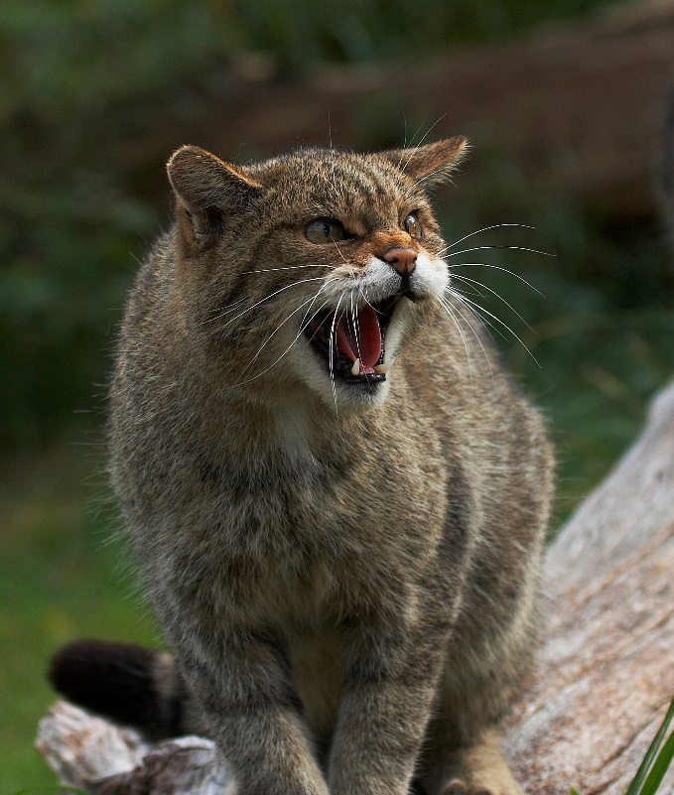
Scottish wildcat © Elliot Smith

Description
The Scottish wildcat looks like a large and muscular domestic tabby cat. Its thick coat is made up of well-defined brown and black stripes and it has a distinctive bushy tail with a blunt black tip. Males are typically between 6-9kg and females 5-7kg (around 50% larger than the average domestic cat).
Hybrids are sometimes difficult to distinguish from pure Scottish wildcats, but:
- In hybrids the stripes on the rump of hybrids tend to break down into spots.
- The tail of hybrids tends to be more tapered.
- The dorsal stripe tends to run onto the tail in hybrids rather than stopping at the base of the tail as it does in the Scottish wildcat.
- Domestic tabby cats and hybrids can have patches of white in their coat but the Scottish wildcat has no such markings.
Some authorities recognise the Scottish Wildcat as a sub-species (Felis silvestris grampia) distinct from European wildcat (Felis silvestris silvestris) as it is larger with darker colouration and bolder stripes on the legs and flanks. However, there is currently no genetic evidence to confirm this differentiation, and the Scottish Wildlife Trust continues to refer to Scottish wildcats as Felis silvestris, which is the conventional way it is described in most of the scientific literature.

Distribution
Once found across the British mainland, eradication mainly due to historical persecution and habitat loss meant that by 1862 the Scottish wildcat was only found in Scotland. It is now confined to the Highlands, and Scottish Natural Heritage’s 2006-2008 survey³ found wildcat strongholds (i.e. large areas supporting more than one territory) in Aberdeenshire, Caithness and Sutherland, the Ardnamurchan Peninsular and Morven. Scottish wildcats prefer wooded landscapes for their homes and are rarely found in land above 500 metres.

Ecology
Scottish wildcats are solitary and largely nocturnal creatures. They rest up in hidden thickets or dens by day and patrol and hunt up to 10km through a range of habitats populated by prey overnight. Territorial boundaries are marked with faeces or spray. Wildcats also leave scent by rubbing glands in their cheeks and tail against objects, or by clawing trees to release scent from glands in their feet.
Their favoured prey is rabbit which can form up to 70% of the wildcat’s diet in eastern Scotland where rabbit densities are high. Where rabbit is unavailable rodents and other small mammals provide the staple food source.
Female wildcats come into season once a year around February, and advertise their readiness for mating through scent marking and night-time "caterwauling". If a male is in the locality the pair come together for a brief mating before parting forever. Three or four kittens are born in early spring. Surviving initially on the mother's milk the kittens quickly progress to eating kills brought to the den for them. Within weeks the mother will bring back live prey for the kittens to catch for themselves, teaching them hunting skills. After a few months they join her on the hunt to observe and learn survival skills before heading out independently around five or six months of age. They will usually mate for the first time in their second year.
Wildcats have been known to live up to the age of 15–16 years in captivity. Studies in Scotland have shown that only 7% of wildcats live longer than six years in the wild⁴, with females living up to a maximum of 10 years and males up to eight years. Young wildcats have a very high risk of mortality within the first few weeks of leaving their natal territory, with many succumbing to road accidents or predation by other species such as foxes and eagles.

Threats
Hybridisation with feral domestic cats is reducing the number of pure-bred wildcats.
- It is currently legal to control feral cats, and confusion between feral cats, wildcats and hybrids can mean wildcats are unwittingly killed.
- Diseases such as feline leukaemia virus are spreading from feral cats and have already been detected in wildcats in Scotland.
- Habitat fragmentation and degradation (including loss of prey, such as rabbits).
- Road traffic deaths are also a common cause of mortality.

Management
- Habitat management
Scottish wildcats require a mixture of open patches of habitat, such as pastures and riparian areas, for hunting and woodlands and thicket areas to provide shelter and resting places⁴. Young forestry plantations in particular are an important habitat for wildcats because they are protected from grazing and support a high density of small mammal prey.
- Control of feral cats
Wide scale neutering of domestic feral and pet cats is the only way to eliminate hybridisation with pure wildcats. There needs to be increased public awareness amongst cat-owners about the consequences hybridisation with domestic cats could have on wildcat conservation.
- Research
Scottish wildcats have been quite well studied over recent years. However more is needed to develop methods for surveying the genetic integrity of the Scottish wildcat and to survey for the species in the field. Research is needed to find genetic markers to distinguish the Scottish wildcat from ‘wild-living’ cats. Once these markers have been identified it should be possible to determine (by collecting faecal samples) if there are any ‘pure’ wildcats left in Scotland.
- Captive Breeding
The official Scottish wildcat breeding-for-release program operates across a number of wildlife parks and private collections across the UK. The primary aim of the program is to build a sustainable captive population of pure breeding pairs enabling releases into carefully selected areas of the wild. This should strengthen population numbers and enable wildcat expansion beyond the current strongholds.

Current work
Scottish Wildcat Association (SWA)
The SWA was formed in 2007 to improve public awareness and unite the individual efforts of various interested parties with the aim of conserving the Scottish wildcat. However, due to difficulties in attracting sufficient funds, the Scottish Wildcat Association wound down in 2013, and is to be replaced by a new charity, the Wildcat Trust.
The SWA’s major action plan is to develop Wildcat Havens⁵. This project has been established in the Ardamurchin peninsula in the West Highlands, with hopes to extend to other suitable areas. Cats are trapped within the project area and all non-wildcats neutered and innoculated against feline diseases. Pure wildcats are held at an in-situ captive breeding centre whilst the neutering work takes place and then released back into the wild.

WildCRU (Wildlife Conservation Research Unit)
WildCRU is part of the University of Oxford which aims to tackle environmental issues by bridging the gap between academic theory and practical problem solving. WildCRU has a Scottish wildcat project that has been carrying out research on the Scottish wildcat for almost 20 years.

Highland Tiger Project
The Highland Tiger is a partnership of organisations including the Cairngorms National Park Authority, Forestry Commission Scotland, Royal Zoological Society of Scotland, Scottish Gamekeepers Association and Scottish Natural Heritage, bolstered by a wider circle of supporting organisations (including the Scottish Wildlife Trust). It was formed to design a conservation project for wildcats in the Cairngorms.

SNH Scottish wildcat Conservation Action Plan
In September 2013, SNH launched its Scottish Wildcat Conservation Action Plan which aims to restore viable populations of this species north of the Highland boundary fault. It covers six years (2013 - 2019). Funding from the Heritage Lottery fund has been secured to help with neutering and vaccinating feral cats in areas of Aberdeenshire, Highlands and Tayside.

The Scottish Wildlife Trust’s priorities for action
The Scottish Wildlife Trust has a policy note for Scottish wildcat, which sets out the following priorities:
- Campaigning for ‘responsible cat ownership’ in Scottish wildcat strongholds, including supporting the work of the Cats Protection in the promotion of neutering and vaccination of domestic cats.
- Advocating our 25-year vision for Scotland’s ecosystems – this will create healthy ecosystems that are beneficial to the Scottish wildcat.
- Advocating an ecosystem based approach to Scottish wildcat conservation
- Demonstrating how to enhance wildcat habitat through the Coigach Assynt Living Landscapes project.
- Promoting a best practice approach to controlling feral cats, positively identified by live trapping, on sporting estates in those areas that are known wildcat strongholds
- Continuing to support the Cairngorms Wildcat Project.
- Supporting the current genetic research into finding a genetic tool to identify Scottish wildcats.
- Objecting to planning applications that will have a significant detrimental effect on the Scottish wildcat population.

Wider Context
Ecologically the wildcat plays an important role as a predator and controller of small to medium size prey, and is an excellent controller of pest species such as rabbits. Culturally, it is rooted in Scotland’s natural heritage, and as a symbol of wild Scotland could be an ambassador for the protection of wild landscapes in the Highlands.
Although some believe that it is too late to preserve pure Scottish wildcats, the population of Iberian lynx of Andalucía in Spain was down to just 100 individuals a decade ago. Following an intensive recovery programme there are now more than 300 individuals and it is thought this could reach a thousand by the end of the decade.

Quick facts
- The Scottish wildcat has excellent hearing and is capable of independent rotation of each ear through 180 degrees.
- Before the Scottish wildcat received legal protection in 1988, approximately 92% of wildcat deaths were attributable to hunting.
- Until as recently as the 1950s, Scottish wildcat were believed to be man killers.
- Vocal communication is extremely rare (silence is essential for hunting and avoiding larger predators) and even wildcat kittens will play in complete silence.
- The Scottish wildcat is infamous as the only wild animal that can never be tamed by human hand, even when captive reared.
- Scottish wildcats are sometimes referred to as ‘Highland Tigers’.
- There are fewer members of Scottish wildcat than there are Bengal tigers in the wild.
- The earliest fossil remains of the Scottish wildcat (once a UK-wide species) were found in Berkshire.
- Historically, Caithness was known as Caitaibh or ‘land of the cats’.
- The wildcat has been used in clan heraldry since the 13th century. For example, the title of the Chief of the Clan Sutherland is Morair Chat (‘Great Man of the Cats’).
- In Scottish mythology, the Cat Sìth is a fairy creature, or sometimes a witch, resembling a large black cat with a white spot on its chest that haunts the Scottish Highlands. The legends surrounding this creature are thought to have been inspired by the Kellas cat, a large black cat that may be a distinctive cross between a wildcat and a domestic cat.

Selected references
www.snh.gov.uk/protecting-scotlands-nature/species-action-framework/species-action-list/wildcat/update/
www.snh.gov.uk/about-scotlands-nature/species/
Beaumont M., Barratt E.M., Gottelli D., Kitchener A.C., Daniels M.J., Pritchard, J.K. Bruford M.W. (2001). Genetic diversity and introgression in the Scottish wildcat. Molecular Ecology (10) 319-336.
Davis, A.R. & Gray, D. (2010). Scottish Wildcat Survey 2006-2008. SNH Commissioned Report 360.
The principal objective of the Scottish Wildcat Survey 2006-08 was to repeat the previous 1983-1987 survey to obtain comparable information on the current distribution of the species in Scotland. The report concludes that wildcats appear to be stable in their historic locations in the north and east of Scotland, with localised populations persisting around Ardnamurchan and Morvern. However, their fate elsewhere is less clear.

Kilshaw, K. (2011). Scottish Wildcats: Naturally Scottish. SNH publishing.
Comprehensive background to Scottish wildcats. Includes ecology, behaviour, status and threats.
Kilshaw, K. & Macdonald, D. W. (2011). The use of camera trapping as a method to survey for the Scottish wildcat. Scottish Natural Heritage Report 479.
The aim of this project was to determine whether camera trapping could be an effective method for future monitoring efforts of the Scottish wildcat. The study indicated that some changes should be made to the camera trapping method in order to increase the capture success; these are to reduce the space between camera trap stations to ≤ 1km, use of bait to attract cats to the cameras and increase the survey length to 2 months or 60 days. · Density estimates could be obtained using the data collected and these estimates were comparable to those from other studies indicating that camera trapping could be a useful tool for monitoring of the Scottish wildcat.
Kilshaw, K. & Macdonald, D.W. (2010). Reintroduction of the Scottish wildcat into the Scottish highlands; a feasibility study. WildCRU publication, 213 pp.
Kilshaw, K., Drake, A., Macdonald, D. W. and Kitchener, A. C. (2009). The Scottish wildcat: a comparison of genetic and pelage characteristics. 67. Scottish Natural Heritage Commissioned Report, 63 pp.
The report concludes that Scottish wildcats can be distinguished from feral cats by their coat markings. The comparison of morphological and pelage characteristics against genetic make-up, led to the conclusion that the appearance of Scottish wildcat is sufficiently unique to identify individuals which are genetically distinct from domestic cats.
Kilshaw, K., Macdonald, D.W., & Kitchener, A. (2008). Feral cat management in the Cairngorms; scoping study. Report to Scottish Natural Heritage, No. 22371, 149 pp.
Kitchener, A. C., N. Yamaguchi, J. M. Ward & D. W. Macdonald (2005). A diagnosis for the Scottish wildcat (Felis silvestris): A tool for conservation action for a critically endangered felid. Animal Conservation, 8: 223-237.
They analysed morphological differences between wild-living cats in Scotland on the basis of 20 pelage characters, scoring from 1 (domestic cat) to 3 (wildcat), in combination with 40skull parameters and intestinal length. They showed that the wild-living cats fell into three main groups without any a priori classification. The three groups are most significantly differentiated by seven pelage characters: (1) extent of dorsal stripe, (2) shape of tail tip, (3) distinctness of tail bands, (4) presence/ absence of broken stripes and (5) spots, on flanks and hindquarters, (6) shape and number of stripes on nape and (7) on the shoulders. In practice, if a wild-living cat does not score 1 for any of the seven characters it should be treated as a wildcat in the field. These definitions provide a simple way of diagnosing a Scottish wildcat scientifically, as well as practically, which will effectively facilitate conservation action and the enforcement of protective legislation.
Macdonald, D.W., Yamaguchi, N., Kitchener, A.C., Daniels, M., Kilshaw, K. & Driscoll, C. (2010). Reversing cryptic extinction: The history, present and future of the Scottish wildcat. In: The Biology and Conservation of Wild Felids (Macdonald, D.W. & Loveridge, A. Eds), Oxford University Press.

A five year programme to provide a strategic approach to species management in Scotland - see: www.snh.gov.uk/protectingscotlands-nature/species-action-framework/
European Directive 92/43/EEC
Davis, A.R. & Gray, D. (2010) The distribution of Scottish wildcats (Felis silvestris) in Scotland (2006-2008). Scottish Natural Heritage Commissioned Report No. 360
Kilshaw, K. (2011) Scottish Wildcats: Naturally Scottish. SNH publishing
www.scottishwildcats.co.uk
www.wildcru.org/research/research-detail/?project_id=73
www.highlandtiger.com
http://www.snh.gov.uk/publications-data-and-research/publications/search-the-catalogue/publication-detail/?id=2050
http://scottishwildlifetrust.org.uk/what-we-do/policy-and-campaigns/policies-and-consultations/

