Red Squirrel

Sciurus vulgaris

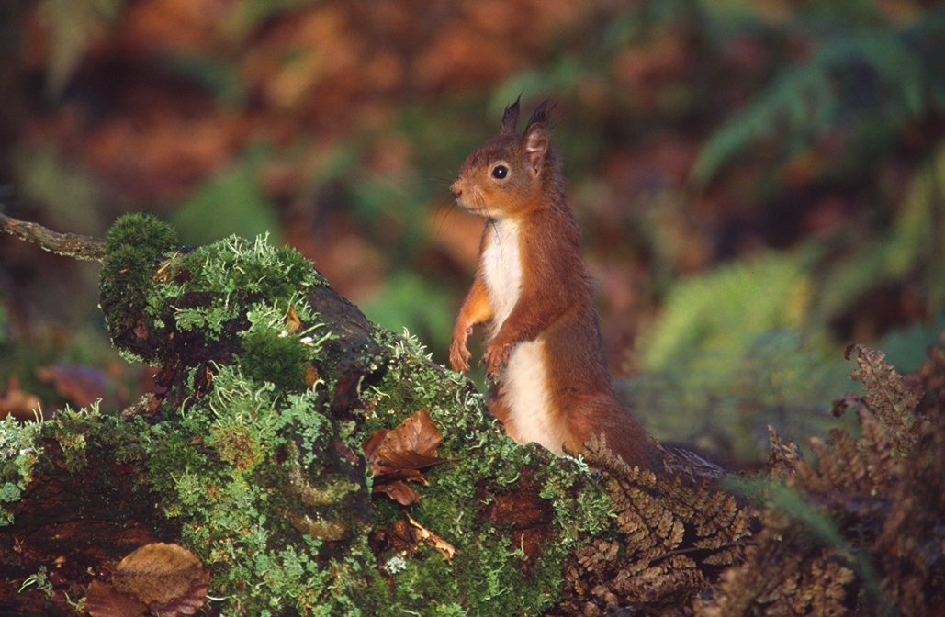

©Jim Wilson Photography

Red squirrels are native to Britain but have suffered a serious decline since the introduction of grey squirrels in the late 1800s. There are about 121,000 red squirrels in Scotland (75% of UK total), but Grey squirrels are far more numerous and continue to threaten the survival of reds. Only the Highlands, most of Grampian, Argyll and northern Tayside remain completely ‘grey-free’ and without sustained action, it is predicted that red squirrels could become extinct on mainland Scotland within 50 years.
The Red squirrel is a Priority Species on the UK Biodiversity Action Plan and is included on the Scottish Biodiversity List. The red squirrel is listed on Appendix III of the Bern Convention and is protected by Schedules 5 and 6 of the Wildlife and Countryside Act, which has been amended and strengthened by the Nature Conservation (Scotland) Act 2004.

Description
Red squirrels are usually a reddish-brown in colour, but coats ranging from almost black to light brown are sometimes seen. The chest and stomach are always creamy white. They have characteristically long ear tufts, which are especially prominent in winter.

Distribution
Until the late 1800s the Red squirrel was the only squirrel species in the UK and it was widespread across the region. Following the introduction of the Grey Squirrel from North America the Red squirrel’s range has been diminishing. It is now absent from most of England and Wales, with the last remaining populations of Red squirrels in mainland England restricted to pockets in Northumberland, Cumbria, North Yorkshire and North Merseyside.
Scotland is the UK stronghold for Red squirrels, supporting over 75% of the entire UK population. The largest populations occur in the Highlands and Dumfries and Galloway. Pockets of Red squirrels also occur in some parts of central Scotland and they are still common in the western Scottish Borders. Red squirrels are widespread in mainland Europe, but are not found in southern Spain and the Mediterranean islands. Grey squirrels are now starting to replace Red squirrels in parts of Italy.

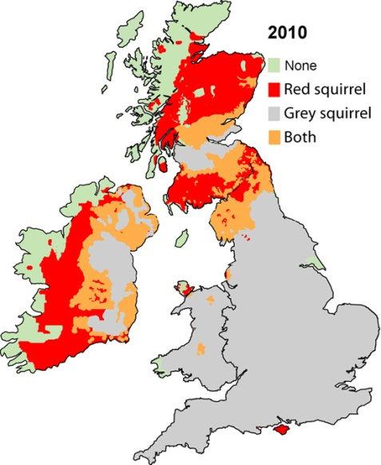
Distribution of Red and Grey squirrels in UK in 2010. (From www.rsst.org.uk)

Ecology
Red squirrels are specialist feeders on tree seed, especially conifers, hazel and beech. They also eat the buds, flowers and shoots of both deciduous and coniferous trees as well as berries, caterpillars, fungi and even birds’ eggs. In the autumn they store surplus food just below the ground or in the gaps in tree trunks. Red squirrels live in arboreal nests called dreys which they line with soft hair, moss and grass. Each squirrel usually has several dreys within a typical home range of three to seven hectares. They do not hibernate.
Mating occurs any time between January and June, although there are two peak periods of January-February and April-June. A litter of usually three or four kittens is born, following a gestation period of about six weeks. The young are weaned at about 10 weeks, and by four months they have their adult coats and are fully independent. Parental care involves only the female. When food is plentiful, red squirrels can raise two litters a year.

Threats
- Competition from North American Grey squirrels
Grey squirrels are physically larger in size than Red squirrels and have higher juvenile survival rates. In addition differences in digestive physiology mean Greys can eat seeds with high tannin content, allowing them to exploit a greater variety of food sources than Reds and giving them a competitive advantage in broadleaved and mixed woodlands.
- Squirrel pox virus
Some Grey squirrels are carriers of a virus called squirrel pox. The disease is highly infectious and although harmless to Grey squirrels, is fatal to our native Reds. The virus was first recorded in Scotland in 2005, with the first Red casualties recorded in Lockerbie in 2007. It causes eyelids and mucous membranes to become infected and swollen. Infected red squirrels are unable to see or to feed comfortably and quickly become malnourished. They usually die within 15 days.
- Loss of habitat
In many places small-scale forests are being lost to development or other changes in land-use, resulting further fragmentation of valuable Red squirrel habitat. In areas where both species of squirrel occur, the only habitat in which Red squirrels seem to have an advantage over Greys is large conifer forests without large-seeded broadleaved trees, such as oak, beech, hazel and chestnuts.
- Poor habitat quality
Many of the larger commercial forests are dominated by a single species of conifer. Although covering large areas, they only support low densities of Red squirrels. These sites could support higher numbers of Red squirrels by planting small areas of tree species favoured by Red squirrels and making small changes in felling regime.

Management
Encouraging Red squirrels
- Improve woodlands for Red squirrels, through appropriate forest planning and promotion of ‘Red-squirrel’ friendly woodland management.
- Continue research (including methods of Grey squirrel control, investigating genetic variation in the Scottish population and developing effective data management).
Controlling Grey squirrels
- Monitor the distribution and spread of Grey squirrels.
- Undertake proactive Grey squirrel control measures at natural barriers and pinch-points.

Current Work
Saving Scotland’s Red Squirrels (SSRS)
Red squirrel conservation through most of Scotland is coordinated by SSRS. This group is managed by the Scottish Wildlife Trust in partnership with Scottish Natural Heritage, Forestry Commission Scotland, Scottish Land and Estates and Red Squirrel Survival Trust. They have recently merged with Red Squirrels in South Scotland and have funding until April 2014. The project is currently focussing on:
- Halting the decline of Red squirrel populations in key areas in north Scotland through targeted Grey squirrel control.
- Slowing and containing the spread of the deadly squirrelpox virus in southern Scotland, through Grey squirrel control.
- Improving forest habitat to help Red squirrels thrive and increase in number.
Forestry Commission Scotland - has identified 18 ‘Red squirrel strongholds’, all large forests with healthy Red squirrel populations. These will be managed over the long term to give Red squirrels a competitive advantage over any grey squirrels which reach the site.

Wider context
The Red squirrel is highly valued by residents and visitors, and is seen by some as one of Scotland’s ‘iconic’ species. It is also one of the most threatened mammals in the UK. It has been the subject of extensive and ongoing research, with clear and targeted management actions relating to Grey squirrel control. There is considerable public interest in saving Red squirrels, which can also provide opportunities to further biodiversity awareness in Scotland. With Grey squirrels becoming an increasing threat to Reds in Italy, the research being undertaken in Scotland and the rest of the UK could prove invaluable to saving Red squirrels in Europe.

Quick Facts
- Red squirrels have four fingers, five toes and double-jointed ankles which allow them to hang upside down.
- They use their tails to communicate with each other.
- Red squirrels can tell whether a nut is good or not by smell.
- Individuals are right or left-handed when eating a pine cone.
- Red squirrels can swim and hang upside down.
- Red squirrels moult twice a year, once after winter and then in the late summer before the weather gets colder.
- They only moult their tail and ear tufts once a year, in late autumn.
- A red squirrel’s incisor teeth grow at a rate of 15 cm per year, but are kept short by gnawing.
- Red squirrels weigh 275-300 g, the same as a packet of biscuits.
- Red squirrels suffer high mortality in their first year: only one in six survives.
- Red squirrels live up to seven or eight years in the wild; (12+ years in captivity).

Selected References
www.red-squirrels.org.uk/ Accessed 20/08/13.
Website of Red Squirrels in South Scotland, which has now merged with Saving Scotland’s Red Squirrels.
www.redsquirrelsofthehighlands.co.uk Accessed 20/08/13.
Website of Feoragan Ruadh na Gaidhealthachd, (Red Squirrels in the Highlands). This project has now ceased, but there is still a blog and general squirrel information on this website.
www.scottishsquirrels.org.uk/ Accessed 20/08/13.
Website of Saving Scotland’s Red Squirrels
Pepper, H. and Patterson, G. (1998) Red Squirrel Conservation. Forestry Commission Practice Note. www.forestry.gov.uk/pdf/fcpn5.pdf/$FILE/fcpn5.pdf Accessed 20/08/13.
Information about the Red squirrel in Scotland and the challenges facing their conservation. Comprehensive, and with useful background information on ecology and methodologies, but no longer up to date.
Lurz, P. (2010). Red Squirrels. Scottish Natural Heritage. Naturally Scottish series.
Bryce, J., Cartmel, S. and Quine, P. (2005). Habitat use by red and grey squirrels: Results of two recent studies and implications for management. Forestry Commission Information Note. www.forestry.gov.uk/pdf/fcin076.pdf/$FILE/fcin076.pdf Accessed 20/08/13.
This Information Note summarises the results of two PhD studies which examined the patterns of habitat use of red and grey squirrels in planted forests at Clocaenog Forest in Wales and Craigvinean Forest in Scotland. The main findings are discussed in relation to other work and possible management implications suggested. It does not establish new policy or guidance. A number of scientific papers in addition to university theses have also been produced as a result of this work.
www.snh.gov.uk/protecting-scotlands-nature/species-action-framework/species-action-list/red-squirrel/ Accessed 20/08/13.
Species Action Framework for Red Squirrel. Contains links to SNH commissioned reports.
SNH (2010). Protecting Scotland’s Red Squirrels: The consultation response. www.snh.gov.uk/docs/A409170.pdf Accessed 20/08/13.
Following public consultation SNH concluded that there is support for grey squirrel control as a temporary measure alongside long-term measures such as habitat management.
www.forestry.gov.uk/forestry/infd-7q3ft8 Accessed 20/08/13.
Forestry Commission Scotland has identified 18 ‘red squirrel strongholds’, all large forests with healthy red squirrel populations. These will be managed over the long term to give red squirrels a competitive advantage over any grey squirrels which reach the site. These are a going concern.

http://scottishwildlifetrust.org.uk/docs/002__057__other_leaflets__Two_different_squirrels___the_facts__1317717918.pdf
www.scottishsquirrels.org.uk/squirrel-facts/squirrel-faqs/are-red-squirrels-an-endangered-species/
http://scottishwildlifetrust.org.uk/docs/002__057__other_leaflets__Two_different_squirrels___the_facts__1317717918.pdf
www.red-squirrels.org.uk/pox.asp
www.red-squirrels.org.uk/pox.asp
www.forestry.gov.uk/forestry/infd-7q3jky
www.scottishsquirrels.org.uk/squirrel-facts/squirrel-faqs/is-habitat-loss-a-factor-in-red-squirrel-decline/
www.scottishsquirrels.org.uk/
www.forestry.gov.uk/forestry/infd-7q3ft8 Accessed 20/08/13.

