Atlantic puffin

Fratercula arctica

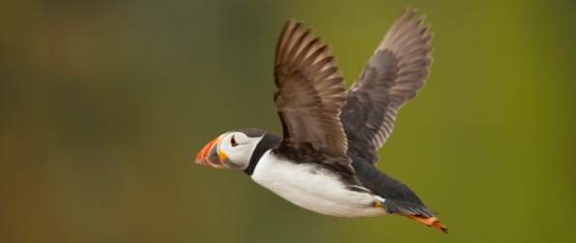
Atlantic Puffin © Neil Aldridge

The Atlantic puffin is widely distributed on islands around Scotland's north and west coasts and in the Firth of Forth. Although it is not under threat globally, some populations have suffered marked declines in recent years and with half of the UK population nesting at only a few sites it is an Amber List species in the UK. Population declines have been linked to changes in the numbers and distribution of their fish prey probably due to rising sea temperatures and a general mismanagement of the marine environment. Similar trends have been recorded in other UK seabirds.

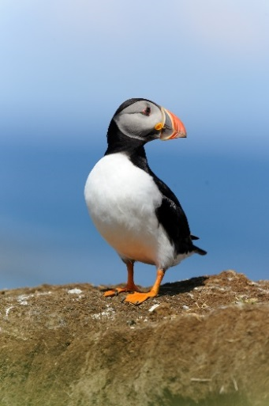
Description
The puffin is one of our best loved seabirds, congregating on offshore islands during the summer months to breed. It has a black back and white underparts and sports a large triangular bill which is striped with bright red, blue and yellow during the breeding season. Bright orange legs, large pale cheeks and red-rimmed eyes complete the clown-like look. After the breeding season, some of the bill's outer horny plates fall off and the bill becomes smaller and duller. The puffin’s plumage also becomes generally drabber at this time – in fact because of the differences in breeding and non-breeding plumage it was once thought to be two separate species of bird.
Puffin (C) Amy Lewis
Distribution
The Atlantic puffin is found throughout the North Atlantic, from Canada to Svalbard and as far south as the Canary Islands. The UK population estimated to be about 580,700 birds. The winter months are spent far out at sea, in Europe as far south as the Mediterranean Sea. They are seldom seen within sight of land until March.
About 9.6% of the world population breeds around the British Isles, where it is the second most abundant breeding seabird¹. The Trust’s reserve on Handa in west Sutherland has more than 250 pairs; other good sites in Scotland are the Treshnish Isles off Mull, Hoy in Orkney, Noss and Hermaness in Shetland and the Isle of May in Fife.
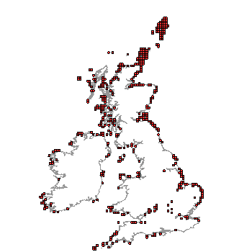
Distribution of Atlantic puffin in the UK (From NBN Gateway: accessed 16/8/13)

Ecology
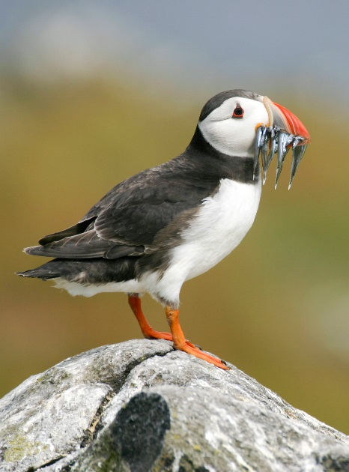
Puffins spend most of their lives at sea, only coming ashore to breed, in Scotland from late April until mid-August. Although breeding birds are well-studied, much less is known about their lives at sea in the winter.
Pairs usually mate for life. Courtship occurs on the water and land, with males flicking their heads back, puffing up their chests, and fluttering their wings to attract females. Pairs also ‘kiss’ by rapidly swinging their heads side to side and repeatedly tapping their bills together.
Their nests are typically underground in burrows, a little under a metre long, dug into the soft sandy soil using their beaks. If they can, a pair will use the same burrow year after year. A single white egg is laid, and both parents take turns incubating it. The egg hatches after about 40 days and the subsequent feeding of the chick is also shared by both parents. It takes 6-7 weeks for the newly hatched chick to learn to fly and survive independently. The young puffins leave their nest for good at this point, heading out to sea under the safe cover of darkness. They will not return to land again for at least two years and most will not start breeding until they are five years old.
Puffin © Tom Marshall
Puffins are excellent underwater swimmers, and can dive to depths of about 60 metres, although they don’t often go deeper than 30 metres. They use their wings to fly through the water in pursuit of fish, preying predominantly (in summer) on small fish, especially lesser sandeel (Ammodytes marinus). Winter diets are not well known. Adults catch and eat their fish at sea, but parents with chicks are able to carry many at once back to the nest. Using their round tongues, they push the fish upward into small backward-pointing spines in their upper bill. This holds the food securely allowing them to open their beak to catch more.

Threats
Puffins are occasionally predated upon by great black-backed gulls and great skuas, and rats have been blamed for decimating some colonies in the past, . However, the greatest threats to puffins come from changes to their marine environment; from pollution, over-fishing and perhaps most significantly climate change.
Climate change has been linked to changing sea temperatures which, coupled with pressures from fisheries, is having a significant impact on distribution and size of fish in British waters. It is thought that the decline in puffin numbers in recent years, especially on the eastern coast of Scotland, is linked to food shortages in the North Sea. Some colony declines are linked to lack of food availability to breeding birds but it is conditions in the wintering areas that are now believed most critical for long-term health of Puffin populations.

Management
- Improved management of the marine environment for fish
Healthy fish stocks are vital to the survival of puffin populations and this can only be achieved by protecting marine ecosystems from unsustainable development, pollution and overfishing.
- Protecting nest sites
Puffins prefer to nest in areas with fewer gulls; where possible gulls should be encouraged away from puffin colonies. The invasive plant tree mallow needs to be controlled at some sites to prevent puffin burrows being obscured and inaccessible.
- Control ground predators
Predators such as mink and rats will take eggs and chicks.
- Disturbance
Although puffin colonies are a big draw for tourists, visitor access needs to be controlled to minimise disturbance to parent puffins and prevent destruction of burrows by trampling. ⁴
- Reduce impacts of climate change
As well as taking measures to reduce greenhouse emissions, the resilience of the marine environment needs to be increased to help withstand the impacts of climate change. Marine Protected Areas are sites at sea that are specifically managed to allow nature to recover and thrive. The Trust is lobbying parliament to ensure sufficient designations are made.
Add Puffin (and other seabirds) and sandeels to the list of species that need to be protected by Marine Protected Areas (MPAs).

Current Work
Scottish Wildlife Trust and partners in Scottish Environment LINK are campaigning for the designation of Marine Protected Areas around Scotland to enable coordinated management of seas around Scotland.
Marine Scotland is leading a research programme that focuses on Scotland's seas. It includes work that the Scottish Government is funding to better understand the potential environmental impacts of marine renewable energy, and also associated work undertaken by Scottish Natural Heritage (SNH).
The programme has been developed in partnership with other organisations including Highlands and Islands Enterprise, The Crown Estate, SNH, the Joint Nature Conservation Committee and representatives of industry. The research programme includes five themes: generic research, marine mammals, seabirds, habitats and fish.

Wider Context
The recent State of Nature Report states 5 out of 12 seabird species are in serious decline in the UK. Climate change is cited as a key factor. Warming of seas around the UK, has led to subsequent changes in the plankton community. This is having knock-on effects further up the food chain. Sandeels are no longer available in the way they used to be. At the same time abundance of snake pipefish Entelurus aequoreus has rocketed, but these fish have minimal calorific value and can present a choking hazard to seabird chicks. Seabirds are key indicators of the health of the oceans²and monitoring their populations can provide us with an indicator of changes taking place in the marine environment. The charismatic and popular puffin can be used to represent all UK seabirds to get the message of their plight across.

Quick facts
- Atlantic puffins live to about 20 years old. The oldest known puffin was 35 years 11 months old.
- The world record for number of fish carried at once is 83 (small) fish.
- Because of the shape of their beaks, Atlantic puffins are sometimes called "sea parrots."
- Another nickname for these birds is "clowns of the sea."
- Each year, as a puffin grows older, its beak grows bigger.
- In the air, puffins are surprisingly fast. By flapping their wings up to 400 times per minute they can reach speeds of 88 kilometres per hour (faster than a giraffe!).
- On the island of St. Kilda, puffins were once used to flavour porridge.
- In 1960 there were fewer than 20 pairs of Puffiins nesting on the Isle of May. By 2006, there were over 80,000 pairs, making them the most numerous nesting bird on the island.
- A baby puffin is called a puffling.
- In 1800s and early 1900s Atlantic puffins were heavily exploited for eggs, feathers and meat and causing a drastic reduction in populations and elimination of some colonies. In England puffins were considered a delicious food, and were sold at the rate of three puffins for a penny.
- Puffins are still eaten on the Faeroe Islands, and the beaks and feet find their way to gift shops for tourists in the form of trinkets such as puffin ear-rings and brooches. Despite this, puffins remain abundant in the Faeroes.
- In Northern Norway folklore it is said that the Puffin will land on its nesting place every year, even in leap years, at 1800h on April 14th.
- Its Gaelic names include Budhaig (Bird with a belly), Seamus Ruadh (Red Jimmy) or Peata-ruadh (Red spoilt child).

Selected references
http://jncc.defra.gov.uk/page-2966
www.rspb.org.uk/wildlife/birdguide/name/p/puffin/index.aspx
www.birdlife.org/datazone/speciesfactsheet.php?id=3321
http://blx1.bto.org/birdfacts/results/bob6540.htm - BTO birdfacts, auks, puffin accessed 1/8/13

CEH (2005). Relationship between tree mallow (Lavatera arborea) and Atlantic puffin (Fratercula arctica) on the island of Craigleith, Firth of Forth (Forth Islands Special Protection Area). Scottish Natural Heritage Commissioned Report No.106 (Purchase order no. 7125).
Tree mallow (Lavatera arborea) is a tall Mediterranean-Atlantic herb that may adversely affect some of the UK’s largest colonies of Atlantic puffins. Numbers of puffins on the east coast of Scotland have shown a general increase over the last 40 years. However, on Craigleith Island, home to one of the largest UK colonies, this trend has recently diverged with numbers dropping from 28,000 burrows in 1999 to only 14,000 in 2003. During this time, tree mallow has increased dramatically and field observations suggest that puffins are unable to breed successfully and abandon their burrows in areas where tree mallow has invaded.
A programme of tree mallow removal followed this report and numbers on Craigleith appear to be recovering.

Finney, S. K. (2002). The dynamics of gull-puffin interactions: implications for management. PhD thesis, University of Glasgow.
Finney, S. K., Harris, M. P., Keller, L. F., Elston, D. A., Monaghan, P. and Wanless, S. (2003). Reducing the density of breeding gulls influences the pattern of recruitment of immature Atlantic puffins Fratercula arctica to a breeding colony. Journal of Applied Ecology, 40: 545–552.
Puffins on the Isle of May breeding colony avoided nesting in close proximity to gulls. The evidence from this study suggests that reducing both the density of breeding gulls and restricting the area where gulls were allowed to nest substantially increased the attractiveness of areas of the island as potential breeding sites for puffins. However, the authors point out the gulls also need protection.
Guilford, T., Freeman, R., Boyle, D., Dean, B., Kirk, H., Phillips, R. and Perrins, C. (2011). A Dispersive Migration in the Atlantic Puffin and its Implications for Migratory Navigation, PLoS ONE 6(7): e21336.
This study showed that young Atlantic puffins migrating for the first time scout out their own routes, rather than relying on genetic programming or help from their parents. 18 Puffins from Skomer Island in Wales were tracked. Each bird used a completely different migration route. Some birds go to waters off Greenland or Iceland for the winter, while others stay closer to home or head out in the opposite direction into the Mediterranean. Some of the birds were tracked the following year, and the researchers discovered that each Puffin followed the route that it used the year before.
Harris, M.P. & Wanless, S. (2011). The puffin. T & AD Poyser, London.
Comprehensive monograph.
Harris M.P. (1984). Movements and mortality patterns of North Atlantic Puffins as shown by ringing. Bird Study 31: 131-140.
Harris, M. P. and Wanless, S. (1991). Population studies and conservation of puffins Fratercula arctica. In: Perrins, C. M.; Lebreton, J.-D.; Hirons, G. J. M., (eds.) Bird population studies: relevance to conservation and management. Oxford, Oxford University Press, 230-248.
Food availability could be a major factor influencing population change. On the Isle of May, a cessation of increase in colony size coincided with a doubling of the annual mortality rate of breeding adults and a reduction in the numbers of Sprats Sprattus sprattus in the North Sea.
Harris, M.P. (1993). Atlantic Puffin. In D.W. Gibbons et al., The New Atlas of Breeding Birds in Britain and Ireland: 1988-1991, T & AD Poyser, London, pp.230-231.
Harris, M. and Wanless, S. (2013). The biggest Atlantic puffin wreck yet. British Birds, 106 (5). 242-243.
Large numbers of dead puffins were washed up on East coast shores during the winter of 2013. There were concerns that this would have a serious impact on breeding pairs during the subsequent season. Surprisingly counts of occupied burrows on the Isle of May did not show a drop in numbers from the last survey in 2009 so impact may not be as severe as initially thought.
Harris, M.P., Wanless, S., Murray, S., Leitch, A. & Wilson, L.J. (2003). Counts of Atlantic Puffins Fratercula arctica in the Firth of Forth, south-east Scotland in 2003. Atlantic Seabirds 5(3): 101-111.
Puffin numbers are assessed by counting burrows at the colony. Counts are made by lines of people walking 3-5m apart across the island. This is done in late April after the birds have cleaned out their burrows after their winter absence and before the vegetation has started to grow. After counting, sample areas are subject to a detailed search to assess what proportions of burrows are occupied by puffins and to determine how many burrows had been overlooked.
Harris, M. P.; Daunt, F.; Newell, M.; Phillips, R. A.; Wanless, S. (2010). Wintering areas of adult Atlantic puffins Fratercula arctica from a North Sea colony as revealed by geolocation technology. Marine Biology, 157 (4). 827-836.
These researchers used miniature geolocating loggers to examine the movements of Atlantic puffins from the Isle of May during the non-breeding months. Numbers have declined in recent years, apparently due to increased overwinter mortality. The most intensively used region was the northwestern North Sea but most puffins also made excursions into the east Atlantic in the early winter. Previous research had suggested that adults from British east coast colonies remained within the North Sea and hence were spatially segregated from those breeding on the west throughout the year. The use of Atlantic waters by East coast birds is probably a recent phenomenon, maybe due to worsening conditions in the North Sea, forcing puffins to fish further afield.
Harris, M. P., Beare, D., Toresen, R., Nøttestad, L. Kloppmann, M., Dörner, H., Peach, K., Rushton, D. R. A., Foster-Smith, J. and Wanless, S. (2007). A major increase in snake pipefish (Entelurus aequoreus) in northern European seas since 2003: potential implications for seabird breeding success. Mar. Biol. 151: 973–983.
This paper collates information from fishermen and divers in the North Sea, and assesses the current status of snake pipefish. They report an increase in the abundance of snake pipefish starting around 2003 and continuing up to 2006 and a range expansion northwards to Spitzbergen and the Barents Sea. Since 2004 snake pipefish have been increasingly recorded in the diet of many species of seabird breeding in colonies around the coast of the UK, and in Norway, Iceland and the Faeroe Islands.
Mitchell, P.I., Newton, S.F., Ratcliffe, N. and Dunn, T.E. (eds.) (2004). Seabird Populations of Britain and Ireland. Poyser, London.
Summarises the findings of Seabird 2000, a national initiative to census all the breeding seabirds in Britain and Ireland which incorporated the work at coastal and inland sites over 15 years. There is an account for each breeding species, with text by a specialist author discussing distributional characteristics and changes. There are 2 maps per species - one pinpointing each breeding colony, and another expressing expansion, decline, extinction and new colonisation.

Harris, M. and Wanless, S. (2004) Atlantic Puffin. In: Mitchell, P.I., Newton, S.F., Ratcliffe, N. and Dunn, T.E. (eds.) Seabird Populations of Britain and Ireland. Poyser, London.
Harris, M.P. & Wanless, S. (2011). The puffin. T & AD Poyser, London.
Lock J. (2006) Eradication of brown rats Rattus norvegicus and black rats Rattus rattus to restore breeding seabird populations on Lundy Island, Devon, England. Conservation Evidence 3, 111-113. www.conservationevidence.com, accessed 18/08/2013
BirdLife International (2009) Seabirds are key indicators of the impact of climate change on the world's oceans. Presented as part of the BirdLife State of the world's birds website. Available from: www.birdlife.org/datazone/sowb/casestudy/279. Accessed: 19/08/2013
Harris, M.P. (1993). Atlantic Puffin. In D.W. Gibbons et al., The New Atlas of Breeding Birds in Britain and Ireland: 1988-1991, T & AD Poyser, London, pp.230-231.
Finney, S. K., Harris, M. P., Keller, L. F., Elston, D. A., Monaghan, P. and Wanless, S. (2003). Reducing the density of breeding gulls influences the pattern of recruitment of immature Atlantic puffins Fratercula arctica to a breeding colony. Journal of Applied Ecology, 40: 545–552.
CEH (2005). Relationship between tree mallow (Lavatera arborea) and Atlantic puffin (Fratercula arctica) on the island of Craigleith, Firth of Forth (Forth Islands Special Protection Area). Scottish Natural Heritage Commissioned Report No.106
www.scotland.gov.uk/Topics/marine/marine-environment/smrrg
Harris, M. P., Beare, D., Toresen, R., Nøttestad, L. Kloppmann, M., Dörner, H., Peach, K., Rushton, D. R. A., Foster-Smith, J. and Wanless, S. (2007) A major increase in snake pipefish (Entelurus aequoreus) in northern European seas since 2003: potential implications for seabird breeding success. Mar. Biol. 151: 973–983.

