Common Juniper

Juniperus communis

Common Juniper (Juniperus communis) is one of three native conifer species in Britain. UK populations are in worrying decline (it has disappeared from over a third of UK sites where it used to be found) and Scotland is an important stronghold, supporting approximately 80% of the UK population. Juniper supports more than 40 species of insect and fungus that cannot survive without it. Furthermore, the conditions that juniper seeds need to germinate probably benefit other threatened wild plants. Encouraging the spread of Juniper will therefore have a positive effect on biodiversity.
Juniper is designated a UK Biodiversity Action Plan priority species and is one of the key woodland species identified for action under the Scottish Forestry Strategy 2006¹.

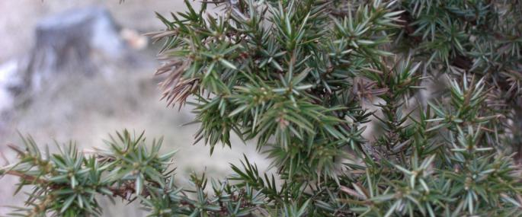
Common juniper ©Kess Vargavind

Description
Common juniper is a small tree; in Scotland few specimens grow taller than five metres. Two subspecies occur in Scotland: upright Juniper, Juniperus communis ssp communis and prostrate or dwarf Juniper, Juniperus communis ssp. nana. The upright subspecies is usually more erect and columnar and the prostrate form is often spreading or mat-forming.
The leaves are blue-green needles, around one centimetre long, strongly keeled with a silvery white band on the upper side. They are arranged in groups of three around the stem and when crushed they smell of apples and lemons. The bark is brown on young plants, but turns grey as it gets older, and is shed in thin strips.

Distribution
Common juniper has one of the largest geographic ranges of any woody plant in the world, with various subspecies occurring across much of the northern hemisphere. Although it is found throughout Scotland, it is only common in the Highlands.
Upright juniper (Juniperus communis ssp. communis) is locally abundant in the central Highlands and is common in open pine woodlands such as the Caledonian Forest, and also in birch woodlands. In some areas it occurs in almost pure stands. There are smaller scattered populations in the islands and down the western side of Scotland. In eastern and southern regions many Juniper populations are very small, but there are some larger stands, particularly on open ground.
Prostrate juniper (Juniperus communis ssp. nana) mainly occurs in exposed coastal and montane heaths, blanket bogs and rock ledges, mainly in the northwest mainland and the Northern and Western Isles. It can be locally common but many populations are very small.

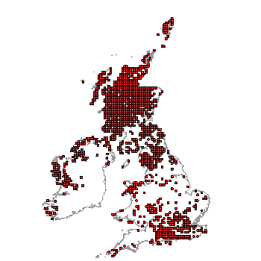
Distribution of Juniper in the UK. (From NBN Gateway: accessed 13/9/13)

Ecology
Juniper is dioecious, which means that individual trees are either male or female. Male flowers are yellow and appear in spring near the ends of the twigs. They produce pollen, which is wind-dispersed. Female flowers are very small scale-like clusters, and after pollination these grow on to become cones. The cones look like berries and are commonly referred to as juniper berries. These ‘berries’ are green at first, but ripen after 18 months to a dark, blue-purple colour. Because of their long ripening period, berries are present on the tree throughout the year, and it is usually possible to see the different development stages on the same plant. Each berry contains 3 - 6 hard black seeds which are eaten and dispersed by birds such as thrushes. The seeds are slow to germinate and normally require two or three winters of dormancy. However, a significant proportion of seeds are non-viable due to damage from insects such as the juniper shield bug (Elasmostethus tristriatus) and the juniper berry mite (Trisetacus quadrisetus)².
Juniper is a slow-growing species; in Scotland it typically only grows three to five centimetres per year². While they are small, the trees are extremely vulnerable to being eaten by sheep, deer, rabbits and voles. The species is intolerant of shade and will only survive in open habitats.
Flowering and seed production begins when the plants are seven to ten years old. Trees usually live for about 100-120 years. Juniper is a very ‘mobile’ species: as seed dispersal is chiefly by birds new trees usually grow some distance from the parent tree. Juniper can also reproduce vegetatively, and this typically occurs more in old, dying stands. Where branches of collapsing bushes touch the ground, they will form roots and produce new growth².
Juniper supports a range of specialist insects, fungi and lichens. 42 species of plant-eating insects are associated with juniper although some of these are non-native species, originating from ornamental junipers introduced to the UK as garden plants². Trees also provide shelter and food for larger animals, and older bushes often protect tree saplings from browsing.

Threats
Common juniper has a wide geographical range and is not globally threatened. However, its range in the UK is shrinking, and the tree has become a priority species under the UK Biodiversity Action Plan. In Scotland it has disappeared from 23% of sites where it was formerly present and only a third of the remaining sites have strong and secure populations¹.
Juniper’s decline in Scotland can be attributed to:
- Ageing bushes
Many trees are over a century old; old trees produce fewer viable seeds. A recent survey found only 13% of juniper sites had juniper seedlings present.
- Poor regeneration
Insufficient grazing prevents seedling establishment. Over shading can also cause loss of mature plants. On the other hand, excessive grazing by deer, sheep, rabbit and voles can destroy young trees.
- Small and isolated populations
Many juniper populations across Scotland consist of less than 10 plants, and only a handful of populations have more than 1000 trees. At least 50 plants are needed for a viable population¹. In addition, lack of both male and female plants in one area makes successful pollination of isolated bushes difficult.
- Land management
Land use changes including afforestation, more intensive agriculture or moorland management and development can all lead to loss of Juniper.
- Climate change
Drier weather may restrict seedling establishment and growth; wetter weather will cause water-table fluctuation and more unsuitable growing conditions, stress and disease; mild winters may reduce germination rates in some areas, because juniper seeds need cold weather to break dormancy¹.
- Disease
Juniper trees have recently started to face a new theat from the fungal disease Phytophthora austrocedrae. This fungus, believed to have originated from South America, was first confirmed in the UK (Upper Teesdale) in 2011. It has now been confirmed from 4 natural sites in Scotland and 2 private (garden) sites. It's thought that some 45% of Scottish junipers could be wiped out by the fungus. The Food and Environmental Research Agency (FERA) and Forestry Commission are currently investigating.

Management
Juniper is a long-lived species, often reaching well over 100 years, and although it needs good deer management it is not as sensitive to browsing as some broadleaved trees or shrubs. There is great potential to introduce juniper into upland planted forests, in order to diversify internal edges, glades, old growth stands and upper margins.
- Safeguard existing juniper stands and encourage new seedling germination and growth by controlled grazing
- Current juniper populations are almost entirely self-sown and so the conservation of juniper should be based on promoting natural regeneration where possible.
- Propagate Juniper in nurseries
- Juniper for planting can be grown from seed or cuttings. There is a need to promote a greater plant supply from sources across Scotland to meet increasing demand and provide genetic variety.
- Increase the use of juniper in restocking and new planting

Current work
There are, or have been recently, a number of Juniper recovery plans throughout Scotland. Organisations involved include Forestry Commission, Scottish Natural Heritage, Scottish Agricultural College, National Trust for Scotland, Plantlife, Botanical Society of the British Isles, Paisley Natural History Society, Highland Birchwoods.
Forestry Commission is undertaking surveys, using Juniper in new and existing woodland planting, working to help natural regeneration at existing Juniper sites and bolstering moribund populations through planting. Where possible new plantings are planned to link and expand existing Juniper stands. Forestry Commission nurseries are working to produce genetically varied planting stock from seeds and cuttings.
Plantlife have a Saving Juniper project taking place across the UK³. The Plantlife Scotland team have been carrying out management trials with Forest Research at five sites across Scotland, testing ways to encourage natural regeneration of populations using cattle grazing, ground scrapes (literally removing the top layer of the ground) or exclosures. Of the three techniques tested, using cattle grazing, on sites where conditions are appropriate for juniper, has been shown to be beneficial in creating conditions that enable seedlings to appear.
Scottish Wildlife Trust have a 2 year project with Scotland’s Rural College (SRUC) to prevent the decline and expand numbers of Juniper at the Trust’s reserve at Grey Hill Grasslands in Ayrshire. Funding for the project has been received from the distillers William Grant & Sons.
The first phase of the project started in summer 2013. Cuttings are being taken and propagated and seeds collected and planted up in polytunnels at three nurseries. Fencing has been erected to control grazing and gorse is also being controlled. Results from the project will be made available to other Juniper conservation projects throughout Scotland.

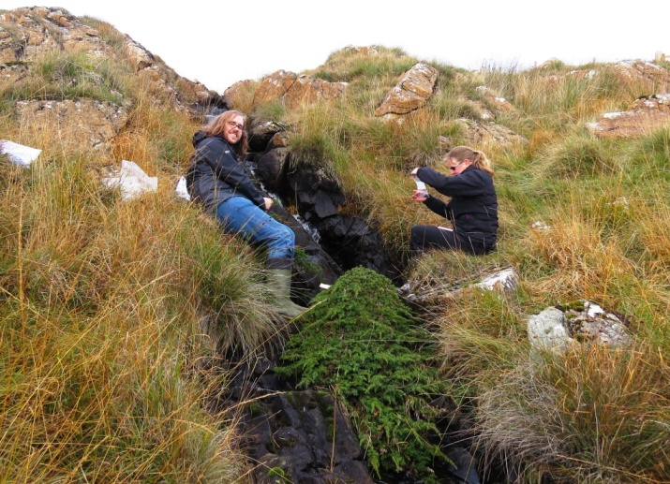
Collecting Juniper berries as part of SWT’s project at Grey Hill grasslands.

Wider Context
As one of our three native conifers, juniper is an important plant in a wide range of native habitats. In southern England juniper is in a critical state of decline with evidence of habitat fragmentation and contraction in range through extinctions and the relative strongholds in the Scottish Highlands could be crucial in securing the tree’s long-term future in the UK. Where juniper is the most dominant woody species, it can form a unique woodland vegetation type, W19 Juniperus communis-Oxalis acetosella woodland community. This community is very species rich and particularly important in terms of nature conservation. Juniper also supports a comparatively small, yet characteristic, native invertebrate fauna, including many species with specialised habitat requirements and restricted distribution in the UK. Stands of juniper can diversify upland bird communities, as bushes are an important food source for frugiforous birds such as Fieldfares, Song thrushes and Ring ouzel. In the absence of other native tree cover, juniper stands also provide valuable winter shelter for Black grouse.

Quick facts
- One of only three native conifers in Britain.
- Juniper is unusual in being able to grow on both acid and alkaline soils.
- The prickly boughs were used as a substitute for barbed wire.
- It supports over 40 species of plant-eating insect including many moths such as the juniper carpet moth, juniper pug and the chestnut-coloured carpet moth.
- Juniper ‘berries’ are actually the cones.
- Juniper can be traced back 10,000 years and was one of the first tree species to colonise the UK after the last Ice Age.
- A law was introduced in the 19th century to outlaw unlicensed whisky stills. Juniper wood burns with an almost invisible smoke, so large tracts of Juniper were harvested for fuel for this illicit trade.
- One specimen in Russia was found to be 544 years old; the oldest recorded in Britain was a tree in Teesdale aged 255 years.
- Although in decline in Scotland it remains widespread: Fife and Renfrewshire are the only Scottish counties to have no records of Juniper.
- Juniper berries add a bitter, spicy flavour to sauces and are popular with game dishes. However their best known use is in flavouring gin; indeed the word gin is probably derived from either the French ‘genièvre’ or Dutch’ jenever’ word for Juniper.
- In the nineteenth century Highland juniper bushes were prolific enough for their berries to be collected by the bagful and taken to the Inverness and Aberdeen markets to be exported to the Dutch gin distillers.
- The oil extracted from the berries was used to terminate unwanted pregnancy, perhaps explaining one of its alternative names, bastard’s bane. In fact, juniper pills for this purpose were still being advertised as late as the 1980s.

Selected references
Broome, A. (2003). Growing juniper: propagation and establishment practices. Forestry Commission Information Note FCIN50.
http://www.forestry.gov.uk/pdf/fcin050.pdf/$FILE/fcin050.pdf
- The advantages and disadvantages of growing juniper from cuttings or from seed
- Where and how to collect seed to maintain the genetic character of populations
- How to strike cuttings and germinate seed.
To help with successful establishment, advice is provided on the importance of weed control, types of shelters that are most effective and the impacts of fertiliser on bush growth. This guidance is targeted at people involved in the practical management of juniper in the uplands.

Green S, Hendry SJ, MacAskill GA, Laue BE, Steele H, (2012). Dieback and mortality of Juniperus communis in Britain associated with Phytophthora austrocedrae. New Disease Reports 26, 2.
Brief overview of status of the new Phytophthora disease that is starting to be seen in UK Juniper.

Long, D. and Williams, J. (2007). Juniper in the British Uplands: the Plantlife juniper survey results. Includes the strategy for juniper conservation in Scotland
http://www.plantlife.org.uk/publications/juniper_in_the_british_uplands/

McBride, A. (2011). Managing Uplands for Juniper. Plantlife: Back from the Brink Management Series.
http://www.plantlife.org.uk/publications/managing_uplands_for_juniper/

Sullivan, G. (2003). Extent and condition of Juniper scrub in Scotland. Report to Scottish Natural Heritage. Contract No. BAT/AC205/01/02/96.

Thomas, P.A., El-Barghathi and Polwart, A. (2007). Biological Flora of the British Isles: Juniperus communis L. Journal of Ecology (95) 1404-1440
An in-depth review of the biology and ecology of Juniper in Britain. The pdf is available at http://www.ringouzel.info/research/Thomas%20et%20al%202007.pdf‎ accessed

Verheyen K, Adriaenssens S, Gruwez R, Michalczyk IM, Ward LK, Rosseel Y, Van den Broeck A, García D. (2009). Juniperus communis: victim of the combined action of climate warming and nitrogen deposition? Plant Biology (Stuttg). Nov 11 Suppl 1:49-59
They studied European populations of J. communis. Found that species is at least partly seed limited – ie areas with fewer seeds have fewer saplings. Nitrogen deposition and higher temperatures had a negative effect on seed viability, but there was no effect of drought. No suggestions or conclusions were drawn of cause and effect.

Ward, L. (2004). Juniperus communis species dossier for Plantlife
Detailed information about the status, ecology and management of Juniper in the UK. http://www.plantlife.org.uk/uploads/documents/Juniperus_communis__Dossier__part1.pdf
http://www.plantlife.org.uk/uploads/documents/Juniperus_communis_dossier__part2.pdf

Ward, L.K. (2010). Variation in ripening years of seed cones of Juniperus communis L. Watsonia, 28. 11-19.
Seeds took mostly 2 or 3 years to ripen and there is evidence that different populations of J. communis have different lengths of time to ripening, depending on the climatic conditions they grow and their genetic provenance.

SWT’s Juniper Project – update (November 2013)
Cuttings: The stock fence to protect the main juniper patch from sheep grazing was installed in the summer. I had the feeling the junipers were already showing better growth. There was certainly plenty of material from which to take this second set of cuttings. As usual, we followed our agreed protocol of carefully labelling cuttings and cleaning equipment between trees. The cool conditions meant we could do without the heavy, cumbersome cool boxes which was a boon. The stats will be collated shortly but as a taster, I have potted 218 cuttings from 22 different trees. Added to my 170 survivors from the July cuttings, SWT’s target of 500 eventual trees is currently well exceeded. I know SRUC’s are also doing well.

Seeds: Plump, purple berries were plentiful. I made off with 200 berries, half of which were delivered to John at Stairway on Sunday, along with his batch of cuttings from 10 trees. From my 100 berries, I extracted 224 seeds by soaking them overnight and pulled them apart with forceps under a dissecting microscope – labour intensive but it meant not one single seed was wasted. Again berries were carefully labelled to indicate which tree they came from. Interestingly, berry abundance varied greatly between trees and we recorded this as well as the proportion of purple to unripe berries. The good quantities of unripe berries bodes well for next year.
Gorse: We were able to cut and treat most of the gorse bushes that were competing with the junipers on the main crags.

Forestry Commission Scotland (2009). Action for Juniper. Species action note. www.forestry.gov.uk/pdf/fcs-species-juniper.pdf/$FILE/fcs-species-juniper.pdf accessed 25/08/13
http://www.treesforlife.org.uk/tfl.juniper.html
http://www.plantlife.org.uk/wild_plants/work/savingjuniper/juniper-work/ Accessed 25/08/13
http://www.forestry.gov.uk/forestry/INFD-8RAJZ3 Accessed 13/9/13
Green S, Hendry SJ, MacAskill GA, Laue BE, Steele H, (2012). Dieback and mortality of Juniperus communis in Britain associated with Phytophthora austrocedrae. New Disease Reports 26, 2.
Broome, A. (2003). Growing juniper: propagation and establishment practices. Forestry Commission Information Note FCIN50. www.forestry.gov.uk/pdf/fcin050.pdf/$FILE/fcin050.pdf Accessed 13/9/13

