Grass of Parnassus

Parnassia palustris

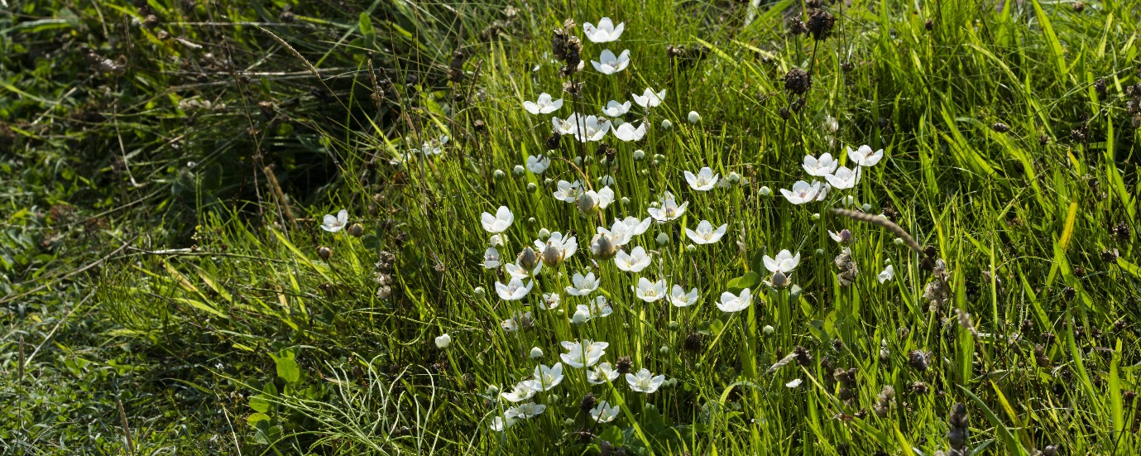
Grass of Parnassus © Katty Baird
Introduction
The Grass of Parnassus, sometimes known as 'bog star', is a member of the Parnassiaceae family. It was once widely distributed across the UK, but following widespread loss of the damp meadows and marshy areas where it grows, it is now largely confined to the North, and is most common in Scotland and Ireland.

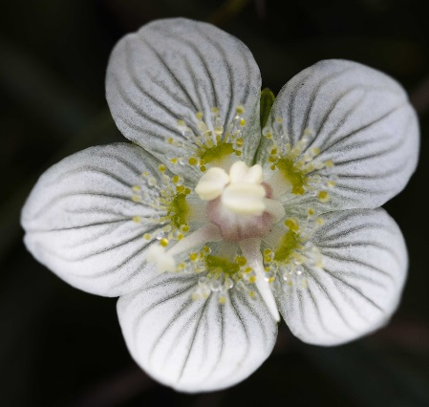
Description
Grass of Parnassus has single, ivory-white flowers with five petals, each around 1cm long and delicately striped with green. The stems are concavely square in cross section and 5-25cm long. Dark green, heart-shaped leaves are produced in a rosette at the base of the plant, and there is a single leaf on the middle of the flowering stem.

Distribution
©Katty Baird
Once widely distributed across the UK, Grass of Parnassus has been in decline across the southern regions for many years, mainly due to land drainage. It is now most common in Scotland and Ireland, but also occurs in northern England and Wales and northern East Anglia. Smaller populations can be found in some parts of the Midlands. It grows on damp soils and is tolerant of both acid and calcareous substrates. It is widely distributed through the Northern hemisphere, from North America, Europe and temperate Asia.

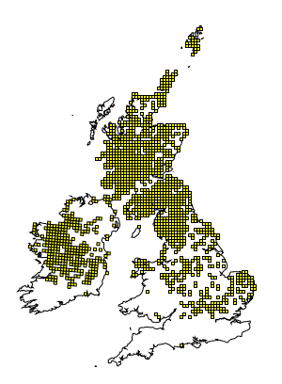
Distribution of Grass of Parnassus in the UK (From NBN Gateway: accessed 24/11/13)

Ecology
Grass of Parnassus is a perennial species, flowering between June and September. It has five sterile stamens, which instead of anthers have bristles crowned with yellow drop-like glands (the 'nectaries') and five fertile stamens topped with cream-coloured anthers. Nectar is secreted which aids in attracting insects, including bees, flies and beetles, for pollination. However, this species is also capable of self-fertilising. Many minute seeds are produced which are dispersed by the wind.

Threats
The Grass of Parnassus has an extremely large range and does not appear to be at risk globally. However, the wetlands habitats in which they grow can be threatened by agricultural improvement and development. This loss of habitat is probably responsible for the marked reduction in the species’ range in the UK. Some small, isolated populations appear to have low genetic diversity with little connectivity to other populations, increasing their risk of extinction,.

Management
- Grass of Parnassus occurs in habitats such as damp meadows, fens, dune slacks and machair. Management of sites should be aimed at traditional grazing or mowing regimes.
- Maintain a structural diversity of plants.
- Use grazing or mowing to create a varied vegetational structure. Allow plants to flower and set seed before cutting.
- Nutrient input should be minimized or absent.
- Prevent scrub encroachment.
- Maintain hydrology.

Current Work
The Wildlife Trusts are working closely with planners, developers and farmers to ensure our wetlands are protected and managed for the benefit of the plants and animals they hold, including Grass of Parnassus.

Wider Context
Human activity, including the drainage of land for agriculture and development, has resulted in the disappearance of many of the UK's wetlands and fragmentation of remaining areas. Sites in the south of the UK have been worst affected. They are important habitats for a range of plant and animals, notably breeding waders such as snipe, curlew and lapwing.

Fun facts
- The name comes from ancient Greece. The cattle on Mount Parnassus developed a taste for the plant; hence it became an ‘honorary grass'.
- The Grass of Parnassus is a symbol of the clan MacLea. Tradition has it that this is because they were the favourite flowers of the early Irish missionary St Moluag, whose holy staff or crozier has been handed down through centuries of MacLea clan chiefs, and is currently in their possession on the Isle of Lismore.
- Other names for Grass of Parnassus are Bog star, Marsh grass, Northern grass of Parnassus, Parnassus.
- Grass of Parnassus is the County Flower of both Cumbria and Sutherland.
- At the end of summer the blooming flowers used to be a sign to peasants to start reaping and hay-work, and in fact the plant’s Swedish name means ‘hay-work’.
- Its Latin species name 'palustris' means 'of-the-bog' or swampy.
- “Grass of Parnassus: Rhymes Old and New” is the title of a book of poetry by Scottish poet Andrew Lang. The first poem in it is called Grass of Parnassus.
Selected references
http://wildflowerfinder.org.uk/Flowers/G/GrassOfParnassus/GrassOfParnassus.htm
Basic information on biology and ecology, with for good photographs of the flower from Lancashire.
Bonnin, I. et al. (2002). Population structure of an endangered species living in contrasted habitats: Parnassia palustris (Saxifragaceae). Molecular Ecology, 11: 979-990.

Looked at genetic markers in populations of P. palustris in northern France. There was no evidence for a recent bottleneck in the population. Although pollen migration was good, allowing genetic mixing between populations, seed dispersal was poor, suggesting new habitats may not be easily exploited if they become available.

Bossuyt, B. (2007). Genetic rescue in an isolated metapopulation of a naturally fragmented plant species, Parnassia palustris. Conservation Biology, 21: 832-841.
Meta-populations of Parnassia palustris in north France and Belgium become genetically distinct and show differences in measures of fitness such as seed and fruit weight. Seed set was best when pollination occurred between individuals from different meta-populations. Suggests that meta-populations need to be linked to prevent genetic erosion of isolated populations and help with conservation of species.

www.plantlife.org.uk/wild_plants/plant_species/grass-of-parnassus/ Accessed 11/11/13
www.arkive.org/marsh-grass-of-parnassus/parnassia-palustris/image-G113286.html Accessed 11/11/13
Bonnin, I. et al. (2002). Population structure of an endangered species living in contrasted habitats: Parnassia palustris (Saxifragaceae). Molecular Ecology, 11: 979-990.
Bossuyt, B. (2007). Genetic rescue in an isolated metapopulation of a naturally fragmented plant species, Parnassia palustris. Conservation Biology, 21: 832-841.

