Eelgrass

Zostera spp.

Eelgrasses are species of seagrass, a group of flowering plants that are unique in that they live in seawater. Two species of eelgrass occur in the waters around Scotland, forming beautiful underwater meadows that are havens for marine wildlife, and important nursery areas for commercially important fish species. A disease caused mass dieback of common eelgrass during the 1920s and 1930s, and the species is still recovering. Threats from marine pollution are hampering its recovery and make it more susceptible to further disease.
Eelgrasses have a patchy distribution in the UK and are considered to be nationally scarce. Eelgrass beds are a UKBAP Priority Habitat and an ‘important feature’ in estuary Sites of Special Scientific Interest, under the UK Wildlife and Countryside Act 1981. They are on the OSPAR (Oslo and Paris Conventions for the protection of the marine environment of the North-East Atlantic) List of Threatened and/or Declining Species and Habitats.

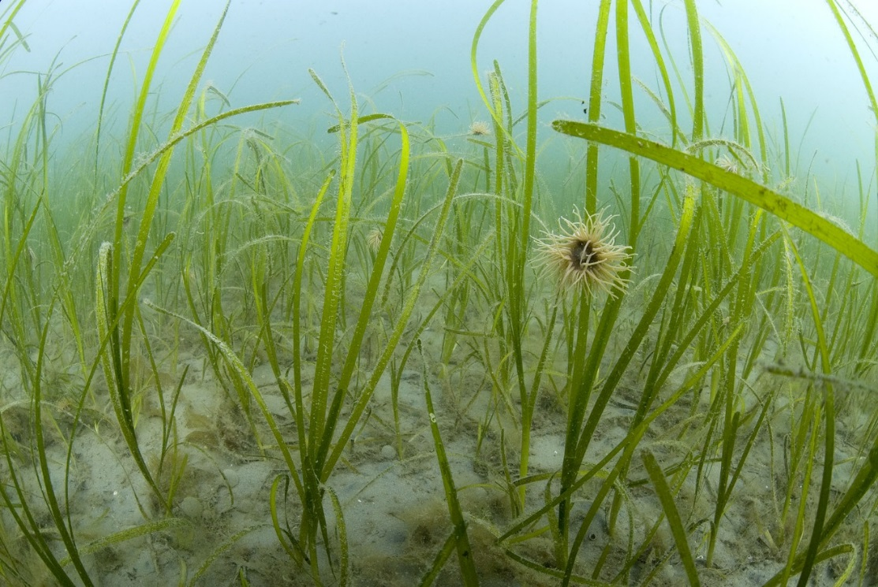
Eelgrass bed © Paul Naylor www.marinephoto.co.uk

Description
Eelgrasses have long, dark green, ribbon-shaped leaves with rounded ends and distinct veins. Two species of eelgrass are found in the UK – Common eelgrass (Zostera marina) with leaves up to 1m long and Dwarf eelgrass (Z. noltii) with leaves up to 20 cm long. The leaves shoot from a creeping rhizome that helps bind the sediment in which it grows. Numerous inconspicuous flowers occur on a reproductive shoot similar to those of terrestrial grasses. Male and female flowers are separate but occur on the same plants.

Distribution
Eelgrasses grow in sheltered waters such as inlets, bays, estuaries and saltwater lagoons on mud and sand substrates. Zostera marina is typically found from the lower shore to about five metres depth on sand or sandy mud substrates. Z. noltii is found in the intertidal region.
- Zostera marina is widespread throughout the Atlantic and Pacific. In the eastern Atlantic it extends from the Arctic Circle to Gibraltar, including the Mediterranean
- Zostera noltii has a more southerly distribution than Z. marina and is occurs on Atlantic coasts from southern Norway to the tropic of Cancer, and the Mediterranean Sea.
In Scotland, Zostera have a wide but patchy distribution. The most significant Dwarf eelgrass beds are found in Moray and Cromarty Firths and most significant Common eelgrass beds along the west coast of Scotland, including the Hebrides.

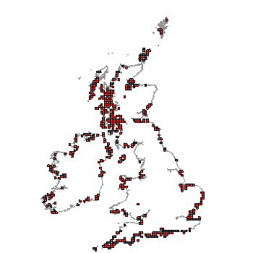
Zostera sp distribution in the UK. (From NBN Gateway, accessed 13/9/13)

Ecology
In Britain, growth generally occurs from April to September. The underground mat of horizontal rhizomes branches and grows, producing vertical leaf shoots. Short pieces of rhizome that break off the parent plant and are carried away by currents may generate new plants if deposited on a suitable substratum.
Eelgrass populations can also expand sexually, by production of seed. Flowers and seeds are generally produced in the summer months. The male flowers release long filamentous strands of pollen which drift in the water until they encounter receptive stigmas. After fertilization, the seed develops within a green membranous wall which photosynthesises, producing a small bubble of oxygen that is trapped inside the seed capsule. Eventually this forces the capsule wall to rupture, releasing the mature seed. The seeds generally sink and are dispersed by currents, waves and, possibly over short distances, on the feet of birds.
Subtidal Z. marina beds in the UK are perennial and are believed to persist almost completely as a result of vegetative growth rather than by seed production. The beds can remain green throughout the year, as summer leaves that are shed in the autumn are generally replaced with smaller winter leaves. In intertidal populations of Z. noltii growth ceases and leaf cover begins to decline during the autumn and over the winter. Intertidal plants may experience a complete loss of foliage, dying back to the buried rhizomes. In perennial populations, the rhizomes survive the winter to produce new leaves the following spring, while in annual populations, both the leaves and rhizomes die.

Threats
Globally 30,000km² of seagrass has been lost in the last couple of decades (equal to 18% of the global area). Disease is responsible for much of this decline, but a degradation of the marine environment is also a problem both directly and through introducing environmental stress, making plants more susceptible to disease. Areas affected are slow to recover.
- Disease
In the 1930s, almost 90% of the eelgrasses around Britain died from a wasting disease. Declines were also seen across Europe and other areas of its range.
- Nutrient enrichment marine pollution
Eelgrasses grow best in undisturbed, clean water. High levels of nitrates (from urban wastewater or farm run-off) have been linked to declines in Zostera in a number of sites around Scotland. High nutrient levels are not only toxic to eelgrass directly but it also acts to stimulate epiphytic algae growth which can outcompete the eelgrass by reducing the available sunlight.
- Physical disturbance
Such as trampling, dredging, anchoring, and the use of mobile bottom-fishing gear can damage and uproot plants.
- Increased turbidity
This results in increased amounts of sediment in the water, which block sunlight and prevent seagrass growth.
- Competition from alien species
Alien species, including Spartina anglica (cord grass) and Sargassum muticom, can affect eelgrass viability through competition.
- Climate change
Climate change is of potential importance for eelgrass growth and distribution through warming water temperatures, rising sea levels, the increase of carbon dioxide in the atmosphere and ocean, as well as the increasing frequency and strength of storms.

Management
Management should incorporate:
- Protection of eelgrass beds and potential eelgrass areas through Marine Protected Areas
- Regulation of land use in catchment areas to reduce nutrient runoff and siltation from soil erosion
- Regulation of aquaculture and fisheries in or adjacent to eelgrass beds
- Creating an awareness of the importance of eelgrasses

Current work
Eelgrass beds are a priority habitat for UK Biodiversity Action Plans, being taken forward by the Scottish Government as part of the Scottish Biodiversity Strategy.
The Scottish Wildlife Trust is campaigning for creation of Marine Protected Areas around Scotland’s coast.

Wider context
Seagrasses are ‘ecosystem engineers’ creating an important coastal ecosystem and help provide ecological services such as maintenance of biodiversity, water-quality control and shore-line protection. Their conservation should be a key target for coastal management strategies aiming to preserve or improve the environmental quality of the coastal zone. Seagrasses also have an important role to play in global carbon budgets; it has been calculated that they account for 15% of the ocean’s total carbon absorption³.

Quick Facts
- The name Zostera comes from the Greek ‘zoster’, meaning ‘belt’, referring to the ribbon-shaped leaves.
- The leaves that are said to look like green eels when they move with the current of the sea.
- Many small invertebrates, particularly sea firs and sea squirts, attach to the leaves of eelgrass, while burrowing anemones, bivalve molluscs and burrowing urchins lie buried in the sand beneath.
- Some rare seaweeds lie unattached between the plants.
- Several species of flatfish use eelgrass beds as nursery areas, to lay their eggs and shelter their newly hatched young. These may include commercially important species like plaice and flounder.
- Native oysters, once common in Scotland but now very rare, grow in some eelgrass beds.
- They can be a major source of food for wildfowl, particularly wigeon but also for mute and whooper swans.
- The roots of eelgrass bind the sand, helping to prevent erosion of the seabed.
- In the Netherlands eelgrass leaves have been used as constituents of dikes ("wierdyken"), were the preferable stuffing of baby mattresses until the 1950s, and are still used in chair seats.
- Due to its low flammability, dried eelgrass shoots were also used as housing insulation.
- It is suggested that only 20 of Britain’s 155 estuaries have eelgrass meadows more than 1 ha in extent (Tubbs, 1995).
- Other common names include, wigeon grass, broad leaved grass wrack, marlee, sedge and slitch.

Selected References
Davison, D.M. and Hughes, D.J. (1998). Zostera Biotopes (volume I). An overview of dynamics and sensitivity characteristics for conservation management of marine SACs. Scottish Association for Marine Science (UK Marine SACs Project). 95 Pages. www.ukmarinesac.org.uk/zostera.htm accessed 06/08/2013
A comprehensive review of Zostera species in the UK.
Tyler-Walters, H. (2008). Zostera marina. Common eelgrass. Marine Life Information Network: Biology and Sensitivity Key Information Sub-programme [on-line]. Plymouth: Marine Biological Association of the United Kingdom. www.marlin.ac.uk/speciesfullreview.php?speciesID=4600 accessed 06/08/2013
Brief summary of Z. marina in the UK. Includes general biology, habitat preferences, sensitivity and importance.
Borum, J., Duarte, C.M., Krause-Jensen, D. and Greve, T. M. (eds.) (2004) European seagrasses: an introduction to monitoring and management. A publication by the EU project Monitoring and Managing of European Seagrasses (M&MS) EVK3-CT-2000-00044 www.seagrasses.org/handbook/european_seagrasses_low.pdf
In depth information on biology and ecology of four species of sea grass (including Zostera marina and Z. nolteii) in Europe. Also review of threats, ecological significance, monitoring and managing. Plus list of references.
Tubbs, C. R., (1995). The meadows in the sea. British Wildlife, 6: 351-355.
An overview of eelgrass beds in the UK. Following the dieback of the 1920s, Tubbs considers that most Zostera beds have not yet fully recovered, and that only 20 of Britain’s 155 estuaries have eelgrass meadows more than 1 ha in extent. He reported that Z. marina has not recolonized the estuaries in southern and eastern England where it was once abundant, but that there are numerous small beds on the Channel coast from the Isles of Scilly to the Isle of Wight. He also reported that Z. marina beds on the west coast of Britain are extensive, dense and vigorous, particularly on the west coast of Scotland and around the Outer Hebrides.

Some authorities distinguish a third species, Z.angustfolia, separated from the more common Z. marina based on morphology, habitat zonation and reproductive strategy.
Davison, D.M. and Hughes, D.J. 1998. Zostera Biotopes (volume I). An overview of dynamics and sensitivity characteristics for conservation management of marine SACs. Scottish Association for Marine Science (UK Marine SACs Project). 95 Pages.
www.seagrasses.org/handbook/european_seagrasses_low.pdf
www.wildlifetrusts.org/wildlife/habitats/seagrass Accessed 12/9/13
www.snh.gov.uk/about-scotlands-nature/species/flowering-plants/coastal-and-marine-plants/eelgrass/ Accessed 2/8/13
Tubbs, C. R., 1995. The meadows in the sea. British Wildlife, 6: 351-355

