I would like to pay £_____.__ each month/year (delete as appropriate)

Minimum membership rates (see below): Membership no: _______________
 | Individual | Joint | Family | Concession | Joint  Concession | Watch | World  Overseas | Life | Joint  Life
Direct Debit | £36.00 p/y  £3.00 p/m | £45.00 p/y  £3.75 p/m | £54.00 p/y  (£4.50 p/m) | £18.00 p/y  (£1.50 p/m) | £24.00 p/y  (£2.00 p/m) | £18.00 p/y  (£1.50 p/m) | N/A | N/A | N/A
Cheque/Credit Card/Cash | £40.00 p/y | £47.00 p/y | £57.00 p/y | £18.00 p/y | £24.00 p/y | £18.00 p/y | £45.00 p/y | £900 | £1,300

Yes! I would like the Scottish Wildlife Trust to Gift Aid my donations and subscriptions and any I make in the future or have made in the past four years. I confirm that I am a UK taxpayer and understand that if I pay less Income Tax and/or Capital Gains Tax in the current tax year than the amount of Gift Aid claimed on all of my donations, it is my responsibility to pay any difference.

SignatureDate
Boost your donation by 25p for every £1!

With Gift Aid you can make your membership subscriptions and donations go further – please tick below!

Keeping involved: Support us in our mission to protect Scotland’s wildlife and wild places! Make sure you hear about the nature conservation, campaigning and fundraising work we are doing and how you can play your part. If you are happy for the Scottish Wildlife Trust to keep in touch, please let us know how you would like to hear from us:
Phone | Yes |  | No
Email | Yes |  | No
Text | Yes |  | No

My Details: Title: _________ First Name: _____________________ Surname:________________________________________

Address: ____________________________________________________________________________________________

____________________________________________________________________ Postcode:_______________________
Email: ___________________________________________________Tel.________________________________________

Yes! I would like the Scottish Wildlife Trust to Gift Aid my donations and subscriptions and any I make in the future or have made in the past four years. I confirm that I am a UK taxpayer and understand that if I pay less Income Tax and/or Capital Gains Tax in the current tax year than the amount of Gift Aid claimed on all of my donations, it is my responsibility to pay any difference.

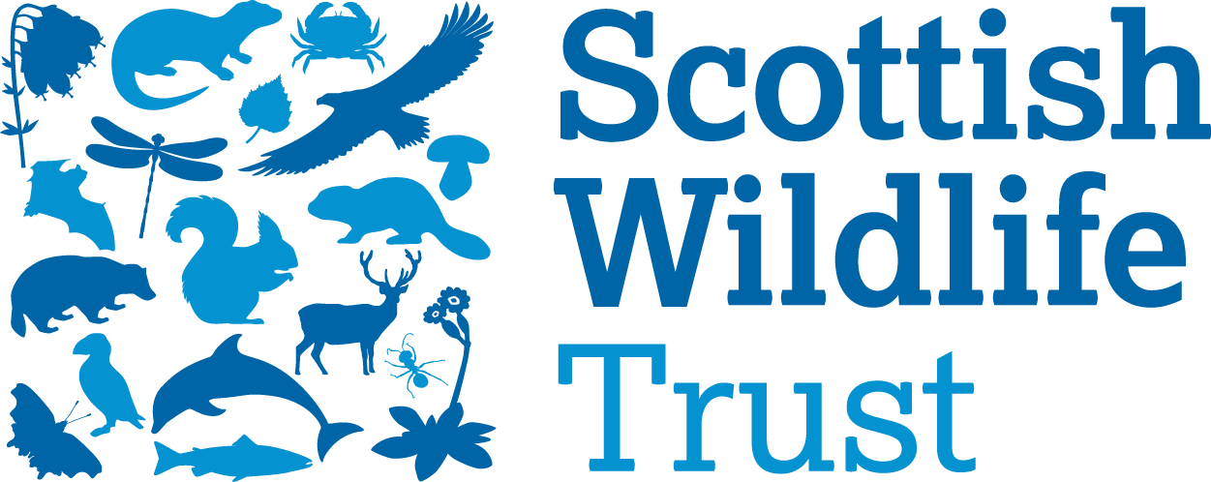 | Instruction to your bank or building society to pay by Direct Debit |  | 
Please fill in the whole form using a ball point pen and send to: Scottish Wildlife Trust, Harbourside House, 110 Commercial Street, Edinburgh EH6 6NF  Name and postal address of your bank/building society:
  Service User Number
  9 | 1 | 4 | 9 | 8 | 4
To: The Manager Bank/building society  ____________________________________________________  ____________________________________________________  _____________________________Postcode_______________ |  | Reference (for SWT use only)  Instruction to your Bank or Building Society
Name(s) of Account Holder(s)  Bank/building society account number |  | Please pay Scottish Wildlife Trust Direct Debits from the account detailed in this Instruction subject to the safeguards assured by the Direct Debit Guarantee. I understand that this Instruction may remain with Scottish Wildlife Trust and if so, details will be passed electronically to my Bank/Building Society.
 |  | Signature
Branch sort code
 |  | Date

Banks and building societies may not accept Direct Debit instructions from some types of account
Code: Web

This guarantee should be detached and retained by the Payer.
The Direct Debit Guarantee
- This Guarantee is offered by all banks and building societies that accept instructions to pay Direct Debits
- If there are any changes to the amount, date or frequency of your Direct Debit Scottish Wildlife Trust will notify you 3 working days in advance of your account being debited or as otherwise agreed. If you request Scottish Wildlife Trust to collect a payment, confirmation of the amount and date will be given to you at the time of the request
- If an error is made in the payment of your Direct Debit by Scottish Wildlife Trust or your bank or building society you are entitled to a full and immediate refund of the amount paid from your bank or building society
  - If you receive a refund you are not entitled to, you must pay it back when Scottish Wildlife Trust asks you to
- You can cancel a Direct Debit at any time by simply contacting your bank or building society. Written confirmation may be required. Please also notify us.

