Northern cranberry

Vaccinium oxycoccus

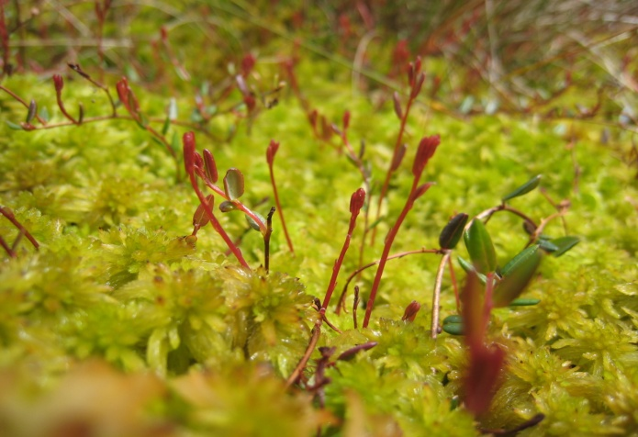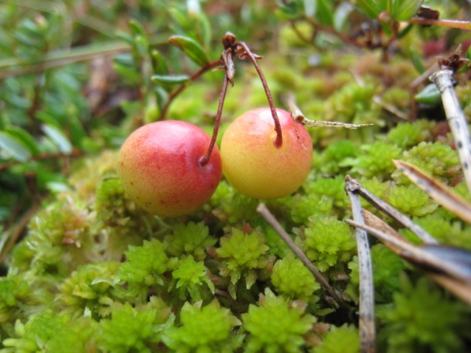
Northern cranberry growing on Sphagnum bog (c) SWT

Cranberries are plants of acidic bogs; several species occur throughout the cooler regions of the northern hemisphere. Vaccinium oxycoccus or Northern cranberry is one of our two native species and is associated with lowland raised bog habitats. It is estimated that only about 6, 000 ha of lowland raised bog remains in the UK and the Northern cranberry, along with other specialised plants and invertebrates that live in this habitat, is becoming increasingly threatened. Restoration of lowland wet bog is essential and urgent, not only to protect plants and animals which depend on them, but also because of the ecosystem services such as carbon sequestration and flood control that they provide.

Description
Northern cranberry is a creeping shrubby plant. It has thin, wiry stems with small dark green oval leaves which area 5-10 mm long. The leaves are quite leathery to feel and persist through the winter (when they may turn dark brown). Flowers are dark pink, with four very distinct backward-pointing petals exposing the prominent stamens as a central purplish spike. The fruit is an edible berry that is larger than the leaves of the plant; it is initially white, but turns a deep red when fully ripe.

Distribution
Northern cranberry has a widespread but local distribution throughout the cool temperate northern hemisphere, including northern Europe, northern Asia and northern North America. It is associated with lowland raised bogs which, in Scotland, are generally found in the Central Belt, the lowlands of the north east and along the Solway coast.
The Trust’s reserve at Carsegowan Moss is one of the best remains of a bog which once formed a large area of peatlands along the Solway. Cranberry and bog asphodel grow within the sphagnum carpet. Red Moss of Balerno is the only raised bog in Edinburgh and is a designated Site of Special Scientific Interest. Other reserves where there are good populations of bog cranberry are Loch Ardinning (north of Glasgow) and Largiebaan at the southern end of the Kintyre peninsula.

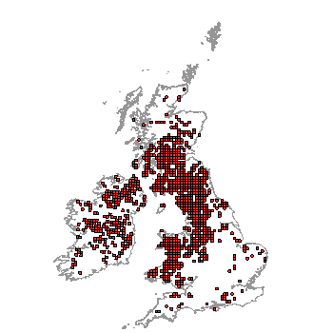
Distribution of Vaccinium oxycoccus in the UK (From NBN Gateway: accessed 13/9/13)

Ecology
Vaccinium oxycoccus (Northern Cranberry) and Vaccinium microcarpus (Small cranberry) are the two native Cranberry species in the UK. Another species Vaccinium macrocarpon is the familiar cranberry of our supermarkets, which is commercially cultivated in America.
Northern cranberry occurs in lowland raised bogs where it trails low over Sphagnum mosses and other low-growing plants. It commonly occurs with Bog-rosemary (Andromeda polifolia). This bog habitat is subjected to constant waterlogging and has a high and stagnant water table with acidic conditions that are nearly always below pH5.
The stems grow horizontally and are continually buried by growing sphagnum shoots so that only the current year’s horizontal stem with its vertical shoots are visible above the sphagnum carpet. It has shallow roots (hardly penetrating more than a few centimetres below living parts of moss layer) so is reliant on the water-conducting capacity of Sphagnum moss for its water supply. Flowers are formed during the previous year to that which they open. In Britain, the flowering period is between June and August.

Threats
The greatest threat to Northern cranberry is the degradation, and eventual disappearance of its specialised bog habitat - lowland raised bogs. Lowland raised bogs are protected under European law and UK national site designations. They have a Biodiversity Action Plan. Despite this, plans to extract peat and drain surrounding areas still get consent.
Afforestation, waste-tipping, opencast coal mining and road development have all had damaging consequence to lowland raised bog. But it is agricultural improvements, local and regional drainage and unsustainable commercial peat extraction for horticulture, which are the most serious threats.

Management
There is currently very little baseline data about the distribution and status of cranberry in Scotland. This needs to be addressed through more surveys and research so that the effects of bog management can be evaluated and appropriate conservation plans can be formulated properly.
Actions to conserve lowland raised bogs include:
- Limiting the amount of peat extraction and using peat alternatives such a coir and chipped bark.
- Maintaining a stable high water table. This includes blocking ditches and re-wetting areas that have been drained to allow the peat building process to restart and specialist bog plants and insects to recolonize.
- Removing any trees planted on the bogs and preventing scrub encroachment.
- Avoiding grazing and burning.

Current work
Scottish Wildlife Trust
The Trust is campaigning to raise awareness of the value of lowland raised bogs and the threats which they face, as well as promoting alternatives to using peat for gardening. The Trust is working to prevent further loss of our lowland raised bogs by looking after many areas as nature reserves. Traditional management techniques, such as grazing and burning are used to maintain them, and areas that have deteriorated are being restored. The Trust also provides advice and guidance for landowners and farmers on wildlife-friendly practices in these areas.

Wider context
Cranberry is associated with lowland raised bog, which is one of Western Europe’s rarest and most threatened habitats. Over thousands of years, layers of Sphagnum moss have developed into huge peat domes, rising up to ten metres above the landscape. Lying above the water table, they are fed entirely by rainwater. Around 94% of this unique habitat has been destroyed or damaged in the UK. The remaining 6,000 hectares are internationally important and support a wide range of birds, plants and invertebrates, some of which are quite rare.
Raised bogs also help reduce flooding because they hold excessive rainfall and release it gradually. In the long term, restoration of raised bogs could help in reducing climate change because of the carbon that they store in the form of peat.

Quick facts
- The name cranberry derives from "craneberry", first named by early European settlers in America who thought the expanding flower and stem resembled the neck, head and bill of a crane.
- The traditional English name for Vaccinium oxycoccos is fenberry, and originated from plants found growing in fen (marsh) lands.
- In Scotland, the berries were originally wild-harvested but with the loss of suitable habitat, the plants have become so scarce that this is no longer done.
- Since the early 21st century, raw cranberries have been marketed as a "superfruit" due to their nutrient content and antioxidant qualities.
- Small cranberry (V. microcarpum) is a smaller cranberry found in similar habitats in Scotland with more triangular leaves and hairless stalks. It can tolerate slightly drier conditions and has more northerly distribution
- V.oxycoccus tends to grow in hollows whereas V. microcarpum is more frequent on hummocks
- North American cranberry, Vaccinium macrocarpon is a larger species that is grown commercially in North America. It was introduced to Britain as a ballast ‘waif’ prior to 1868 and has naturalised in a few places and is also widely sold as a garden variety.
- North American cranberry, Vaccinium macrocarpon is mostly sold as juice, sauces, jams and dried berries. It is particularly important as part of Thanksgiving meals in North America and Canada.
Selected references
Jacquemart, A-L. (1997) Vaccinium oxycoccus L. (Oxycoccus palustris Pers.) and Vaccinium microcarpum (Turcz. Ex Rupr.) Schmalh. (Oxycoccus microcarpus Turcz. Ex Rupr.). Journal of Ecology 85: 381-396
An in depth review of the biology and distribution of Vaccinium oxycoccus and V. microcarpum. Lots of botanical information - not very easy-going for a non-botanist! Not much about ecology.
Matthews, P. (2012) A Survey of 15 Scottish Lowland Raised Bogs: Findings from a survey of lowland raised bogs with landowners supportive of restoration. Scottish Wildlife Trust, Edinburgh.
A total of 15 Scottish lowland raised bog sites were surveyed during summer 2012 as part of the Scottish Wildlife Trust’s lowland raised bog project. These sites were additional to the 62 sites that were surveyed during 2010/11 during the first stage of the project. These formed the basis of a study to assess the current state of Scotland's lowland raised bogs and to assess change since the mid-1990s. The aim was to identify and determine the state of 15 sites that are suitable for restoration, and to calculate the costs associated with returning them to favourable condition. Of the 15 sites surveyed, 12 sites have a high potential for restoration and the remaining 3 sites have a low to medium potential for restoration.
Matthews, P., Hughes, J. and Dowse, G. (2012). The state of Scotland’s raised bogs in 2012: interim findings from a survey of 58 Scottish raised bogs and analysis of change since 1994/95. Scottish Wildlife Trust, Edinburgh.
- 48% of sites showed deterioration in condition, 36% of sites showed an improvement in condition and 16% of sites showed no change in condition
- 39 out of 41 private landowners questioned (95%) were either very supportive or broadly supportive of grant-aided restoration measures being carried out on their sites
- Active management will be required to counteract past damage and bring the sites into favourable condition

Jacquemart, A-L. (1997) Vaccinium oxycoccus L. (Oxycoccus palustris Pers.) and Vaccinium microcarpum (Turcz. Ex Rupr.) Schmalh. (Oxycoccus microcarpus Turcz. Ex Rupr.). Journal of Ecology 85: 381-396
Jacquemart, A-L. (1997) Vaccinium oxycoccus L. (Oxycoccus palustris Pers.) and Vaccinium microcarpum (Turcz. Ex Rupr.) Schmalh. (Oxycoccus microcarpus Turcz. Ex Rupr.). Journal of Ecology 85: 381-396
http://www.biodiversityplanningtoolkit.com/stylesheet.asp?file=794_lowland_raised_bogs Accessed 05/11/13

