Cladonia Lichens
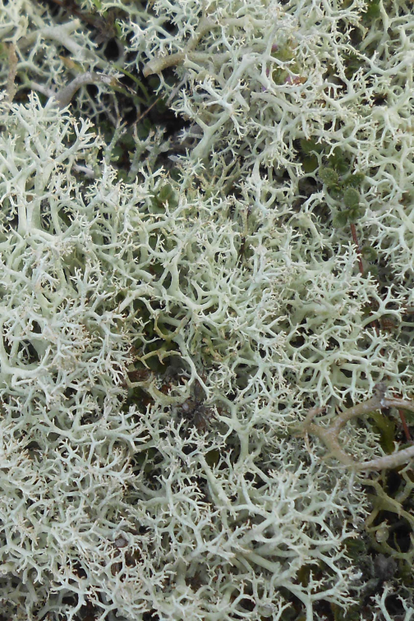
Cladonia sp. growing on coastal dunes ©Katty Baird
Cladonia is a genus of lichens, many of which are associated with coastal dune habitats. Indeed, they are a defining character of grey dune, a priority habitat for conservation under the E.U. Habitats Directive. It is a large genus (61 species are treated in The Lichen Flora of Great Britain and Ireland) and includes species more commonly referred to as ‘cup lichens’ and ‘reindeer moss’.

Description
Lichens can be divided into groups based on their structure and form. Cladonia are fruticose lichens. Their branches can be rounded or flattened but both upper and lower surfaces are similar. Many species can be further described as ‘cup lichens’ with stick or goblet-like podetia (stalks), often tipped with red or brown, growing out of a basal thallus. Other members of the genus, sometimes referred to as reindeer lichens, are bushier in form.
Distribution
Cladonia lichens are often a significant component of fixed grey dune vegetation, which occurs mostly on large dune systems around UK and other west European coasts. The best Scottish examples of grey dune habitats with Cladonia lichens are in the north-east at sites such as Culbin, Ferry Links, the Spey mouth and Cuthill Links. Here the lack of grazing, trampling and fire has resulted in the lichen swards developing an unusual luxuriance.
In some places shingle occurs as a component of dune systems and when buried under a thin veneer of sand often creates the richest lichen habitats because the nutrient-poor situation restricts growth of vascular plants.

Ecology
A lichen is an organism formed by a fungus and a photosynthetic alga or blue-green alga (cyanobaterium) living in close association. The photosynthetic partner manufactures food for the whole lichen and the fungus provides a stable, protective environment for its alga. The relationship is generally believed to be symbiotic with both partners deriving some benefit from the union.
The main body of a lichen is called a thallus, which only develops when the fungus and alga have joined. The upper surface of many lichens bears special structures called fruit bodies. This is where the fungal spores are produced. When ripe these spores can be forcibly discharged to a height of a few millimeters where they have a good chance of becoming airborne. The spores come only from the fungal partner and do not contain any algal cells. Reproduction by spores is a risky business as, on landing and germination, they need to meet the right algal partner before they can form a new lichen. Many lichens also reproduce vegetatively by producing special parts (called isidia and soredia) that become detached and grow into a new plant (propagule) containing both alga and fungus.
Lichens can grow in extreme conditions withstanding wind, drought and storms. Lichens absorb water and minerals from rainwater and directly from the atmosphere, over their entire surface area. They are therefore extremely sensitive to atmospheric pollution.

Threats
- Trampling
Ground-growing lichens can be damaged by excessive trampling and vehicle damage. However, at low levels, trampling can be beneficial by aiding dispersal - trampling damage causes the plants to fragment and the liberated portions are able establish on neigbouring bare ground.
- Tree and Scrub encroachment
With insufficient grazing, scrub such as gorse can establish and expand. If it becomes widespread, this has the effect of eliminating all other ground vegetation including any lichens. However, discrete clumps and patches can provide benefit through provision of shelter and by discouraging animals and people from access to certain areas.
- Grazing
Grazing can damage Cladonia lichens both directly and through trampling. However, some grazing is beneficial as it keeps scrub development in check. The presence of rabbits is generally seen as beneficial to dune lichens. Their grazing reduces competition from other plants, giving lichens a greater opportunity to thrive.
- Pollution
Although there are a few species that are able to tolerate air-borne pollution, nitrogen pollution arising from industry, agriculture and transport is increasingly causing concern for many species.

Management
Grey dune sites generally require little management beyond protection from vehicle and pedestrian damage and prevention of scrub encroachment. As far as possible, natural processes should be allowed to operate, which should give the right balance of newly deposited sand/shingle with vegetation with longer term stability developing at the back of the dune or shingle ridge.
However, lichen data from coastal sites in Scotland is incomplete and there is a need for more surveys and research to assess conservation priorities and inform management practices.

Current Work
The British Lichen Society promotes the study and conservation of lichens in Britain. In Scotland it works in conjunction with SNH and Plant Link Scotland (PLINKS) to support survey, publish reports and raise awareness of conservation issues.

Quick Facts
- With over 1,500 species thriving in our cool, wet climate, Scotland is internationally important for lichens. They are more abundant and diverse in Scotland than anywhere else in the British Isles.
- In the past lichens played an important role in the Scottish economy, being used for a dye by the manufacturers of the world-famous Harris tweed
- Pixie Cups and other Cladonia species contain Didymic Acid which was once collected from the lichen and used in folk-lore medicine to treat tuberculosis.
- Antibiotic compounds are extracted from some species to create antibiotic cream.
- In Gaelic crottle was used as a general term for lichens
- Cladonia diversa is sometimes called Lipstick lichen because it produces these bright red fruiting bodies around the rim of the cup.
- The algal partners in lichens can be found living on their own in nature, as free-living species in their own right. The fungal partners in British lichens are recognizable fungal types, but they need the right kind of algal partner in order to survive and are not found living on their own.
- The same alga can combine with different fungi to produce entirely different lichens. The same fungus can also form different lichens depending on the type of alga which it associates with.

Selected references
Dobson, F.S. (2011) Lichens – An Illustrated Guide to the British and Irish Species 6th Edition
Useful guide to identifying the British and Irish species, both for the beginner and the more advanced lichenologist. With detailed air pollution references and distribution maps, it offers the environmentalist and ecologist a concise work of reference.
Fletcher, A., Coppins, B.J., Hawksworth, D.L., James, P.W. Lambley, P.W. (1984) Lichen habitats. Lowland Heath, Dunes and Machair, a survey by the British Lichen Society. Nature Conservancy Council, Peterborough.
Hodgetts, N. (1992), Cladonia: a field guide. Joint Nature Conservation Committee, Peterborough.
An introduction to this widely distributed lichen genus; keys and descriptions for 82 species and varieties.
Lambley, P.W. Hodgetts, N.G. (2001). Lichens and bryophytes of British coastal shingle In: Packham, J. R., Randell, R.E., Barnes, R.S.K. & Neal, A. eds. Ecology and geomorphology of coastal shingle. Otley: Westbury Publishing. pp.380-392.
Scottish Lichenology discussion group
http://uk.groups.yahoo.com/group/scottish_lichenology/ accessed 11/11/13
Sneddon, P. Randall, R, R.E. (1993) Coastal vegetated structures of Great Britain: Main report. Appendix 2 Shingle sites in Scotland (1994a). Appendix 3 Shingle sites in England (1994b). Joint Nature Conservation Committee, Peterborough.
Woods, R.G. & Coppins, B. J. (2012). A Conservation Evaluation of British Lichens and Lichenicolous Fungi. Species Status 13. Joint Nature Conservation Committee, Peterborough.
Available at http://jncc.defra.gov.uk/pdf/Lichens_Web.pdf
“An essential reference for anyone trying to assess a habitat from a lichen species list”. Basically a directory of all British lichens and many lichenicolous fungi with their conservation status and with notes on particular species.

Purvis, O.W., Coppins, B.J., Hawksworth, D.L., James, P.W. and Moore, D.M. (1992) The Lichen Flora of Great Britain and Ireland. London: Natural History Museum Publications & British Lichen Society.
www.britishlichensociety.org.uk/ Accessed 16/11/13

