Brown Hare

Lepus europeaus

The Brown hare is a familiar mammal, widespread through much of Britain. However numbers have declined by more than 80% during the past 100 years, and it is second only to the Water vole as the British mammal which has shown the greatest decline during this period. Agricultural intensification resulting in loss of suitable habitat is believed to be the major contributing factor to this decline. It was one of the first species to be included on the Government’s Biodiversity Action Plan, which had among its aims a doubling of the Brown hare population by the year 2010. This target was not met.

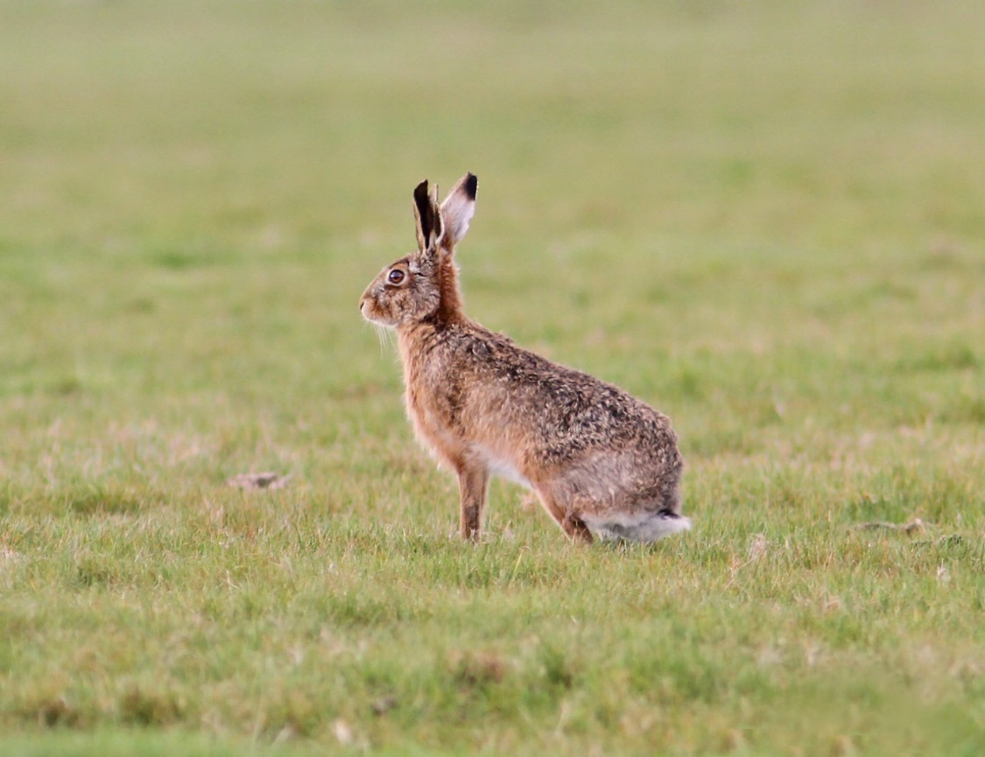

Brown Hare ©Gary Cox

Description
Brown hares are a brown-russet colour, with white underparts. They have slight yellowish flecking to the fur, more so than the grey-brown rabbit. They have longer and larger bodies than rabbits and longer hind legs. The ears are also longer than a rabbit’s, and black-tipped. The tail is black on the upper surface and white underneath.

Distribution
Originating from the open steppes of Central Asia, the Brown hare is found through most of Europe except Iceland, northern Scandinavia and large areas of Ireland. They are present in most of Scotland, with the exception of parts of the North and West, but in upland areas they are replaced by Mountain hares. Their preferred habitat is arable farmland with short growing crops, areas of longer grassland and an abundance of weeds. Woodland and hedgerow edges provide important cover during the day. The UK population is greatest in the Eastern side of the country where arable farming predominates¹.
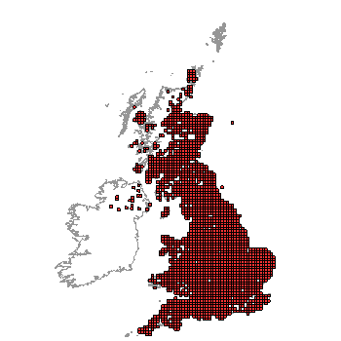
Distribution of Brown Hare in the UK (From NBN Gateway: accessed 3/9/13)

Ecology
Brown hares are at their most visible in early spring when pairs can be seen fighting or 'boxing'. This well-known 'mad March hare' behaviour actually involves unreceptive females fending off amorous males. Hares breed between February and September and if the weather is favourable, a female can rear three or four litters a year, each of two to four young. The young, known as leverets, are born fully furred with their eyes open. The mother leaves them in a form (which is simply a shallow depression in the ground or grasses) close to their birth place and only returns once a day, in the evening, to suckle them briefly. Otherwise they receive no parental care. This strategy helps avoid attracting predators to the young at a stage when they are most vulnerable. Leverets are weaned by four weeks at which point they become fully independent.
Brown Hares are mainly nocturnal, foraging between dusk and dawn. They move over wide areas to graze on young grasses, cereals and herbs. In the winter they will also nibble bark from young trees and bushes. Daytime is spent sheltering in a form.

Threats
A number of factors have been suggested as contributing to the decline in Brown hare, a decline which has also occurred throughout much of Europe.
- Farming intensification
Hares need a constant food supply throughout the year. Farming intensification has led to a decrease in crop diversity, larger fields and the loss of headlands and hedgerows (which are important daytime lying up sites). Increased use of herbicides can cause direct mortality as well as a reduction in their food plants.
- Changes in the pattern of land use
A reduction in spring sown crops mean hares suffer a food shortage at the height of their breeding season. A move from hay to silage production which requires regular cutting, both kills animals directly (from farm machinery) and leaves them more exposed to predators
- Increased predation from foxes
Foxes are important predators of young hares and where foxes are common there are likely to be few hares. In many places, fox numbers have increased dramatically in recent years.
- Shooting, coursing and poaching
The Brown hare is a game animal and is shot in some areas, notably those with high hare densities or where they are causing crop damage. A closed season for shooting hares has recently been introduced in Scotland (The Wildlife and Natural Environment (Scotland) Act 2011) preventing shooting without licence from 1st February to 30th September. In England however, hares still lack this protection. Hare coursing is now illegal in the UK (since Hunting Act 2002) but poaching is still widespread.

Management
The Brown hare is a farmland animal that thrives best on arable farms managed to provide as much variation in habitat types as possible. Farms should be managed to provide:
- A mixture of different arable crops (wheat and beet are particularly beneficial¹), grassland fields, set-aside or other fallow land and small areas of woodland.
- Small fields are better than large, but large cereal fields can be divided using “beetle banks” or mown grass strips to provide local feeding when crops are too tall to be grazed by hares.
- On pastoral farms some fields should be left without livestock in the autumn and winter.
- Where rabbit and fox populations are high consider the need for their control, to reduce competition and predation respectively.

Current work
The Hare Preservation Trust is an organisation run entirely by volunteers. It acts as a focal point for information gathering, raises the profile of the hare to the public, landowners and government. It liaises with other relevant charities and statutory authorities and encourages further research.
The Scottish Wildlife Trust is helping the Brown hare through its Living Landscape projects, by encouraging sympathetic management of farms, wildlife corridors, and other green spaces. It also lobbies government on farming policy.

Wider Context
Over three quarters of the Scottish countryside is farmed, making agricultural environments a really important place for nature. Brown hares, Lapwing, Barn owls and Corncrake are just some of the wildlife associated with farms in Scotland. The recent State of Nature report claimed that of species associated with farmland 60% are declining, 34% of them severely and many of these reductions are linked to shifts in farmland management. Farming methods need to be adapted to encourage and conserve wildlife. Appropriate management of the wider landscape can also be beneficial, for example through the Wildlife Trust’s Living Landscape schemes.

Quick Facts
- When frightened a Hare will lower its tail, whereas Rabbits will raise theirs exposing a white underside.
- While in their forms they digest the previous night's forage by the re-ingestion of soft droppings. Hard droppings, the contents of which have been digested twice, are produced at night.
- A Brown hare can run as fast as 72 kilometres per hour (45 miles per hour). They are the fastest land mammal in the UK, and one of the fastest animals on the planet
- Hares belong to the order Lagomorphs, which includes rabbits. They are unique in having a small pair of secondary incisor teeth in the upper jaw, just behind the main pair. These are never present in rodents and clearly distinguish the two animal groups
- It is widely believed Romans introduced the Brown hare to Britain, as there are no records of this species before Roman times. However, some believe they may have been present in the UK as early as the iron age
- In contrast to rabbits, which have a brown iris, the Brown hare has a golden iris and a black pupil.
- In the past, as Brown hares spread into lowland farming districts they probably displaced the smaller Mountain hares which formerly inhabited low-ground areas, (as they do in Ireland today). In the uplands, Mountain hares have held their own.
- Brown hares can live to 12 years, but few make it to five years and the majority have a life span of just 14 months.

Selected References
www.hare-preservation-trust.co.uk/index.php
www.mammal.org.uk/brown_hare
Mammal Society factsheet on the Brown hare.
2011 Brown Hare. Natural England Species Information Note SIN001 2nd Edition http://publications.naturalengland.org.uk/file/127022 Accessed 24/08/13.
www.gwct.org.uk/research__surveys/species_research/mammals/brown_hare_bap_species/1184.asp Accessed 24/08/13.
Game Conservancy Trust information. Background to the Brown hare, trends in Brown hare numbers and game keeping and hare numbers. Analysis of the cause for population trends in terms of historical changes in farming practices and shooting.
Reynolds, J.C., Stoate, C., Brockless, M.H., Aebischer, N.J. & Tapper, S.C. (2010). The consequences of predator control for brown hares (Lepus europaeus) on UK farmland. European Journal of Wildlife Research, 56: 541-549.
Analyses data from three studies covering the period 1985-2006, in which predator control was undertaken to increase densities of wild game on farmland in England. They found that predator control was a significant determinant of hare population change. Where farmland habitats were also improved for hares, predator control resulted in a large increase in hare numbers. However, if predator control is stopped hares densities fall, even where habitat improvements for hares remain in place.
Langbein, J., Hutchings, M.R., Harris, S., Stoate, C., Tapper, S.C. & Wray, S. (1999). Techniques for assessing the abundance of Brown Hares Lepus europaeus. Mammal Review, 29: 93-116.
Published information on counting hares is reviewed, and the various techniques compared by applying them to a number of sites in southern England.
Three basic approaches are available: counts of inactive hares, counts of active hares and indirect methods. Counts of inactive hares include total clearance, wide belt and line transect counts. Total clearance counts give an absolute figure, but are labour intensive and can only be applied to restricted areas. Wide-belt assessments are difficult to apply in certain habitats and even in open areas tend to produce a substantial over-estimate. Line transect counts are easy to undertake and are not labour intensive but should only be applied to large areas, or data from several small areas combined. Counts based on active hares are more problematical, because it is difficult to determine what proportion of the population is inactive at any one time. Spotlight counts based on variable circular plots are the most accurate but difficult to apply widely, and twilight counts are very subjective in their interpretation, especially when surveying small areas or areas with a large proportion of concealing habitats. Of the indirect methods, dung pellet counts can be valuable in specific areas but are difficult to apply across a range of habitats.
Of the various techniques considered, line transect counts have the greatest potential for a national survey, but need to be stratified so that enough transects are undertaken within each habitat stratum to obtain a reliable mean population estimate for each stratum.
GWCT (2010). Conserving the Brown hare: A practical Guide. Game Conservation Trust, Fordingbridge.
Species background, information on recent population trends and information good management practices and agricultural schemes available to landowners to help hares on their land.

www.hare-preservation-trust.co.uk/index.php Accessed 5/11/13
Natural England Species Information Note SIN001
Tapper, S. and Barnes, R. (1986). The influence of farming practice on the ecology of the brown hare (Lepus europaeus). Journal of Applied Ecology, 23, 39-52.
Reynolds, J.C., Stoate, C., Brockless, M.H., Aebischer, N.J. & Tapper, S.C. (2010). The consequences of predator control for brown hares (Lepus europaeus) on UK farmland. European Journal of Wildlife Research, 56: 541-549.
www.nfus.org.uk/farming-facts Accessed 5/11/13
www.wildlifetrusts.org/publications#state-of-nature Accessed 5/11/13

