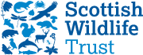

The North of Scotland Group Presents

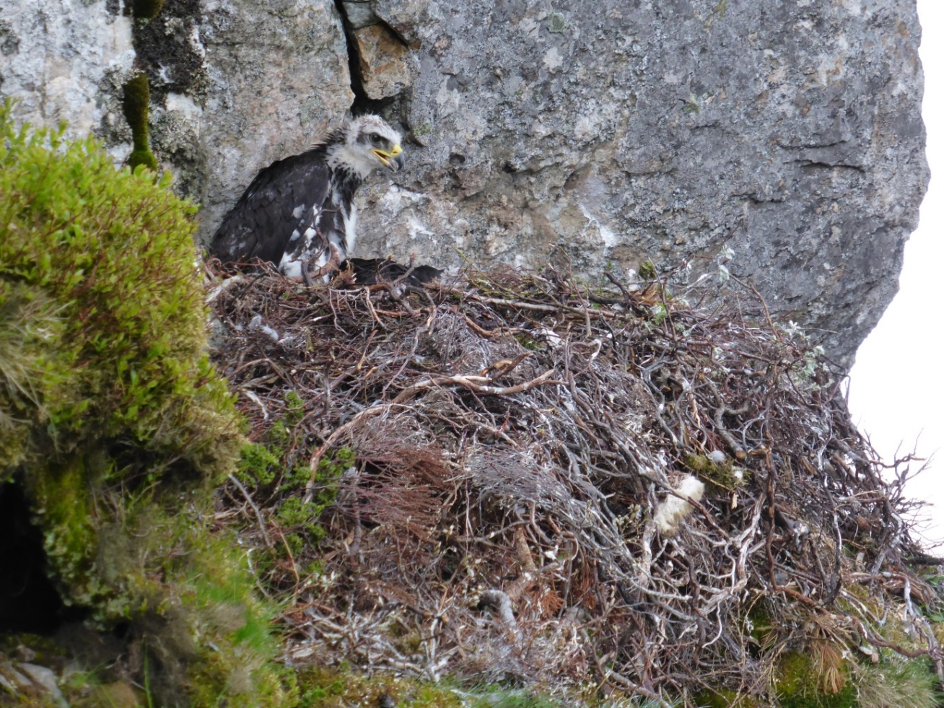

The National Golden Eagle Survey 2015
(how it’s done, how many were there and what it tells us)

Stuart Benn - RSPB

Wednesday 15 February at 7.30 pm
at
The Waterside Hotel – Inverness
All welcome

£4 inc. tea/coffee (suggested donation), Free to students
The Scottish Wildlife Trust is a company limited by guarantee and registered in Scotland (registered no. SC040247). It is also a Scottish registered charity (charity no. SC 005792)

