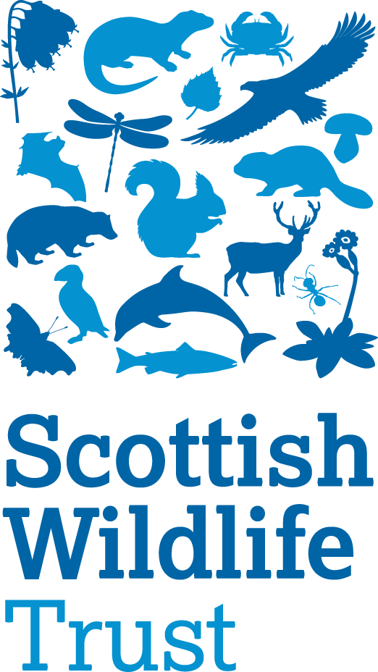

Responding to an application
Responding at Development Plan stage
Local Development Plans are the most common form of development plan and exist for every Council area in Scotland, as well as for the Cairngorms National Park and Loch Lomond and the Trossachs National Park.
Planning authorities will consult on Development Plans for at least six weeks, enabling you to submit comments - you may see the consultation dates advertised in the local press. It may seem like a complicated process, but don’t be daunted - the Planning Authority should be able to help you get involved.
The typical stage of the process for public consultation is known as the Main Issues Report (MIR) which focusses on major changes since the last plan was published and the proposals of the Planning Authority for future development. All relevant documents will be on the Planning Authority website, with hard copies available at certain locations (e.g. Council offices or libraries). Contact the Planning Authority / Council for further details of where you can access the documents.
Responding at the early stages of the planning process, particularly at the Local Plan stage, is the most effective way to ensure important sites are protected, and that biodiversity is given appropriate consideration. It is much better to highlight potential issues, or areas where biodiversity / ecological connectivity can be enhanced, at this early stage than when a planning application is submitted. Local knowledge can be of huge importance here. Remember that the Development Plan, and development in general, can enhance the environment. A report produced by the Wildlife Trusts and RSPB, while focussed on England, may be a useful source of information and can be viewed here.
Because the process and rules may differ between Planning Authorities, always check with the Planning Authority and follow any guidance they have on how to be involved.
Make your points clearly, politely and concisely, and provide reasons and/or evidence for them. Provide a reference to any data or other evidence that you use, so that it can be checked if necessary.
Stick to the facts – if there is uncertainty, this may mean further research or survey work is needed. You can call for this. For example, if you believe that an area of woodland is ancient, but it is marked on the map as newly planted.
Responding at planning application stage
Planning applications may be submitted first as Planning Permission in Principle (PPP) before an application for Full Permission. When looking at applications listed on Planning Authority websites, the reference number for the application may end in PPP or FUL to make this apparent, but it will also be stated in the application itself. It is good to submit comments at the PPP stage if you are aware of the application at this point. This is because, for example, if the application would impact on an important site for biodiversity and PPP is granted before you comment, comments at the later stages should be about details of the design rather than the overall principle of the development taking place. Look at Local Development Plan on the planning authority website – this will typically include interactive maps allowing you to see whether the site of the proposed development is allocated for development or not. If not, this map should also enable you to see why not – e.g. designated as nature reserve or recreation space.
Environmental Impact Assessment
Environmental Impact Assessment (EIA) is a legal requirement for certain types of development. It aims to ensure that environmental effects of a proposal are identified and considered before a decision on the proposal is made. The document that is produced by an EIA is called an Environmental Statement. If you are studying this for biodiversity impacts, the most relevant chapters will be Ecology, Ornithology, and sometimes Hydrology / Peat Management (e.g. to view impacts on blanket bog / deep peat).
Some developments automatically require an EIA. If the proposal is for a development that may or may not require EIA, the first stage of the process is called Screening – this is where the planning authority decides whether a full EIA is required.
The next stage of the process is called Scoping – this is where the applicant consults widely on the plans, enabling individuals and organisations to comment on them. This is a good time to get involved in the process, because making any changes to the plans is easier at this stage than when a full application has been submitted.
After Scoping, the applicant will prepare an Environmental Statement. This is a large, complex document often produced by numerous specialist consultants from different disciplines and different organisations. This document is submitted for consideration with the planning application.
Section 36 applications
Proposed power generation projects (e.g. onshore wind farms) with a capacity in excess of 50 megawatts require the consent of Scottish Ministers under Section 36 of the Electricity Act 1989. For these applications, you will typically submit your comments directly to the Scottish Government’s Energy Consents Unit, but you may also write to the relevant Local Authority. Follow the instructions given on the application advert / consultation invitation as appropriate.
Tips for when responding to planning applications:
- Include your name and address, and any other contact details if you wish.
- You should make it clear early in your response whether you object, support or simply have comments to make about the proposal.
- Clearly state your reasons, and any relevant evidence – provide references for this.
- Keep your response as short as possible – if necessary, you could add any relevant documents to an appendix.
- Stick to facts, not opinions. It helps to ensure that points you make will constitute ‘material considerations’ which are matters that may be considered by the planning authority when assessing an application. A useful guide to material considerations has been produced by Planning Aid for Scotland and can be accessed here.
A few considerations when assessing a proposal to ensure that biodiversity has been considered:
- Are there any high value habitats that have been retained where possible (e.g. mature trees, semi-natural grassland, ponds, hedgerows)?
- Does any landscaping/planting use native species, and create any semi-natural habitats that are of value (e.g. SuDS ponds with native aquatic plants, wildflower meadows, native trees)?
- Are there any simple changes to the design that could reduce the impact on wildlife or increase the value of the development for wildlife?
- Planning conditions – you can call for these e.g. habitat enhancements on a solar farm – could call for native hedgerows to be planted instead of/ in addition to fencing. Could call for grassland to be converted from improved grassland to a semi-natural vegetation type such as a meadow which would benefit biodiversity.
Key documents are:
- The National Planning Framework – currently in its third edition (NPF3) which sets the context for development in Scotland and the Government’s priorities for development over the next 20-30 years. This document must be taken into account when preparing development plans and when making development management decisions (i.e. decisions on planning applications). NPF3 can be downloaded from the Scottish Government website here.
- Scottish Planning Policy (SPP) is a replacement to numerous former documents, and outlines the Scottish Government’s definition of sustainable development, the purpose of the planning system and policies about specific matters (e.g. ancient woodland). The document can be downloaded from the Scottish Government website here.
- Development Plans - these include Local Development Plans and, for city regions, Strategic Development Plans. These documents outline where certain types of development are likely to be permitted (and where this is unlikely) and provide an overall vision for an area in terms of future development. They can be found on Local Authority websites e.g. the Council or National Park Authority.
A proposal you are concerned about may have an impact on designated sites, or their ‘qualifying features’ (i.e. the reasons they were designated).
The main forms of international designation are Special Protection Areas (SPAs) and Special Areas of Conservation (SACs), sometimes collectively known as Natura sites.
The main forms of nationally protected sites are National Nature Reserves (NNRs) and Sites of Special Scientific Interest (SSSIs).
If a proposal may have impacts on such sites, it is likely that Scottish Natural Heritage (SNH) will submit comments on the application. If SNH has responded, their response should be available on the Planning Authority website. If you want to discuss any matters with SNH, you may wish to contact the Area Officer for the region of the proposed development. Contact details for SNH Area Officers can be found here.
You can find details of SSSIs, NNRs, SPAs and SACs on the SNH SiteLink website. This will give maps of the sites, and their qualifying features. The SNH SiteLink website can be accessed here.
Locally designated sites are typically selected by local authorities (e.g. Councils). They include Local Nature Reserves (LNRs) and Local Nature Conservation Sites (LNCS), sometimes called Local Wildlife Sites, Local Biodiversity Sites or Sites of Importance for Nature Conservation (SINCs). Not all Councils designate such sites, but if they do, a list should be available on the Council, or you can contact the Council’s Biodiversity Officer.
If a development is not in a designated site, it may still have significant biodiversity impacts which you may wish to comment on.
Relevant legislation:
Scottish Biodiversity Strategy
The UK Biodiversity Action Plan (UK BAP) ran until 2012. However, individual local authorities have Local Biodiversity Action Plans (LBAPs) which outline species and habitats that are priorities for action – it is useful to study these to see if any such habitats / species will be negatively impacted by the proposals. They should be on the local authority website or can be found using a search engine – you may wish to check with the local authority to ensure you have the most recent version. In Scotland, the UKBAP was replaced with the 2020 Challenge for Scotland’s Biodiversity, which can be downloaded here.
The Scottish Biodiversity List which details various conservation designations, priority habitats and species can found at here.
Wildlife & Countryside Act 1981
In Scotland, the legal framework has become quite complicated, but broadly speaking, changes to the Act have been made through the Nature Conservation (Scotland) Act 2004 and the Wildlife and Natural Environment (Scotland) Act 2011. This legislation outlines a large number of offences regarding killing/taking wild birds, plants and animals and provides the legal setting for Sites of Special Scientific Interest (SSSIs). In some situations, staying within the law would simply require any removal of nesting habitat to be undertaken outside the bird nesting season. In other cases, the situation can be much more complicated. If you believe that an application is not meeting the Wildlife & Countryside Act (and associated legislation), you may wish to speak to the Local Authority Biodiversity Officer/Ecologist, or the SNH Area Officer.
Habitats Directive
This legislation provides the legal setting for SPAs and SACs. It also lists habitat types and identifies priority habitats such as active raised bogs/blanket bogs. Details of priority habitats are available here.
European Protected Species (EPS)
These are plant and animal species afforded protection under the Habitats Regulations 1994 (as amended in Scotland). Certain actions that would otherwise constitute an offence can be licensed by SNH under strict conditions:
- The licence relates to one of the reasons listed in Regulation 44 (2) of the Habitats Regulations 1994 (e.g. protection of public health, scientific or educational purposes.
- There must be no satisfactory alternative.
- The proposed action must not be detrimental to the maintenance of the species at ‘favourable conservation status’.
Any Environmental Statement or ecological report should consider potential impacts on EPS. Further details on EPS, including species occurring in Scotland and licensing, can be found here.
Invertebrates
Invertebrates are frequently given very little consideration in planning decisions, but are a hugely important part of our natural heritage. The charity Buglife has created guidance for assessing the impact of proposals on invertebrates which can be found at the here. Note that development can offer opportunities to invertebrates as well as threats, e.g. if wildflower meadows or green roofs are part of a development.
Ecological enhancement
There may be some planning applications that you do not wish to object to but you see significant potential for ecological enhancement. A primary function of the planning system should be to ‘further the conservation of biodiversity’ as stated in section 1 of the Nature Conservation (Scotland) Act 2004 – this is often referred to as the Biodiversity Duty.
You may wish to comment on a planning application in order to call for the biodiversity of the site to be enhanced by the development. For example, a solar farm in a pasture comprising improved grassland could be screened by native hedging instead of solely by metal fencing. Or the grassland could be converted to a species-rich meadow, benefitting pollinating insects. Another situation may be a development close to an area of woodland, where a buffer zone of vegetation could prevent excessive disturbance to the woodland. Or you could call for swift nest boxes to be installed on the eaves of a housing development if construction would lead to loss of existing nest sites. It is useful to think about connectivity of species and habitats when suggesting such enhancements – could the green space (often called green infrastructure) in a development be used to link habitats or populations, e.g. by connecting fragments of woodland with new hedgerows, or creating ponds that reduce the distance between existing ponds in the local area? If an application would be acceptable to you if such enhancements were made, you can call for these to be made subject to a Planning Condition, meaning that if planning permission is granted, they must be done.

Scottish Wildlife Trust policies that you may wish to read and refer to are:
- Policy Futures 1: Living Landscapes – towards ecosystem-based conservation in Scotland
- Natural Connections: A vision for re-building Scotland’s wildlife
- Policy on the Planning System
- Policy on Energy and Nature Conservation
- Policy on Local Biodiversity Sites
- Policy on Lowland Peat and Horticulture
- Policy on Natural Greenspaces in Towns and Cities
- Guidance for planning authorities on implementing the Biodiversity Duty
All of the above documents can be found on the Policies and Related Documents page of our website.
Useful links to species / habitat-specific organisations:
http://www.bats.org.uk/pages/planning.html
https://www.buglife.org.uk/planning
http://butterfly-conservation.org/files/planning-guidance.pdf
https://www.rspb.org.uk/joinandhelp/campaignwithus/takeaction/scotland/
https://www.woodlandtrust.org.uk/get-involved/campaign-with-us/in-your-community/write-an-objection/

