**Scottish Wildlife Trust Glasgow Group  
Spring events 2025**

All welcome! You don’t have to be a member to come to our walks and talks**.**All talks are at Hyndland School, Clarence Drive G12 9RQ from 7.30 – 9.30pm.

**Walk around Hogganfield Loch**Saturday 15 February 2025 from 10.30 – 13.00 approximately.

Meet in the car park beside the loch (not the new car park).

Join us on a walk to observe winter wildlife at this nature hotspot, which was designated a Local Nature Reserve in 1998. The reserve includes herb-rich grassland, hedges, marshy ponds, scrub, woodland and the large loch itself. Hogganfield’s accumulated bird list includes over 140 species and on most visits, recorders note 25 to 30 species at any time of the year. The loch is particularly favoured by waterfowl in winter.

By car, leave the M8 at junction 12 and take the A80 towards Cumbernauld. The reserve car park is on the right after the Glasgow Life’s Lethamhill golf course.

The number 38 bus route connects West George Street in Glasgow with the Cumbernauld Road. There is also a train service to Robroyston Station which is 15 – 20 minutes’ walk from the Loch.

**Talk: Marine conservation in Scotland and my journey as a Marine Mammal Specialist**

Wednesday 26 February 2025   
Speaker: Ashleigh Kitchiner - Marine Mammal Specialist

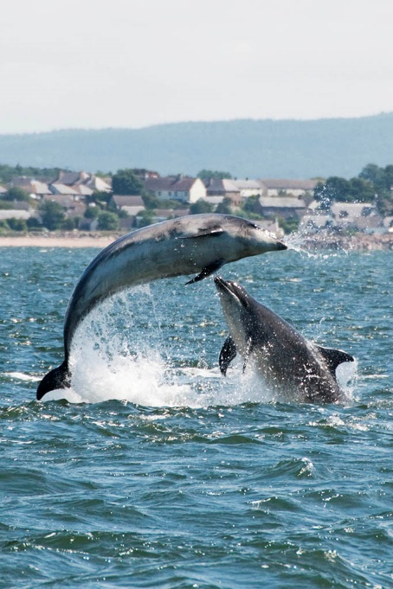

In this talk, I will explore Scotland’s diverse marine ecosystems and the importance of conservation efforts to protect its rich biodiversity, including seals, dolphins, and whales. I will discuss the challenges posed by climate change, pollution, and human activities, and how science plays a critical role in addressing these issues.

Drawing from my career as a marine mammal specialist, I’ll share experiences in studying and protecting these creatures, highlighting the skills required and the impact of my work on broader conservation efforts.

Whether you're passionate about marine life or curious about careers in conservation, this talk will offer valuable insights into the world of marine mammal conservation in Scotland.

Photograph by David Palmar www.photoscot.co.uk

**Talk: Some of Glasgow’s Remarkable Trees**Wednesday 26 March 2025 with Bob Gray

Glasgow possesses an impressive portfolio of about 100 parks containing many thousands of trees, both conifers and hardwoods, both native and introduced. Many are of considerable interest, particularly owing to their rarity in this country. Some are even uncommon in their native habitat.

Owing to the diversity of trees found here the city has been described as a “super arboretum”. This talk aims to describe some of these trees, their location, their appearance and what makes them special

**Walk around Gleniffer Braes and Fereneze Braes**Saturday 29 March 2025   
Further details to follow.