The North of Scotland Group Present

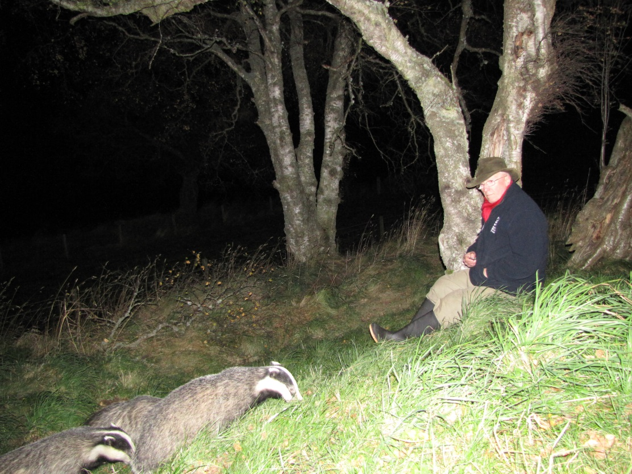
Badgers up close and personal
by
Allan Bantick

Wed 6 Nov at 7.30 pm
at
The Glen Mhor Waterside Hotel – Inverness

All welcome
£4 members, £5 non-members inc. tea/coffee (suggested donation to meet costs)

Free to students

