**Scottish Wildlife Trust Glasgow Group**

**Events February to June 2025**

All welcome! You don’t have to be a member to come to our walks and talks**.** All talks are at Hyndland School, Clarence Drive G12 9RQ from 7.30 – 9.30pm.

**Talk:**

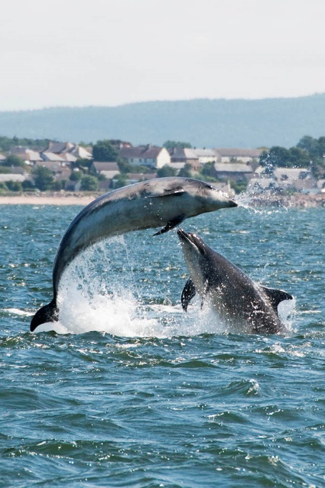**Marine conservation in Scotland and my journey as a Marine Mammal Specialist**Wednesday 26 February 2025   
Speaker: Ashleigh Kitchiner - Marine Mammal Specialist

In this talk, I will explore Scotland’s diverse marine ecosystems and the importance of conservation efforts to protect its rich biodiversity, including seals, dolphins, and whales. I will discuss the challenges posed by climate change, pollution, and human activities, and how science plays a critical role in addressing these issues.

Drawing from my career as a marine mammal specialist, I’ll share experiences in studying and protecting these creatures, highlighting the skills required and the impact of my work on broader conservation efforts.

Photograph by David Palmar www.photoscot.co.uk

Whether you're passionate about marine life or curious about careers in conservation, this talk will offer valuable insights into the world of marine mammal conservation in Scotland.

**Talk: Some of Glasgow’s Remarkable Trees**Wednesday 26 March 2025 with Bob Gray

Glasgow possesses an impressive portfolio of about 100 parks containing many thousands of trees, both conifers and hardwoods, both native and introduced. Many are of considerable interest, particularly owing to their rarity in this country. Some are even uncommon in their native habitat.

Owing to the diversity of trees found here the city has been described as a “super arboretum”. This talk aims to describe some of these trees, their location, their appearance and what makes them special

**Walk around Gleniffer Braes and Fereneze Braes**Saturday 29 March 2025

Meet at Robertson car park Grid Reference NS455606, Postcode PA2 8UQ   
Time: 11:00 to 14:00 approximately

Join us on a circular walk in the Gleniffer Braes Country Park. Gleniffer Braes are a short range of hills and park area to the south of Paisley, The wildlife of Gleniffer Braes Country Park is typical of woodland and moorland. Birds regularly seen include skylark, meadow pipit, kestrel and sparrowhawk.

The tit families feed in the treetops along with goldcrests and chaffinches. Treecreepers can occasionally be seen in Glen Park where the mature trees provide a constantly changing pattern of colour as the seasons change. Colourful wild flowers include Heath-spotted orchid, wild pansy and Tormentil on the grasslands, and Red Campion and Herb Robert in the woodlands.

Suggested donation: £2 per person   
Contact: Mike Turner [mgturner@gmail.com](mailto:mgturner@gmail.com)

**Exploring the RSPB Nature Reserve at Loch Lomond**  
Saturday 26 April 2025

Now spring is here, we will be visiting the RSPB’s reserve on the shores of Loch Lomond. The site includes mixed woodland, marsh, loch shore, hedges and ponds. There is a car park and now toilets at the reserve entrance.

**A tour of Ardmore Point**

Saturday 31 May 2025

Ardmore point, jutting into the Clyde shore west of Cardross, is a well-known location for waders and waterbirds. There is a good, fairly level footpath around the headland. Inshore, there is woodland and a dense under-storey of native and introduced shrubs and flowers. In May, we should hear plenty of bird song and, weather permitting, have a lovely walk along the Clyde shore.

There is on-street parking nearby, Cardross Station is the nearest rail link.

**Glen Moss SWT Reserve (Kilmacolm)**Sunday 22 June 2025  
Further details to follow.

c:\users\user\documents\swt\website\next season events\walks and talks january to june 2025 v2.docx