E-version of Newsletter No 12 October 2021


Scottish Wildlife Trust, Callander Local Group

including villages from Doune to Lochearnhead

Hello, welcome to a later than usual ‘annual’ newsletter. This is our second newsletter this year after our additional one last winter in lieu of having a winter talks programme. A longer electronic version of this newsletter is available on our page on the SWT website https://scottishwildlifetrust.org.uk/local-group/callander/. As always, the content reflects the interests of those who sent us information and many thanks to them. Please let us have your feedback.

Sadly, we have been unable to organise any live talks due to the Covid safe distancing requirements. The Committee did discuss options for outdoor events but for various reasons they became impractical. We are continually reviewing the options for restarting indoor talks and had planned to start again in October, probably returning to St Andrew’s Church Hall. However, with increasing Covid cases, we decided not to set a start date yet. We will continue to keep an eye on the situation and hope that we will be able to hold some talks this winter. Other groups are arranging Zoom talks with mixed response but we have not pursued this route, other than Tom Bowser’s talk on Argaty back in January which was technically supported by SWT. We would appreciate your views on how best to proceed with talks: would log in to talks on Zoom? What circumstances / arrangements would you need to see in place before you would come to face-to-face meetings?

We did manage to hold the usual fund-raiser on 14 August in Ancaster Square. Nick Wright manned an SWT information stall, generating a large amount of interest and demonstrating a good breadth of knowledge in children. Despite a quiet day and not including the usual ‘Bottle Stall’ (asking for donations didn’t seem appropriate in the current financial climate), we did raise just under £500 from plant sales.

Mammals News
Beavers are still present in the Balquhidder Station area and felled trees can now be seen from the main road. There is still a low level of beaver activity around Callander and the species is now widespread in our area from Stirling to Killin (see report below) and are spreading west towards Crianlarich. Otters continue to be seen by our members throughout the area. An unusual sighting in April was one on the A84 near Drumvaich where the River Teith passes close to the road. The animal, probably a youngster held up a couple of cars as it ran across the road and up the bank away from the river. This all in broad daylight at 11am! A hedgehog, an increasingly rare animal was seen in Strathyre on 22nd April and stoat and weasel were both seen around the village in the same month.

Red Squirrels: The latest newsletter from Saving Scotland’s Red Squirrels included an interesting article on urban red squirrels. As urban areas expand they become increasingly important and are proving to be suitable habitats for red squirrels due to ‘anthropomorphic food sources’ i.e. bird feeders and squirrel boxes full of peanuts! https://mailchi.mp/cfaf41922a76/e2gtlfosba-287404?e=7d39f287e5

Please continue to report all of your sightings of both squirrels to scottishsquirrels.org.uk for inclusion in a national database that directly influences conservation action.

Notable Bird news and sightings, late winter to autumn 2021

Movements of birds in the late winter period included 15 golden plover which flew south over Leny Meadows on 3rd February. The wintering blackcap seen in a private garden in Callander and reported in the last newsletter remained through the winter and into late March at least. The same garden was also visited by a brambling in March, a species that appeared to be more common in central Scotland last winter. April was unusually cold and dry and May was often cold and wet. This appeared to disrupt our migrant birds a bit. Cuckoos seemed to have arrived early with reports of calling birds from 20 April. The poor weather seems to have wiped out a sand martin colony on the River Balvaig although the birds later returned to the colony.

Three pairs of hen harriers were monitored in the National Park area with two pairs successfully breeding and rearing three young each. There were also sightings of male hen harriers at Braeleny and the Killin area in April as well as two white-tailed eagles also near Killin. White-tailed eagles were seen at Lochs Earn, Tay and Lomond later in the summer and at Balquhidder in early September. Golden eagles had a mixed year with at least three nests failing, but one pair reared two young. Goshawk appear to be doing well in central Scotland with several new pairs located. One of these was found in our area in April in an area of mature larch forest. The pair were seen skirmishing with local buzzards and red kites, the latter also at a new breeding site which produced at least one chick. Another goshawk nest was found near Argaty. One of the first osprey sightings of the year was at Drymen on 30th March. Ospreys also returned to Argaty as hoped and had laid eggs there by 4th April, a camera at the nest establishing the laying date. There was nationwide coverage of the senseless destruction of an osprey nest in Wales. The local link is that one of the pair at the nest concerned was a bird ringed at Lake of Menteith. Ospreys were also seen at Glen Finglas reservoir. Kestrels have been reported from Glen Finglas, Glen Ample and Glen Kendrum this spring, so the species is still widespread in our area despite declines nationally.

Smaller bird breeding records included nuthatch nesting just north of Strathyre at a new site and a pair of house sparrows taking up residence at a new nest box in farm buildings at the same location. A spotted flycatcher, an increasing scarce bird was observed in a Callander garden the first after an absence of many years. A dead siskin was found at Balquidher Station on 7th May, its ring revealing it had been ringed at Peebles in 2019. A pair of Stonechats were in Glen Ample on 20th March. Summer visitors started to leave in August and September as usual. Late staying/passing migrants included a wheatear at Strathyre on 30th September and three swallows at Argaty on 1st October. However, one of our members observed that swallows left unusually early from the Callander area this year and along with swifts and martins, were scarcer this year possibly due to the cold spring.

A great northern diver was seen on Loch Lubnaig on 7th July, possibly the same bird that was seen on Loch Tay the same day and throughout the month. Finally, black grouse appear to be doing well in the Callander area with 19 birds seen at two leks in April and also 11 at Glen Finglas. Seven counted on the Braes of Doune was the highest number recorded there in many years.

Records from SWT Committee & members, Central Scotland Raptor Study Group & LL&TNP staff.

Barn owls in Central Scotland: 2021 has been a disappointing year for owls. Stirlingshire and West Dunbartonshire experienced a widespread collapse in the field vole population, resulting in a huge decline in barn owls and tawny owls attempting to breed. Some tried unsuccessfully and other adults seemed to simply roost in the nest boxes. The Falkirk area did particularly well and Clackmannan still recorded the same number of breeding pairs but productivity was lower.
However the good news is that the adults from previous seasons are still predominantly there waiting until the vole population starts to recover, so they should be ready to kick start next season. The owls have had good weather conditions throughout the summer so, provided we do not experience extreme winter weather, numbers should recover in 2022.
I am retiring from monitoring & ringing owls after 31 years, and can honestly say that barn owl numbers have increased dramatically over this period. Mike Steward

Amphibians: the Callander Toad Patrol ran from 15 February to 5 April 2021. Frogs appeared from 19 February and toads from 8 March but, apart from 3 good nights in mid-March, cold weather made it a very slow process. The total of 53 toads, 35 frogs and 4 newts saved is slightly up on 2020 (40, 23, 1) but reflect longer trends of reducing numbers. We are still waiting for the Froglife summary report to see trends in other areas. As usual the river Teith flooded the
Meadows several times so the new Froglife ponds merged into the fast-flowing river. It is not known for sure but there are concerns that animals and/or spawn may be washed downriver, further reducing local numbers. Coilhallan Woods regularly has large amounts of frogspawn although that laid in ditches may not survive dry spells. Maybe that is a site to be developed. The Callander’s Landscape project did include 2 small ponds there and discussions are underway to make sure these happen.

Wildlife at the Head of Loch Tay - Spring and Summer 2021
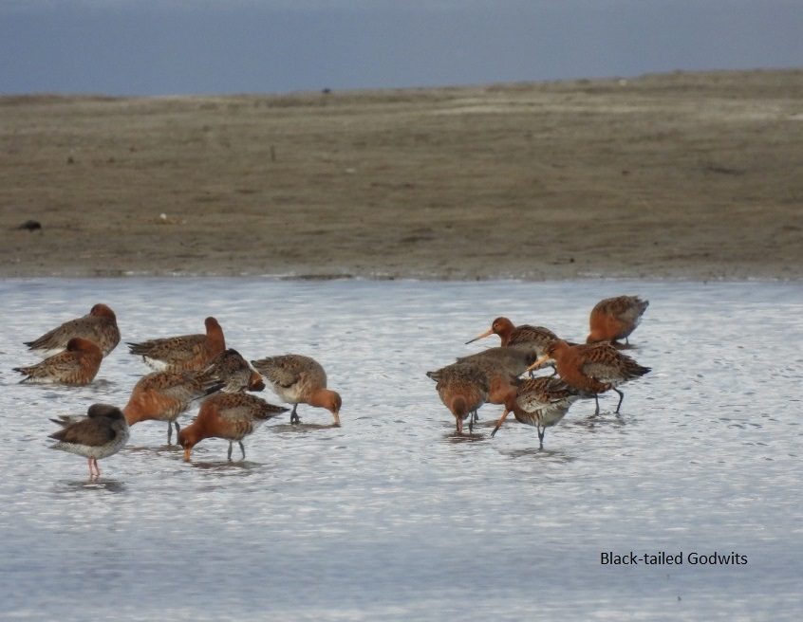
One of the highlights of Spring 2021 on Loch Tay was the flock of 94 Black-tailed Godwits in resplendent summer plumage, on April 20th. A few were also seen passing through during July (11th, 12th, 13th and 29th). Also on April 20th were 36 Redshank.
For the fourth year in a row, Little Ringed Plover have been recorded at the head of the loch with one seen on the sand bank from April 26th to May 5th. A Wood Sandpiper was feeding on the mud where the river enters the loch on May 8th and on following day there were 18 Dunlin and 2 Whimbrel on the sand bank. Eight Ringed Plovers were present on the sand bank on August 20th.
An adult Great Northern Diver was a surprising sight on July 4th and it was then seen regularly through to July 13th. Black-throated Divers were occasionally seen throughout the Spring and Summer with six adults present on August 15th. Three Shelduck were on the loch on the 12th of May, and a male Common Scoter was present on July 10th.
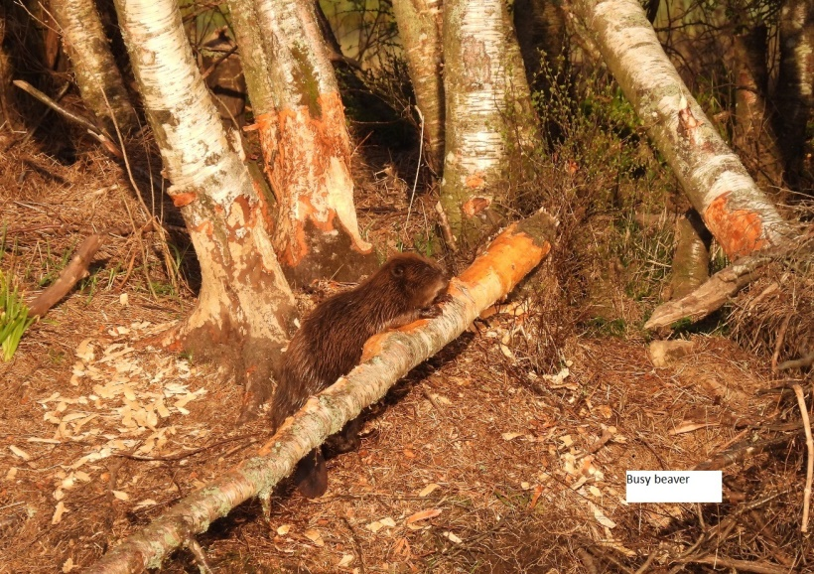
2021 was an exceptional year for passage of White Wagtails with birds present on the sand bank from the beginning of April through to the beginning of June with a maximum of 14 on May 5th. On the morning of September 25th a Hen Harrier (ringtail) was quartering the Kinnell marshes on and there was a single adult Whooper Swan on the loch.

Beaver presence continues to increase with up to seven adult beavers seen at the head of the loch during spring with at least four kits present from June onwards. A female otter with two cubs were also occasionally seen on or close to the island.
John Holland

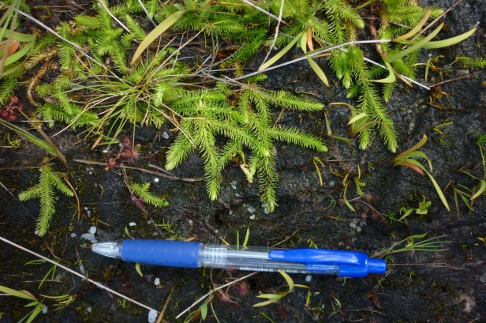
Plants: The rare Marsh Clubmoss (Lycopodiella inundata) – (Endangered and Nationally Scarce) was initially found by accident in 2016 on the north shore of Loch Katrine near Strone. There was concern that other vegetation might swamp this small, low growing plant but several populations have been rediscovered recently surviving in an old, wet track which is encouraging that it might continue to survive for a few years yet.

Over the last eighteen months, local volunteers have been improving a small stretch of path by Loch Ard which is used by residents to access Lochard Forest tracks. It was boggy, and over-run with bamboo, cotoneaster, dogwood and raspberries. Their removal has seen an increase in native flora from 70 species in 2020 to 95 in 2021, including the Locally Scarce Gypsywort (Lycopus europaeus). Vegetation has been cut for winter raked onto bare areas with regular bamboo patrols to cut any shoots that dare to appear!!! Jane Jones

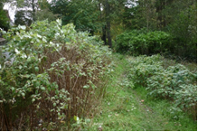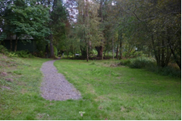

Miscellaneous

Callander’s Landscape: as mentioned previously, our group is representing SWT on this Heritage Lottery-funded project. A survey was carried out in September to check usage of the bat boxes and various bird nest boxes in Little Leny Meadows, purchased via our Stirling Council Community Pride award. Encouragingly for the first year, the more sheltered south meadow had 6 of 7 bat boxes used by pipistrelles and nests in 8 of 17 bird boxes. The two special boxes for tree creepers both attracted wood mice, one still in residence as the box was opened, surprising both parties!

Callander residents will be aware of the new Rural Stirling housing at Claish Farm on the A81. The site development includes surrounding areas of wildflowers, unchanged wet areas and native trees around the houses. Our request for a ‘hedgehog highway’ across gardens by cutting holes in the bottom of fences has been adopted. Although no bird and bat boxes will be installed on the houses, a donation of £750 has been made for use elsewhere in the community for wildlife. Several options are being investigated.

As always we need your feedback to help decide how to proceed in future, preferably more than the couple who usually make helpful comments. Views on the content and format of the newsletter; suggestions for improvements or just whether you think it is ‘of interest’ or ‘not worth the effort’. Also any suggestions for future talks and outings when we are able to meet again in person will allow us to tailor events to members’ interests.

Kevin Duffy (Chairman) Tel: 0776 6725392 E: kjduffy2012@hotmail.co.uk

Lesley Hawkins (Secretary) Tel: 01877 339080 E: mlhawkins@tiscali.co.uk

