Newsletter No 10 summer 2020


Scottish Wildlife Trust, Callander Local Group

including villages from Doune to Lochearnhead

We hope you are all keeping well and coping with the necessary constraints to keep safe from the pandemic. As many have commented, the wildlife seems to be enjoying the reduced disturbance and cleaner air and many have been encouraged to spend more time watching our local species!
Most spring surveys were cancelled due to Covid-19 lockdown, including BTO, red squirrels, pine martens and RSPB’s black grouse. However, reported local sightings are encouraging.

2019’s successful fund-raising stalls again enabled us to make generous donations; £300 each to SWT, BTO’s Short-eared Owl Project and Taiga Bean Geese satellite tracking. Unfortunately, we had to spend £100 on replacing one of the two trail cameras which were stolen in 2019. Ancaster Square has been booked for 15 August for this year’s bottle stall and plant sales along with SWT and SSRS information stalls. At the moment we can’t be sure whether this will go ahead so please check the website for the latest information but if it does we will be asking for your help!
The 11 July & 23 August planned dates for continuing our battle with Himalayan Balsam now seem unlikely to be group events. Please feel free to remove any you come across, it is harmless and just needs to be uprooted and left suspended to dry. Every plant removed will prevent hundreds more!
For updates on all events please check out the Local Group’s page on the SWT website https://scottishwildlifetrust.org.uk/local-group/callander/.

2020 was our third annual toad patrol with 14 volunteers patrolling along the A84 in Callander over 6 weeks from mid-February. Once again numbers were down with only 64 live animals cf 138 in 2019 The prolonged cold spell could be responsible since they generally don’t move at less than 6C but Froglife’s summary report is delayed so we don’t know if this is a local or general trend. Only 10 miles away, Argaty Red Kites recorded 375, mainly frogs, in one early March night! Do our very bright LED street lights have an impact? Was it so wet that suitable ponds formed in the woods?

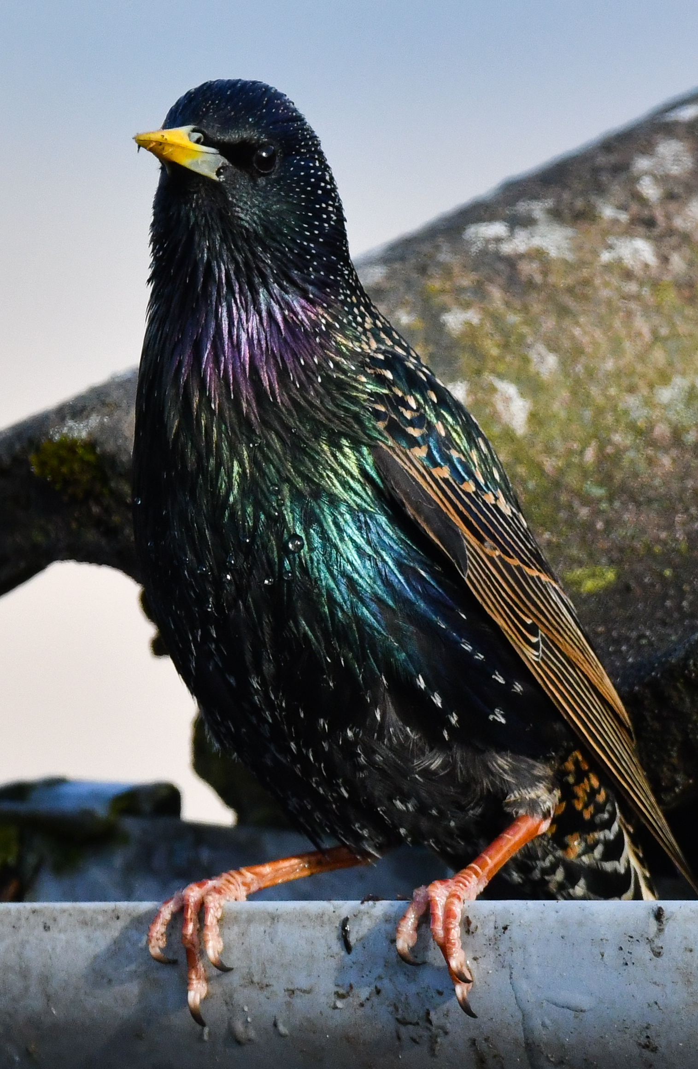
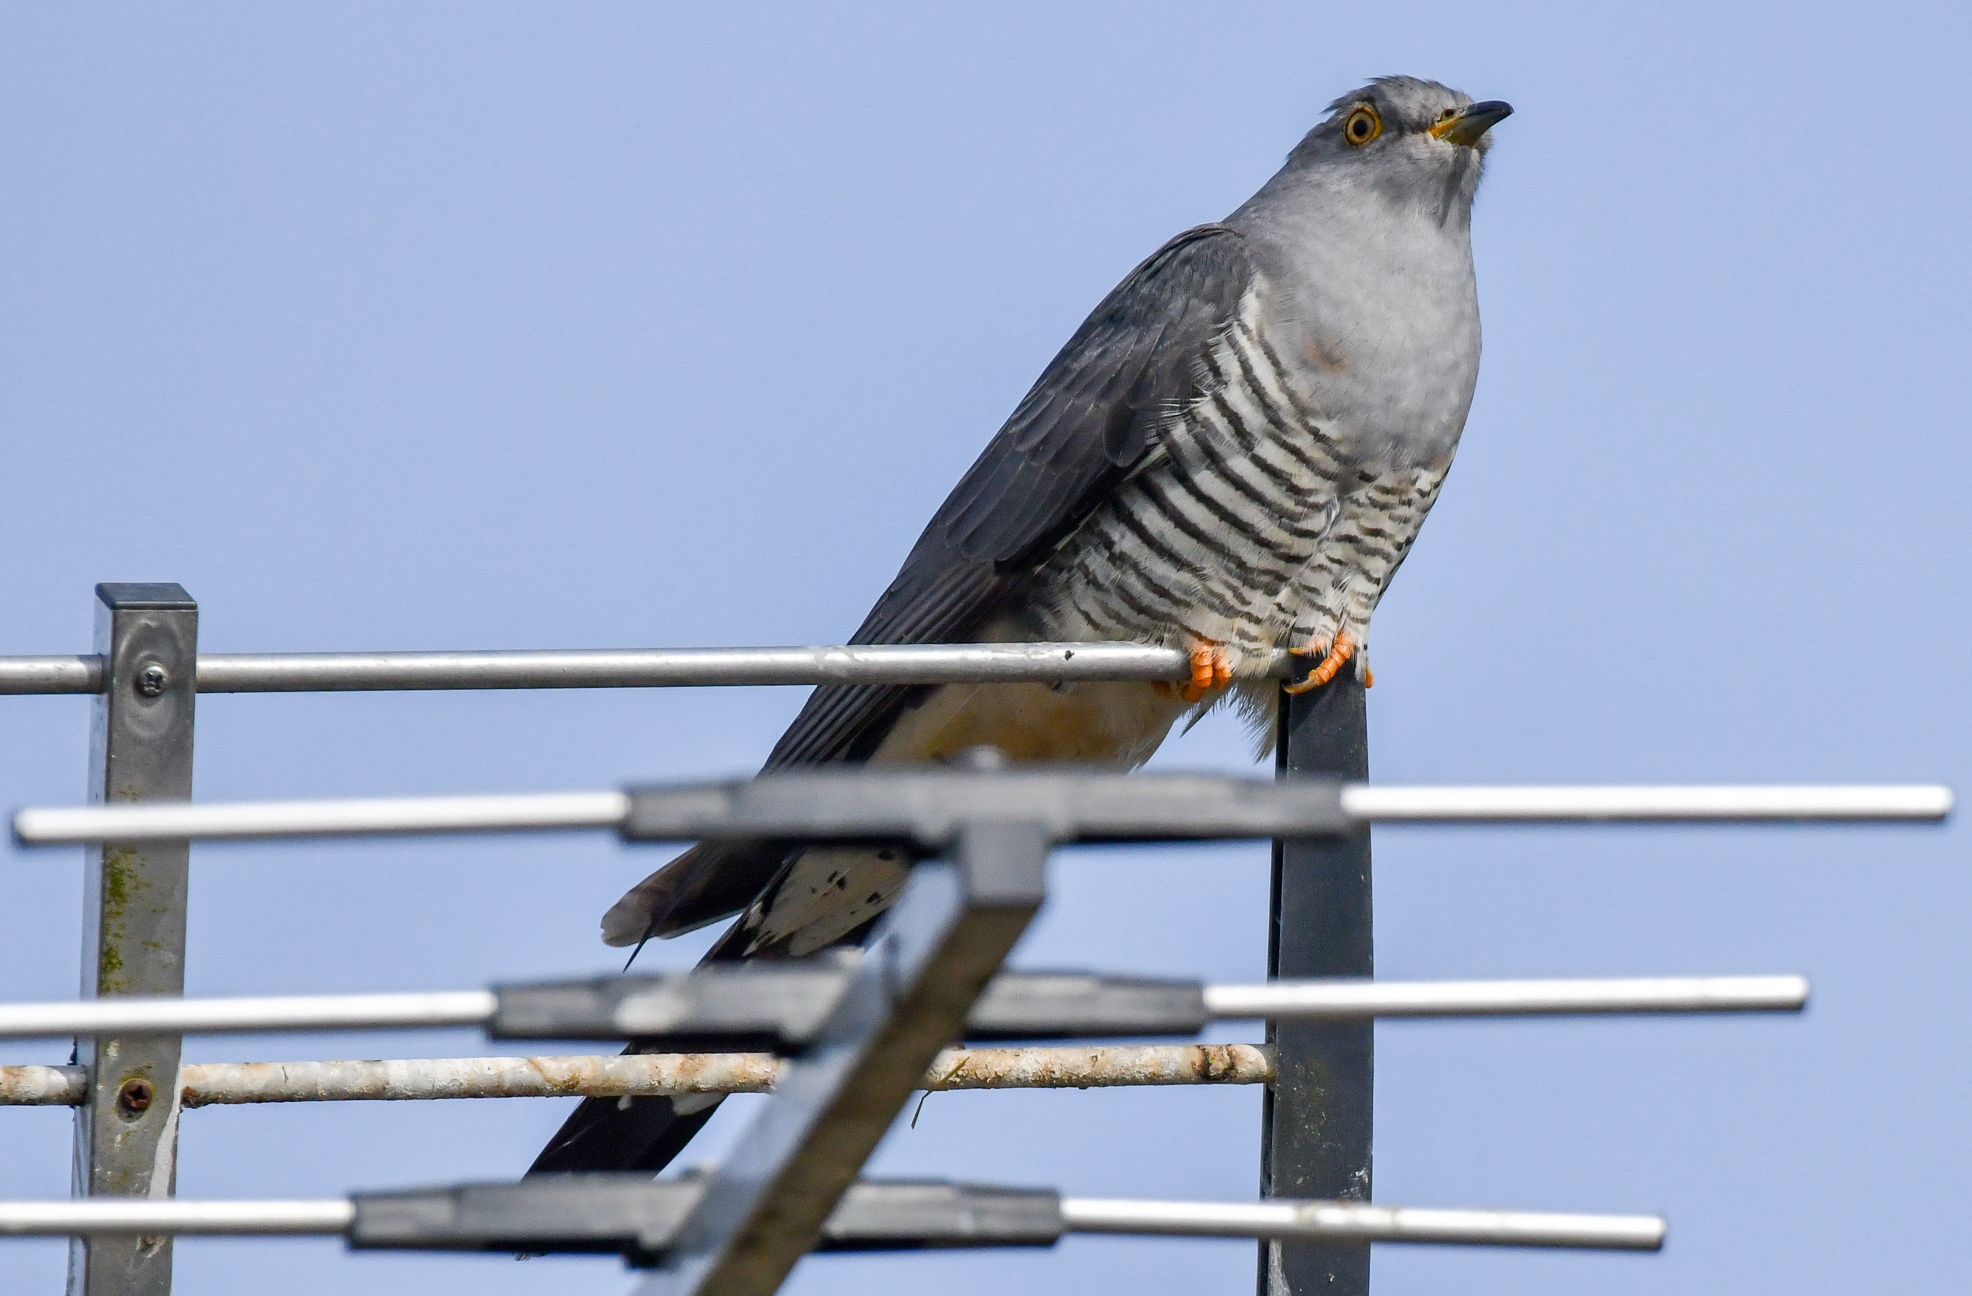
As temperatures soared by early April we saw the benefit of a good butterfly year in 2019 with high numbers of peacocks. Bird song has been more prominent with reduced background noise, the green woodpeckers in the local wood calling loudly from early March along with the less musical herons. By mid-April, warblers, swallows and cuckoos had returned. One of the best views of a cuckoo was this extrovert, spoiling a neighbour’s TV reception.
Sometimes the more ‘common’ species are worth a longer look, like this iridescent starling outside its nest under roof tiles.

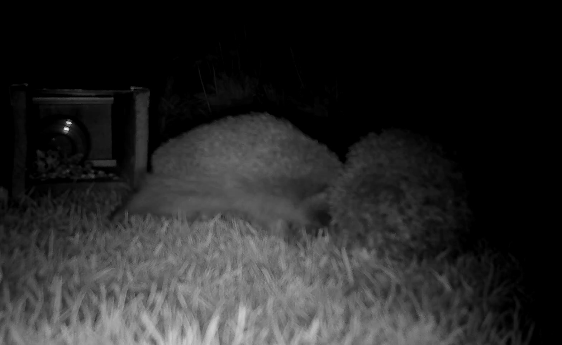
Wildlife cameras offer a great insight into what is happening in your garden, even overnight. This still is taken from a video of two hedgehogs in the garden, the larger resident aggressively trundling an intruder away from the food. See the amusing live action on
https://www.youtube.com/watch?v=oBBPqqs3S-E&feature=youtu.be

The Callander group represents SWT on the board of the Callander’s Landscape HLF-funded project with direct involvement in some of the Restore activities like plant surveys in Little Leny Meadows which are being managed to restore rare wet hay meadow habitat. Recently we were awarded a Stirling Council Community Pride award for the purchase of bat and bird boxes. A range of designs aim to attract woodland birds such as tits, robins, nuthatch and tree creepers along with barn owls. The boxes will be installed by volunteers and are intended to be in place for winter roosts and next year’s nesting season. The location of the site close to town and the Primary School will allow its use as a natural classroom or for public awareness events. Maybe we should include a guided walk around the site in 2021 after the winter floods subside?

Notable bird sightings and snippets 2019-20
Red kite and osprey populations continued to increase and expand in our area in 2019. Golden eagles locally remained at 10 pairs although they had a poor breeding season. Three pairs of hen harriers were present in the LL&T National Park with one pair breeding successfully. There were several sightings of honey buzzard in our area in 2019: this elusive and under-recorded bird is of increasing interest to the raptor study group and other ornithologists and is probably much more common in our area than realised.
Swifts stayed much longer than usual in 2019, usually leaving our shores by mid-August but some remained even into early September due to a late breeding season. Cuckoos also leave us early but there was a late sighting of one near Argaty on 4 August. Other summer visitors, ring ousel and whinchat were once again present at Glen Kendrum with wood warbler on the nearby Edenchip Estate. Redstart were present at the Flanders Moss Reserve car park and are increasingly seen in cleared, scrubby areas of Coilhallan Wood and neighbouring woodland. More readily heard than seen, the green woodpecker are resident in woods in Callander and at Argaty.
Into the winter period waxwings were present in the area and seen throughout central Scotland with a flock in Dunblane well into April 2020. More common winter visitors, fieldfares were also widely seen with 82 in Glen Buckie on 16 March. Siskins were present in big numbers throughout the UK and locally over the winter: big flocks were noted in Strathyre forest, with a flock of 36 in the village itself on 08 March. Five Goldeneye spent the winter on the Teith in Callander, maybe the same ones seen on Loch Lubnaig on 6 April?
2020’s spring period saw the return of summer visitors: A sand martin at Strathyre on 28 March with big flocks (over 110) passing over on 6 April. Blackcap had also arrived there by 6 April.
By the end of May swallows, martins and finally swifts had returned but apparently in much reduced numbers across the UK, possibly due to a freak storm in Greece in April with thousands blown off course and found dead in the streets. However, without actual surveys, BTO cannot confirm this.
Records from Central Scotland Raptor Study Group, SWT Committee and members

Barn Owls Trends in 2019
Those who read last year's report may remember the field vole population crash in the middle of the barn owl breeding season, resulting in a large proportion of the newly fledged chicks and adults dying of starvation. 2019 was therefore expected to be a very poor season.
However, the vole population crash was not uniform across the region so the outcome was very mixed. In some areas all of the adults had disappeared (presumed died), and in other areas all the nest sites were occupied, each fledging 3-5 chicks plus some newly occupied sites. The worst affected areas were east of Flanders Moss to Stirling, Callander northwards and the northern part of Loch Lomond round to Killin. All the other areas monitored had a similar number of breeding pairs to the previous season, apart from Falkirk and North Lanarkshire where the owls were particularly successful.
Ironically, when all was tallied up, the breeding levels were good. Having dropped to 71 breeding pairs from 84 in 2018, they fledged at least 196 chicks, 68 more than in 2018. This should mean that with a building vole population and a large number of young owls looking for new territories, 2020 should be an interesting season. However, due to the Covid 19 lockdown we have been unable to monitor the owls so far this season. Mike Steward

Reported mammal sightings have included increasing numbers of red squirrels and pine martens with few greys from Callander northwards. Close to woods roe deer are quite common but up to 20 red deer are also regulars on Flanders Moss with 4 fallow deer seen in Glen Ample along with hares. Otters are flourishing across Scotland: watching a female and two kits playing and calling on the river bank at Strathyre for 15 minutes in February snow showers must have been pretty special. Signs of beavers are being increasingly reported round Callander as Taysiders spread southwards.

Many thanks to all who supported our 2019/20 programme of talks which averaged 28 attendees. Lockdown lead to cancellation of the April talk and AGM. Hoping we will be able to restart the talks programme in September, the first 3 booked speakers will cover Vultures, Lynx and Argaty. Meetings will again be in Callander Kirk Hall with the same suggested donations of £2 for members. The AGM will be rearranged and we would love to have your ideas and volunteers for committee.

Kevin Duffy (Chairman) Tel: 0776 6725392 E: kjduffy2012@hotmail.co.uk
Lesley Hawkins (Secretary) Tel: 01877 339080 E: mlhawkins@tiscali.co.uk

